Productive task :
- Calculating germination percentage.
- Calculation of seed rate for 1000 Sq Ft area.
- Performing seed treatment for known quantity of seeds.

Concept :
Sexual propagation in plants, Seed formation, Pollination, Seed germination, seed rate , seed treatment

Tools :
Hand gloves , microbial seed treatment culture, water , jaggery , tub (Ghamela) etc

Class-Age Group : 14 +

Study of seed propagation
- Seed treatment
- Ganesh Pingle & Ranajeet Shanbhag
Open Education Resource
Productive task-
- Calculating germination percentage.
- Calculation of seed rate for 1000 Sq Ft area.
- Performing seed treatment for known quantity of seeds.

Productive task objective -
- After going through this unit students will be able to select proper seed for cultivation with calculated germination rate and seed rate.
- After going through this unit students will be able to identify different seed treatments and perform seed treatment for their selected crop.

Introduction-
Bad seed is a robbery of the worst kind: for your pocket-book not only suffers by it, but your preparations are lost and a season passes away unimproved. -------------- George Washingtoin

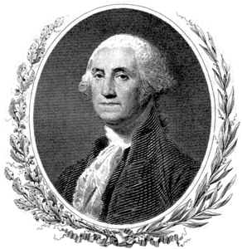

This very famous quote tells us importance of seeds in agriculture. But why seeds are so important, than any other inputs in agriculture business? A simple answer for this is a complete new progeny that is a new plant life starts with a simple seed and that’s the plant propagation.
Importance of propagation –
- To multiply the different species in large number.
- To protect the plant species which are endangered?
- To improve the characteristics and quality of the plants.
- To produce quality and healthy plants for commercial purpose.

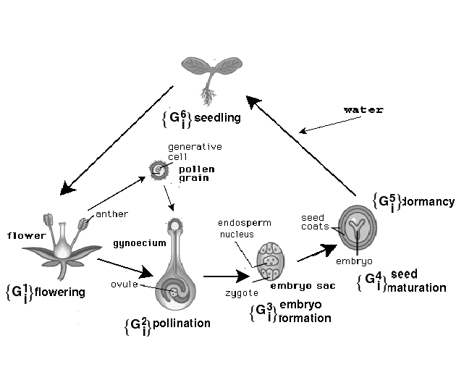

So, for propagation, plants produce seeds. Then, is it the only way plants can be re-produced? Certainly not, there are 2 major types of reproductive systems in plant kingdom, as -
- Sexual propagation or seed propagation.
- Asexual or vegetative propagation by vegetative plant parts like root, stem, leaf etc.
We are going to see all the details about first type (sexual method of plant propagation OR propagation by seeds) in this OER document.

Sexual Plant Propagation / seed propagation –
Seeds can be defined as a dormant plant which develops into a complete plant when subjected to required environmental conditions.

If seeds are so important for us let’s see how seeds are produced by any plant –
VIDEO LINK ( Pollination & seed formation) –
http://www.youtube.com/watch?v=AbpEhe6eXGI

Now let’s see how seed germinate for starting new life –
VIDEO ANIMATION (Seed germination) –
http://www.youtube.com/watch?v=3Ij1eW_gsrM&list=PLppNh27-S9-e-ah7mdlHA3ZiqWmreU7F3
http://www.youtube.com/watch?v=oYzXToyEzBU

Diagram: - Seed Germination –

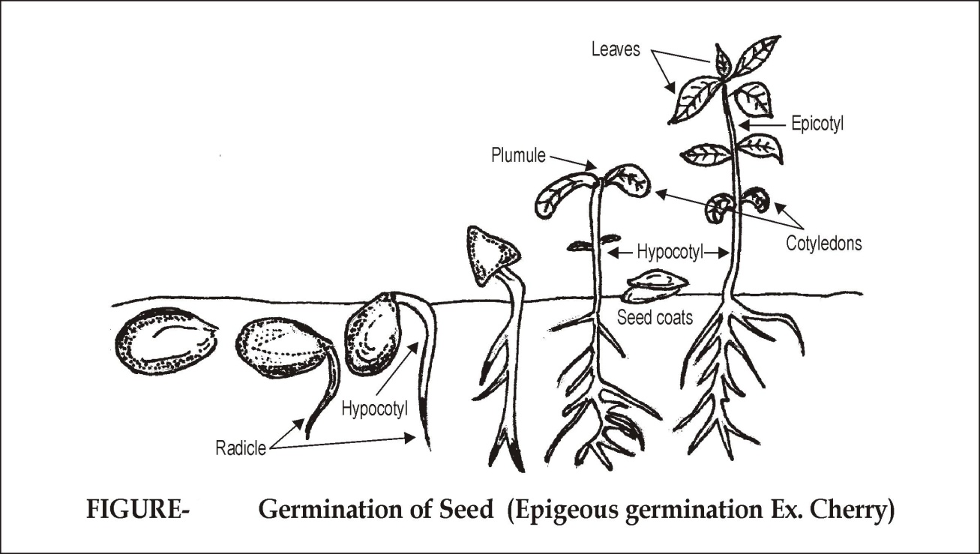

Steps in seed germination are as –

These above processes are either wholly or in part influenced by the food reserves, hormone supply, water supply, oxygen supply and temperature level.

Now, Let’s see which are the advantages and disadvantages of sexual propagation –
Advantages of Sexual Propagation:-
- This is very simple and easy method of propagation.
- Some species of trees, ornamental annuals and vegetables which cannot be propagated by asexual means should be propagated by this method. E.g. Papaya, Marigold, Tomato etc.
- Hybrid seeds can be developed by this method.
- New varieties of crops are developed only by sexual method of propagation.
- Root stocks for budding and grafting can be raised by this method.
- The plants propagated by this method are long lived and can resistance to water stress.
- Transmission of viruses can be prevented by sexual method.
- Seed can be transported and stored for longer time for propagation.
Now as you know advantages of seed propagation, can you think disadvantages of it?
Note down below and check you’re with point given below -

Disadvantages of sexual propagation:-
- Characteristics of seedling propagated by this method are not genetically true to type to that of their mother plant.
- Plants propagated by sexual method requires long period for fruiting.
- Plants grow very high, so they are difficult for intercultural practices like spraying, harvesting etc.
- The plants which have no seeds cannot be propagated by this method. E.g. Banana, fig, Jasmine, Rose etc.

Seed Germination rate :

Productive task 1 -

Calculation of germination rate –
Plant 100 seeds ( Jowar / wheat / or any other easily germination seed) in a tray and water it. After 3 -4 days, count seedlings (plants from seeds) developed in tray. Now calculate germination %.
Note - Seed germination is very important factor in quality of seeds we use in agriculture.
Video link - http://www.youtube.com/watch?v=eelwEB4Z1GA

HPNPDL Session -

- What is plant kingdom? Find out further details & classification of plant kingdom.
- Why seed required water / moisture for germination?
- What is cross pollination?

Seed Rate & Seed treatment-
We have seen seed germination and advantages of seed propagation; now let’s see what is SEED RATE in agriculture -
Seed rate refers to number of seeds (Kg) to be used per hectare / acre to ensure proper plant density (Plant population) for maximum yield.

Let’s now see how to calculate seed rate –
Suppose we want to calculate seed rate for cultivation of maize crop, then we need to find out:
1. Spacing (that is planting distance) of the maize crop.
2. Weight of 100 seeds
3. Calculate average weight of maize crop seeds required for 1 hectare (considering weight measured for 100 seeds)
Let us calculate above three things:
- Spacing of maize is 0.6 * 0.23 m, so maize plant will required 0.138 sq m space to grow.
- Now by this we can say that around 72463 plants will be required
for 1 hectare area. (1 ha = 10000 sq m)
that means (10000/0.138 = 72463 ) in other words (1hectare/space required for one plant = Total plants per hectare)
- Now count 100 seeds of maize crop and weigh them.
- Let’s consider weight of 100 seeds of maize crop is 28 gm
- We can calculate weight of 72463 seeds by multiplying it with weight of 100 seeds.
72463 * 28 / 100 = 20.28 kg.
- So seed rate of maize crop will be 20.28 kg / hectare.
- Please note that above seed rate will be for 100 % germination rate so first we have to calculate actual germination rate for given seeds and then make correction in calculated seed rate.
- So if we got germination rate 90 % then raise seed rate by 10 %.

Self assessment -

Productive task 2 -
Calculate seed rate for wheat or any other crop as per season and your area crop for 1 Guntha (1089 sq ft ) area and then convert this seed rate for 1 Hectare area. .

So far we have seen – How seed germinate, importance of seed propagation, how to calculate germination rate & seed rate we are just one step behind sowing our seeds in field and that is SEED Treatment.
Let’s see what seed treatment is and why this is so important in agriculture –

Seed Treatment-

What is seed treatment?
- Before planting, a chemical treatment or dressing (typically antimicrobial or fungidal) is given to the seeds, which is known as a seed treatment.
- How that helps?
  - Improves germination rate
  - Improves immunity of plants
  - Improves crop productivity
  - Improves quality of crop
To know more about seed treatment refer PPT Link– Seed treatment Eng

Productive task 3 -
Perform any one seed treatment method for wheat seeds (calculated as per above task) and sown these seeds in field.

Summary –
Learnings –
- Propagation is an important technique of multiplying useful plants.
- We can propagate plants by sexual or by asexual means.
- Science behind seed germination and calculating germination rate and seed rate.
- Important methods of seed treatment and performance of seed treatment for different crops.

Other Session -

For further reference on important crops and their seed treatment follow PPT link given below–

Seed treatments based on crop classification

