Basic information about Soil Formation
Open Education Resource
Basic information about soil formation:
http://www.youtube.com/watch?v=vg-hwKwT-Hs

Basically, soil is made up of different components.
Following figure will give you an idea of components of soil.
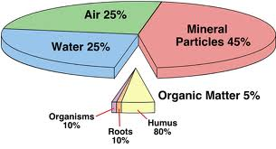

The sequence of processes in the formation of soils is:
Weathering of rocks and minerals -> formation of regolith or parent material ->formation of true soil from regolith
Rock ->Weathering ->Regolith* ->Soil forming factors and processes ->True soil
*Regolith is a layer of loose, heterogeneous material covering solid rock.
2 processes involved in the formation of soil are:
- Formation of regolith by breaking down (weathering) of the bed rock.
- The addition of organic matter through the decomposition of plant and animal tissues, and reorganization of these components by soil forming processes to form soil.
Factors which contribute in the formation of soil are:
Soil is formed from the rocks by the process called weathering of rocks and by different pedogenic processes. The properties a soil are dependent on the rock from which that is formed, climatic conditions, organisms and time. The study a soil profile gives us knowledge about its formation and quality.
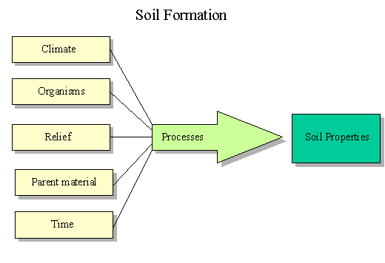
Well developed soil = Function of (Parent material + Topography (relief) + Climate +Living things (organisms) +Time)
Now let’s see, major types of soils found in India -
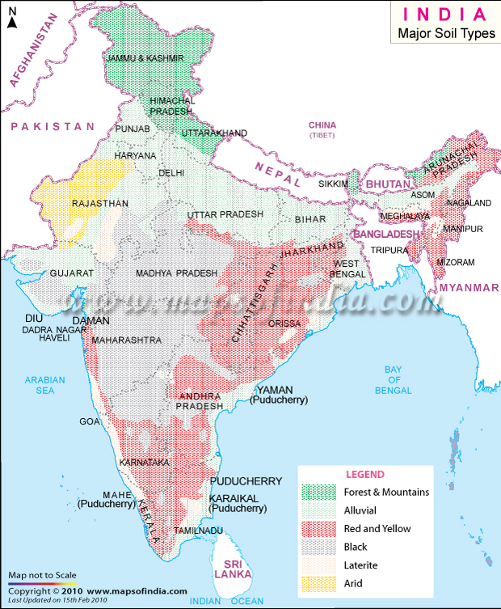

Source - http://www.mapsofindia.com

As shown in above map, there are 6 major types of soil found in India pre-dominantly accordingly topographical and climatic conditions of country.
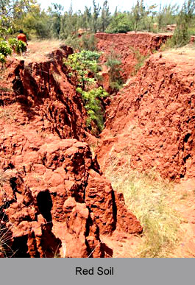
These are -
- Red Soil:
Generally these soils are light textured with porous and friable structure and there is absence of lime Kankar and free carbonates. They have neutral to acidic reaction and are deficient in nitrogen humus, phosphoric acid and lime.
Crop suitability - rice, millets, tobacco and vegetables (also groundnuts and potatoes at higher elevations).
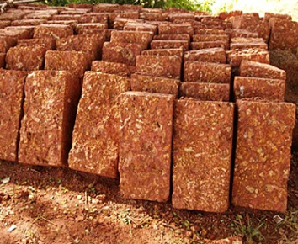
- Laterites and Lateritic soil:
These soils are red to reddish yellow in colour and low in N, P, K, lime and magnesia. These soils are formed in situ under conditions of high rainfall with alternation dry and wet periods. On account of heavy rainfall there is an excessive leaching of soil colloids and silica hence the soils are porous.
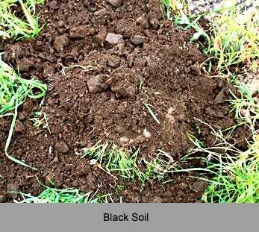
Crop suitability - tea, coffee, rubber, cinchona, and coconut and suitable for rice and millet cultivation if manure is added.
- Black soil:
These are mostly clay soils and form deep cracks during dry season. An accumulation of lime is generally noticed of varying depths. They are popularly known as “Black cotton soils” because of their dark brown crown colour. These are also known as Indian regurs.
Crop Suitability - cotton, cereals, oilseeds, citrus, fruits & vegetables, tobacco & sugarcane

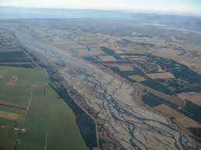
- Alluvial soils:
These soils occur along rivers and represent the soil materials that have been deposited by the rivers during flood. These soils are one of the most fertile soils in the world due to organic matter deposition by river flow. Usually they are very productive soils but many are deficient in N, P and humus.

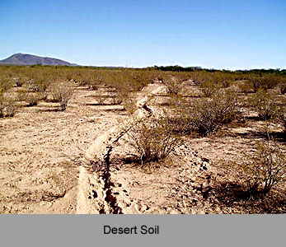
- Desert soils:
These are mostly sandy soils that occur in the low rainfall track. They are well supplied with soluble salts but are low in nitrogen and organic matter and have a high pH value. These are quite productive but often subjected to wind erosion.

- Forest and hill soils :
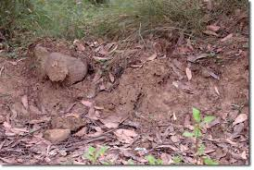
These soils occur at high elevations as well as at low elevations, where the rainfall is sufficient to support trees. These soils are very shallow, steep, stony and infertile for production of field crops. These serve a very useful purpose by supplying forest product such as timber and fuel.
Crop suitability - good for plantation of tea, coffee, spices and tropical fruits
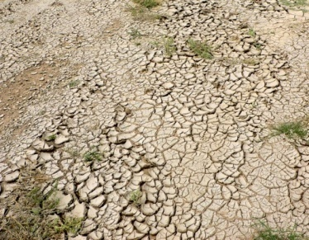
- Saline and Alkaline soils :
These soils occur in areas having a little more rainfall than the areas of desert soils. They show white incrustation of salts of Ca and Mg & Na on the surface. These are poor in drainage and are infertile.

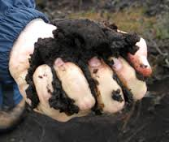
- Peaty and Marshy soils :
These types of soils are found in Kerala,coastal track of Orissa, sunderban area of W.B. When the vegetation growing in such wet places dies, it decomposes very slowly dues to excessive wetnessnof soils and after several hundreds of year a layer of partly decayed organic matter accumulates on the surface, giving rise to such peaty and marshy soils. These are black coloured , heavy and highly acidic soils. When properly drained and ferlilized, these soils produce good crops of rice.

Soil Improvement:
We have already learned characteristics of an ideal soil but we could not find such soil all the time. There are many types of problem soils and we have to improve those soils.
Problem Soils:
The soils with acidic or basic reaction, soils with poor drainage, soil with low water holding capacity,salt affected soils, and soils with pathogen are known as problem soils. Such soils have bad effect on crop growth and plants show defeciencies of different nutrients.
Steps for improvements of problem soils are:
- Bunding and leveling: the soil should be leveled properly and provided with strong bunds along with field boundary.
- Provision of irrigation Water: Sufficient salt free water should be made available.
- Drainage: Provision od adequate drainage is essential. Proper surface and subsurface drainage is important factor in soil improvement.
- Application of amendments: Gypsum is standard amendment for alkaline soils. For acid soils calcium carbonate is applied as amendment.
- Leaching: Leaching means removal of soluble salts fron root zone.
- Cropping: grow the crops which tolerate particular problem soil. For example; salt tolerant crops like sugarcane, barley, and oats.
- Addition of organic Manuare: Addition of organic manure in sufficient amount will provide drainage in heavy soils and improves water holding capacity of poor soils.

