Demonstrate measurement capability using Measuring Tape , Vernier caliper, and screw gauge

**Scope** :

1. Study of measuring instruments
2. Applications of measuring instruments
3. Demonstrate measurement capability using different measuring instruments

**Tools** : Measuring Tape, Vernier caliper, and screw gauge

* **Demonstrate measurement capability using different measuring instruments**

**Introduction-**

In this document we will learn the very basics of physics i.e. measurements. We have to measure length almost everywhere, let’s say how tall a person is? OR what is a diameter of small hole?

So what is length basically? It is the measurement of distance, or more simply, it is a physical quantity which tells us how far objects or two points are. Its SI unit is metre (m). (The *International System of Units* is the world's most widely used system of measurement).

We can’t really use a single instrument to measure height of a person and diameter of a small hole, can we? Of course not. So the instrument used depends on the magnitude of length to be measured.

Every instrument is designed for different precision and range. So, question is what is precision and what is range? Precision is the smallest unit (minimum length) an instrument can measure, like the ruler you use at school probably measures at least 0.1 cm or 1 mm. Range is the maximum length an instrument can measure, for example- a ruler can measure a maximum of 1feet, hence it is its range.

Simple Isn’t it?

Now let us see the basic measuring instruments used :

There are three instruments used:

1. Measuring Tape

2. Vernier Caliper

3. Micrometer Screw Gauge

Measuring tapes are basically rulers that are flexible in nature. Often they are constructed of a thin band of metal or made with cloth. These handy measuring tapes normally take up very little space, making them ideal for carrying or storing in small spaces.

They can be used in a number of different professions with ease, making them extremely popular and functional.

**1. Measuring Tape**

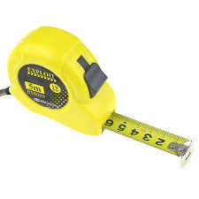

Measuring Tape will typically use the same units of measurement that are common with rulers.

1. **Vernier Caliper**

Inside jaws

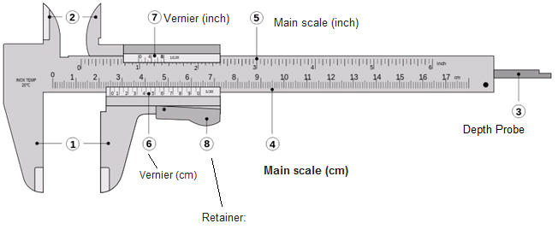

Outside jaws

Outside jaws

1. **Outside jaws**: used to measure external length
2. **Inside jaws**: used to measure internal length
3. **Depth probe**: used to measure depth
4. **Main scale** (cm)
5. **Main scale** (inch)
6. **Vernier** (cm)
7. **Vernier** (inch)
8. **Retainer**: used to block/release movable part

Vernier calipers are actually used to measure smaller lengths to acquire a greater accuracy as it’s precision is 0.01 cm i.e. 0.1 mm. The inside jaws shown are used to measure the internal diameters of objects while the outside jaws are to measure the external diameter. The vernier calipers have a main scale and a sliding vernier scale.

Now we’re going to learn how exactly measurements are taken using vernier calipers. But before starting this, you should all know about zero error. Hmm.... so what is it? It’s actually an error in the instrument which occurs when the zero of the main scale and vernier scale do not coincide when the jaws of the calipers are closed

1. Firstly, just read the centimeter mark on the main scale to the left of the 0-mark on the vernier scale. (10 mm in this case)



1. Now, find the millimeter mark on the main scale that is just to the left of the 0-mark on the vernier scale. (6mm as you can see)



1. Now we have to take the readings on the sliding vernier scale. For this, look along the ten marks on the vernier scale and the millimeter marks on the main scale, until you find the two that most nearly line up. (0.25mm on the vernier scale)



1. Okay so finally, just simple add this found digit to your previous readings to obtain the diameter of the object, as shown:



1. **Micrometer Screw Gauge**

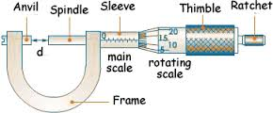

More closer look of thimble and sleeve:



Micrometer Screw Gauge consists of a hollow cylinder mounted on a U frame. The hollow cylinder leads to a ratchet which is meant for fine adjustment. The U frame consists of a flat end known as stud and a screw on the other side. This screw can be moved inside the nut by fitted in the U frame by rotating the hollow cylinder called the thimble. This is called the main scale. The hollow cylinder or the thimble is graduated into 50 or 100 equal parts. This is called the circular scale.

**How to measure?**

To measure even smaller lengths, micrometer is used as it has an even smaller precision i.e. 0.001 cm or 0.01 mm. It’s range is less than 2 cm. But before taking measurements, again, we’re going to look for zero error. Zero error is absent if the zero of thimble scale coincides with the line on sleeve (datum line) when the anvil and spindle are closed.

Steps to measure :

1. The object whose diameter is to be measured is placed between anvil and spindle (shown above). The ratchet which is a kind of knob is turned to tighten spindle until a ‘tick’ is heard.
2. What is the maximum reading visible on sleeve? It’s 7.5 mm. And on the thimble scale? We’ll determine this by looking at the mark which coincides with the line on sleeve (called datum line), labeled as 0.38 mm with an arrow above. Finally, we’ll add up the two readings, as shown in the diagram below :



**For further information refer VIDEO LINKs**

# 1. How to use a vernier calliper

<http://www.youtube.com/watch?v=4hlNi0jdoeQ>

<http://www.youtube.com/watch?v=4hlNi0jdoeQ>

# 2. Experiment on Screw Gauge (Micrometer)

<http://www.youtube.com/watch?v=JpcWj7dkkeI>