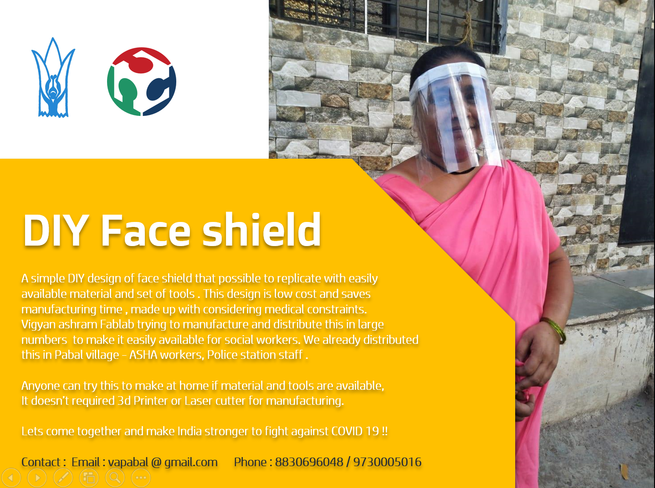

Considering the current situation and spreading rate of COVID 19 virus its become challenging to provide medical preventive instruments/ resources to each social worker and infected persons. Even its huge burden on all suppliers , manufacturers to make these safety instruments available in a short time. To maintain this demand vs supply ratio global fablab community decided to start an initiative to collaborate in this global cause with providing low cost solutions which anyone can fabricate with local available resources and in short time.

As part of this initiative Vigyan ashram Fablab also works on few projects that anyone can replicate with available local material. DIY face shields is one of them, there are many face shield designs available on the link below ,but these need either a 3D printer or Laser cutter machine for mass manufacturing. It's also possible to replicate these designs and we replicate a few of these designs at VA, but the VA team decided to work on a very simple design that anyone can replicate using a very simple set of tools, without a 3D printer or laser cutter.

https://gitlab.fabcloud.org/pub/project/coronavirus/tracking

Why face shields ?

As we know all worldwide governments putting efforts to procure/ produce and distribute more and more PPEs and N95 masks to all healthcare practitioners on duty, it is evident that as of today there is scarcity of PPEs and N95 masks across the globe.
By producing face shields, a transparent OHP sheet attached on the head mount, we can minimize direct exposure of healthcare practitioners, social workers to respiratory droplets and hence maximize the lifetime of N95 masks / respirators.

Let’s have a look at simple steps to make a DIY face shield.

Note : Before starting making shield wash your hand with soap or use hand sanitizer

Required material and specifications: (material per shield)

Material description | Specifications | Quantity
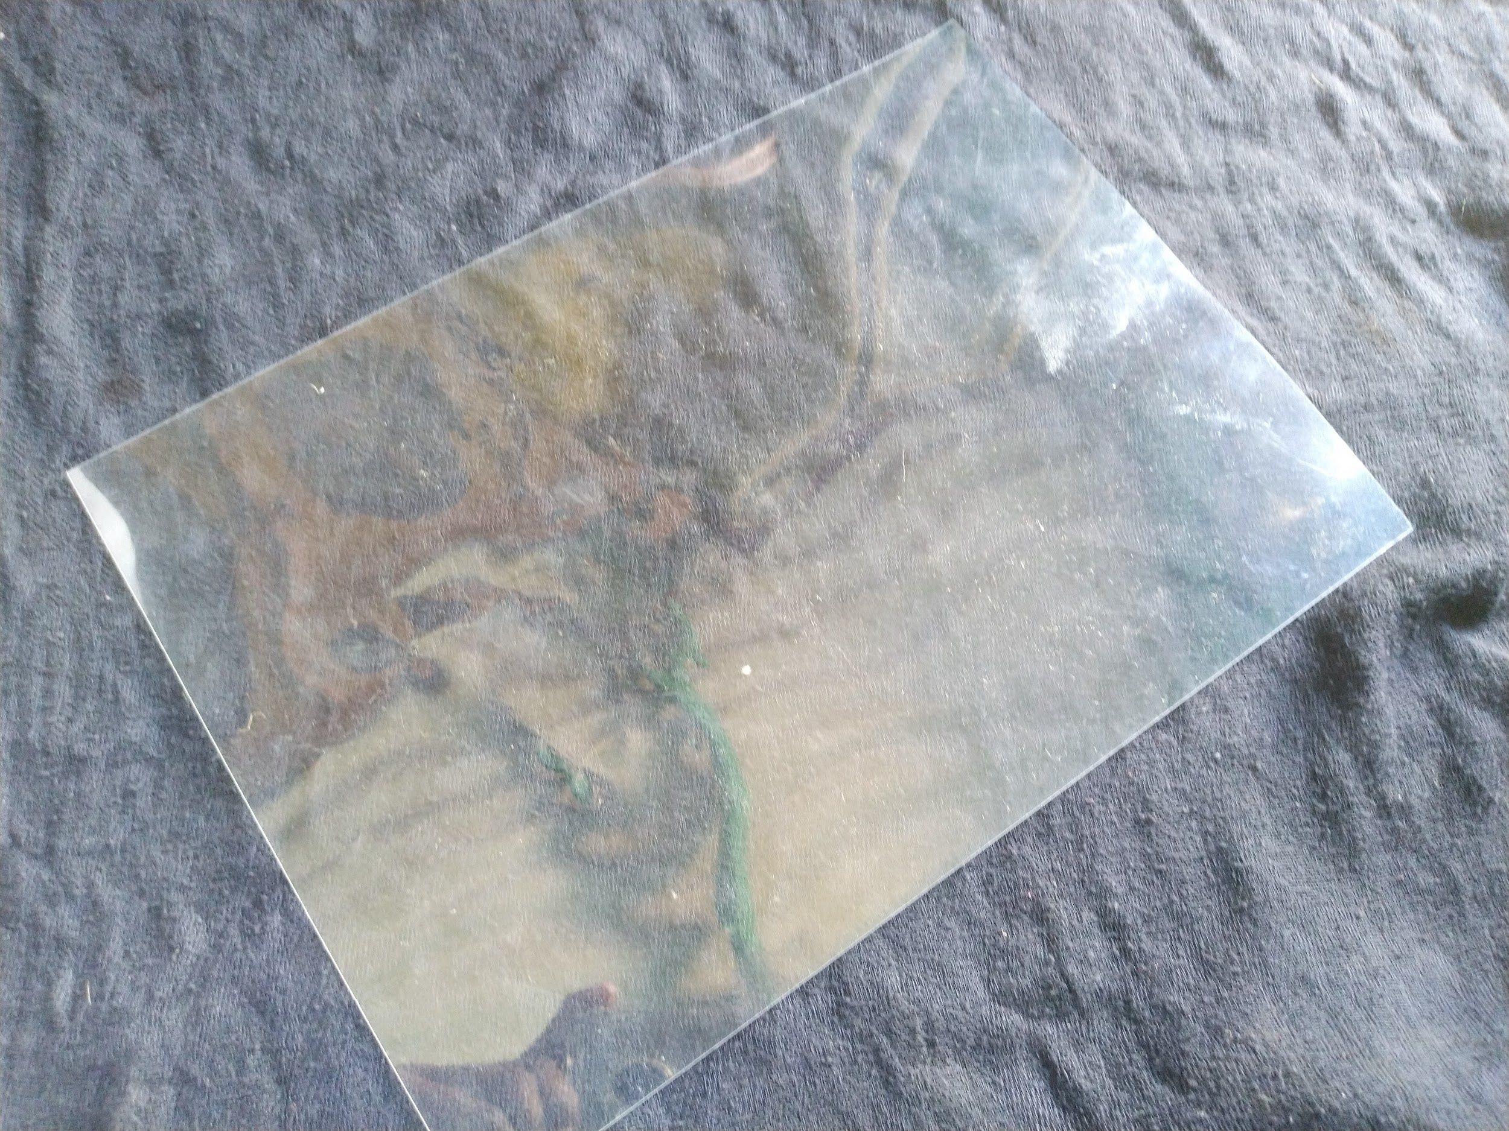  Transparent OHP sheet | Sheet size : A4  Thickness : 1mm  Type : OHP sheet | 1
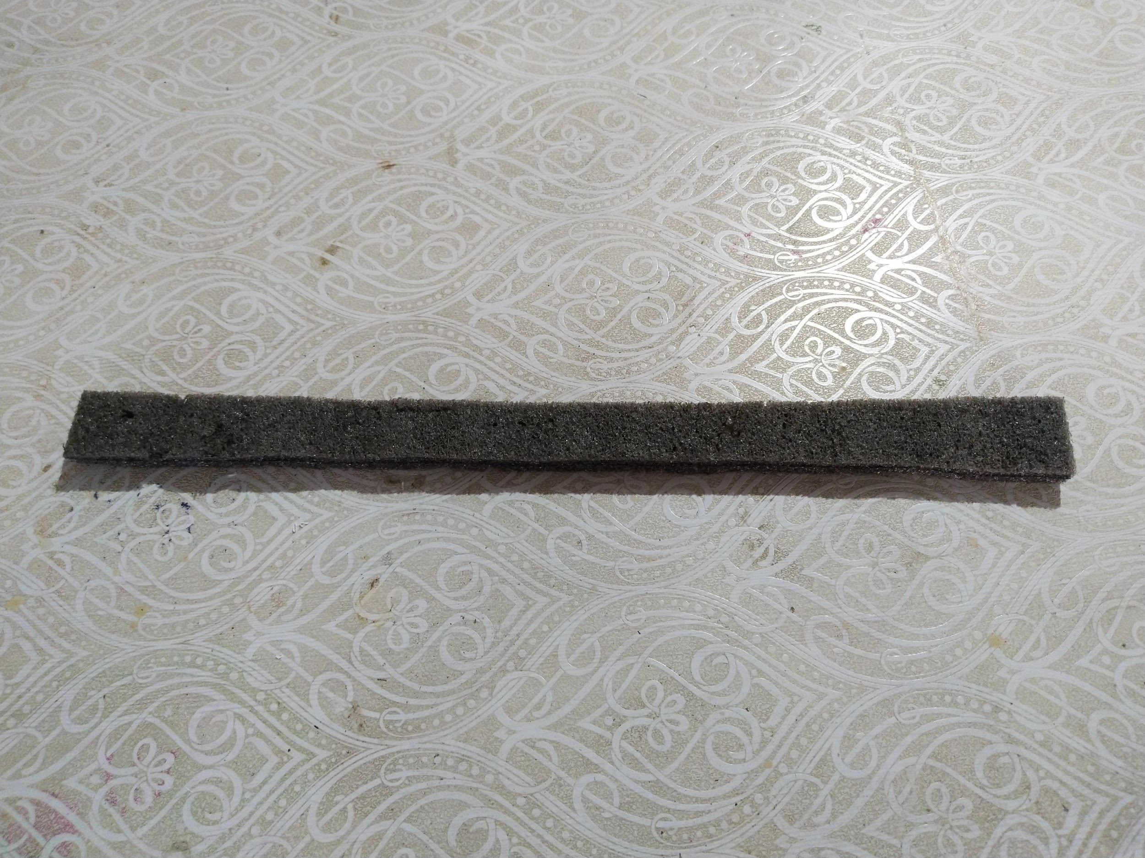  Foam Sheet | Piece size :  Length : 28cm  height : 2.5cm | 1
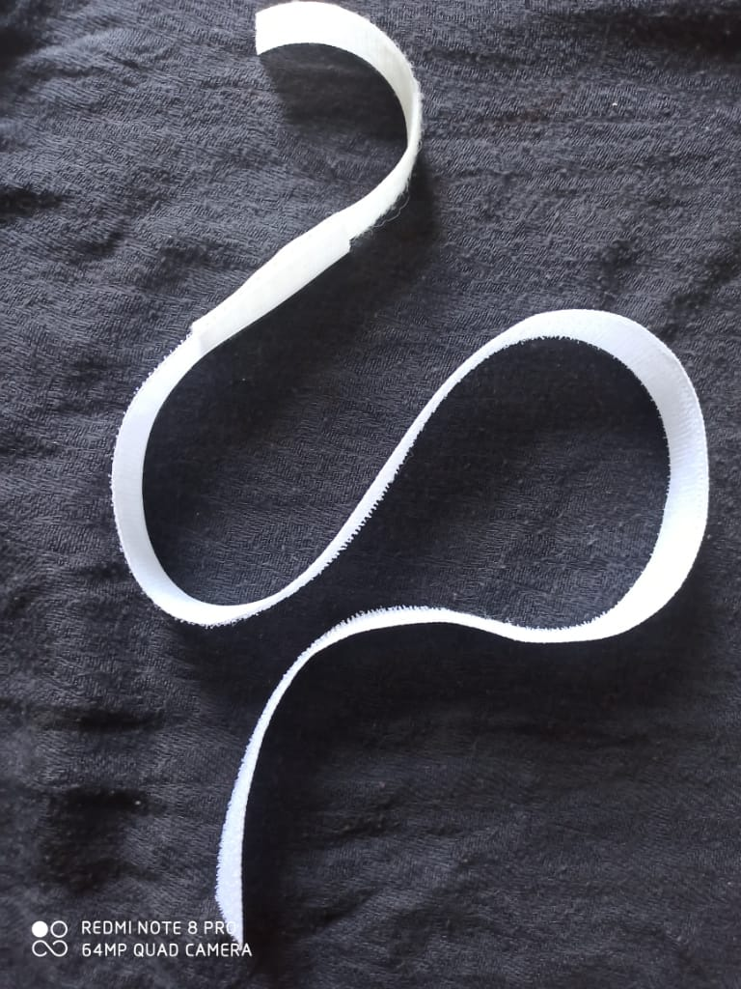  Velcro | Length : 70cm
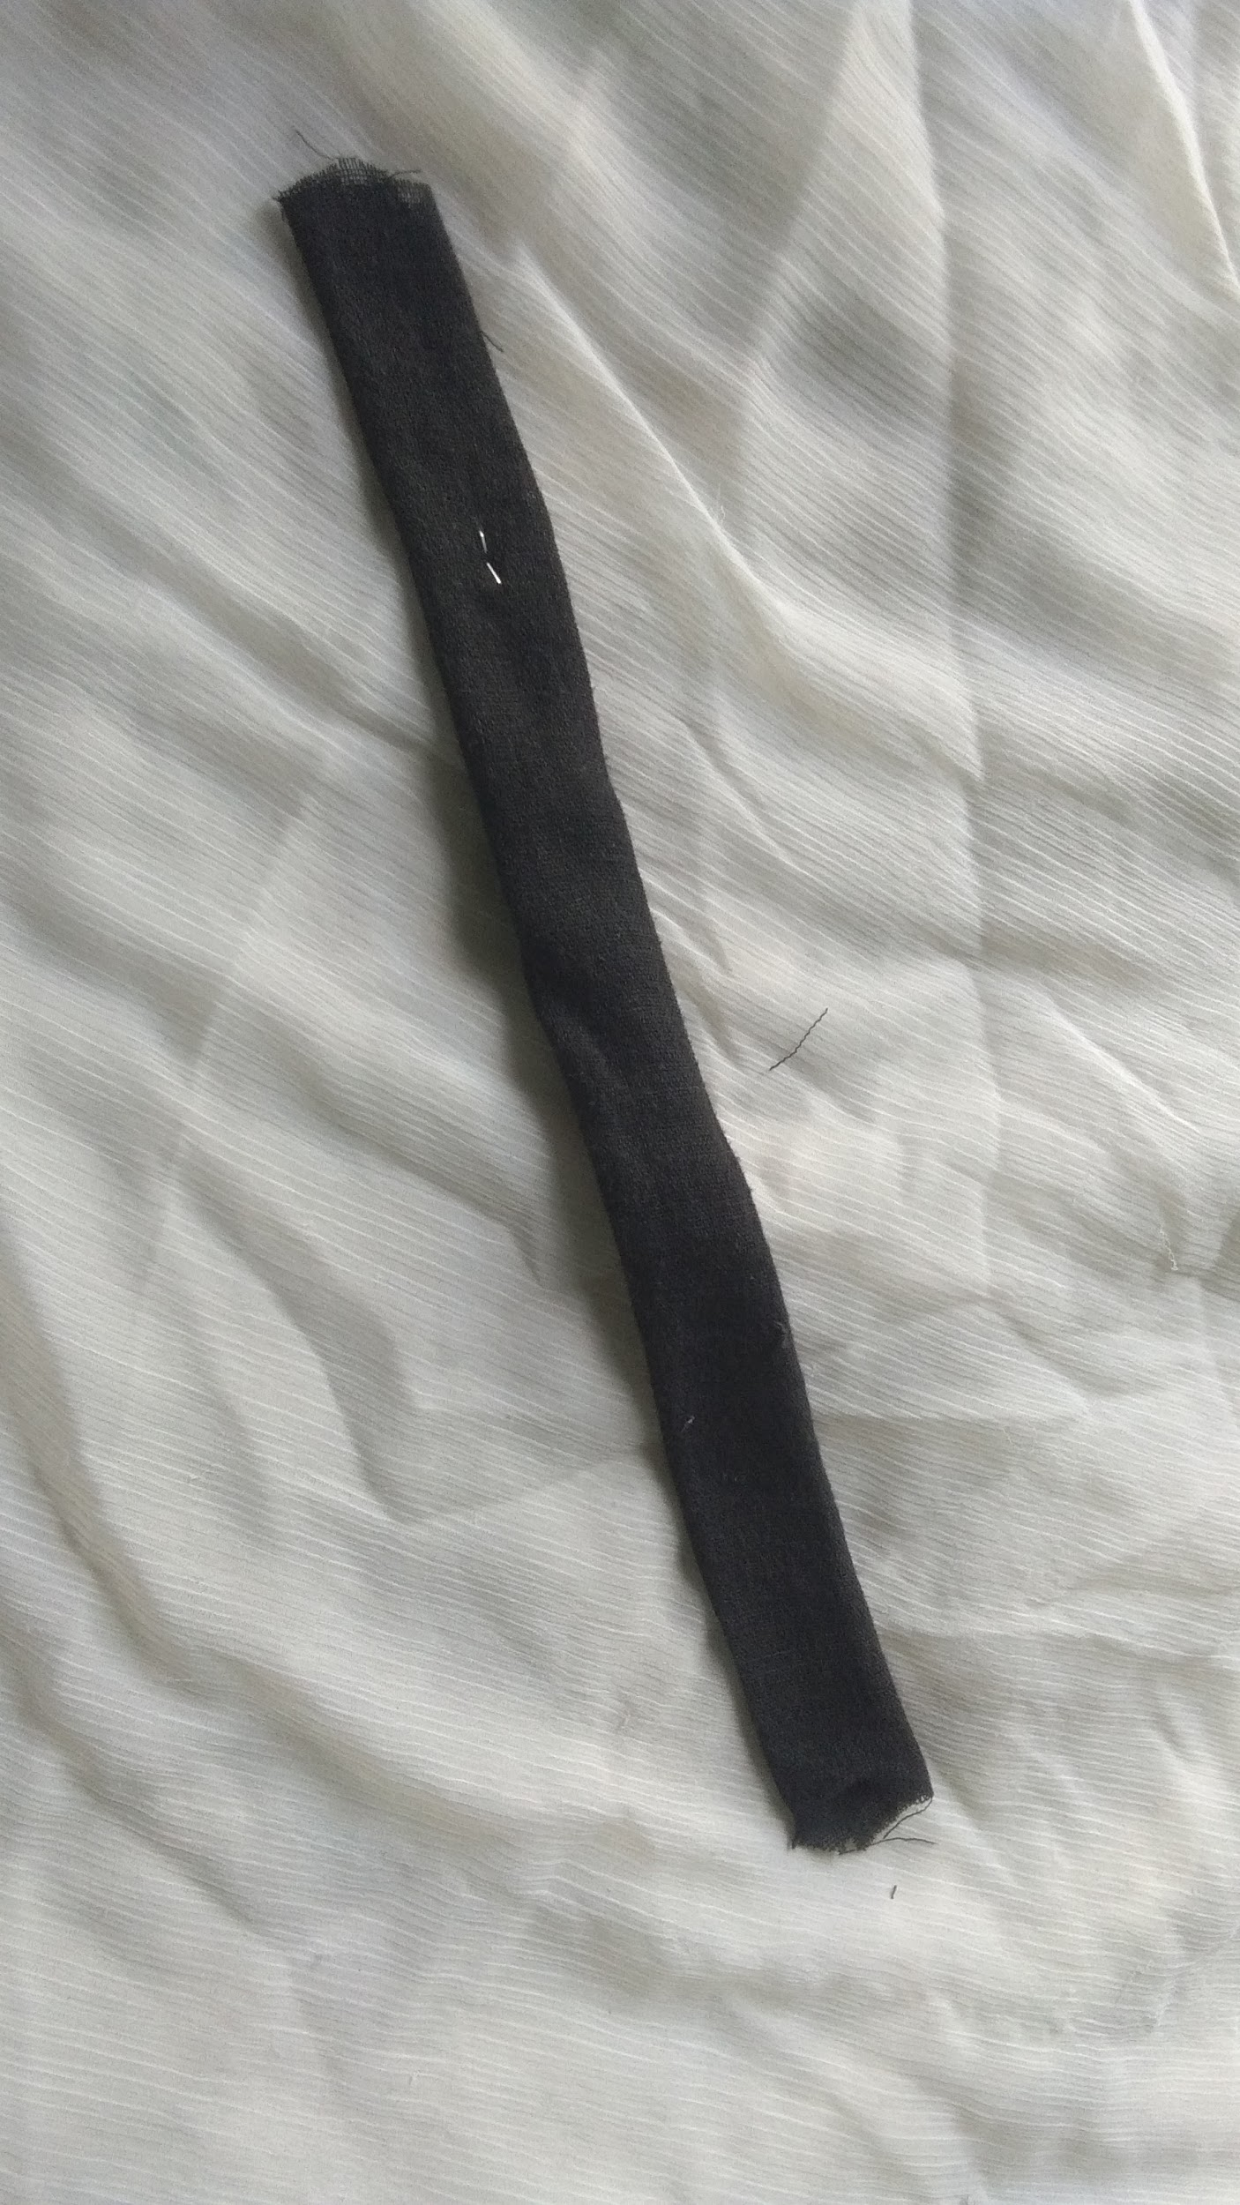  Cotton cloth piece | Size :  Width :2.5 cm  Length : 28 cm

Make ready following list of tools :
- Scissor 2. Steepler and pins
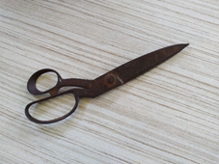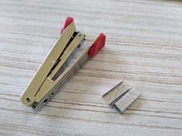

3. Measuring scale 4. Measuring tape
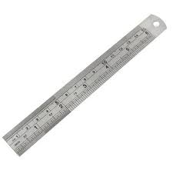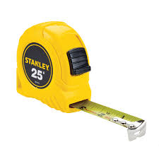

Follow below steps to make it :
Steps | Photos
- First take a measurement of your head (You can take this with using thread or directly using Velcro or measuring tape ), keep extra 10-12 cm extra length.  Generally length comes around 70cm, considering velcro overlapping parts. Cut velcro using scissor with taking same measurement of your head diameter plus extra part | 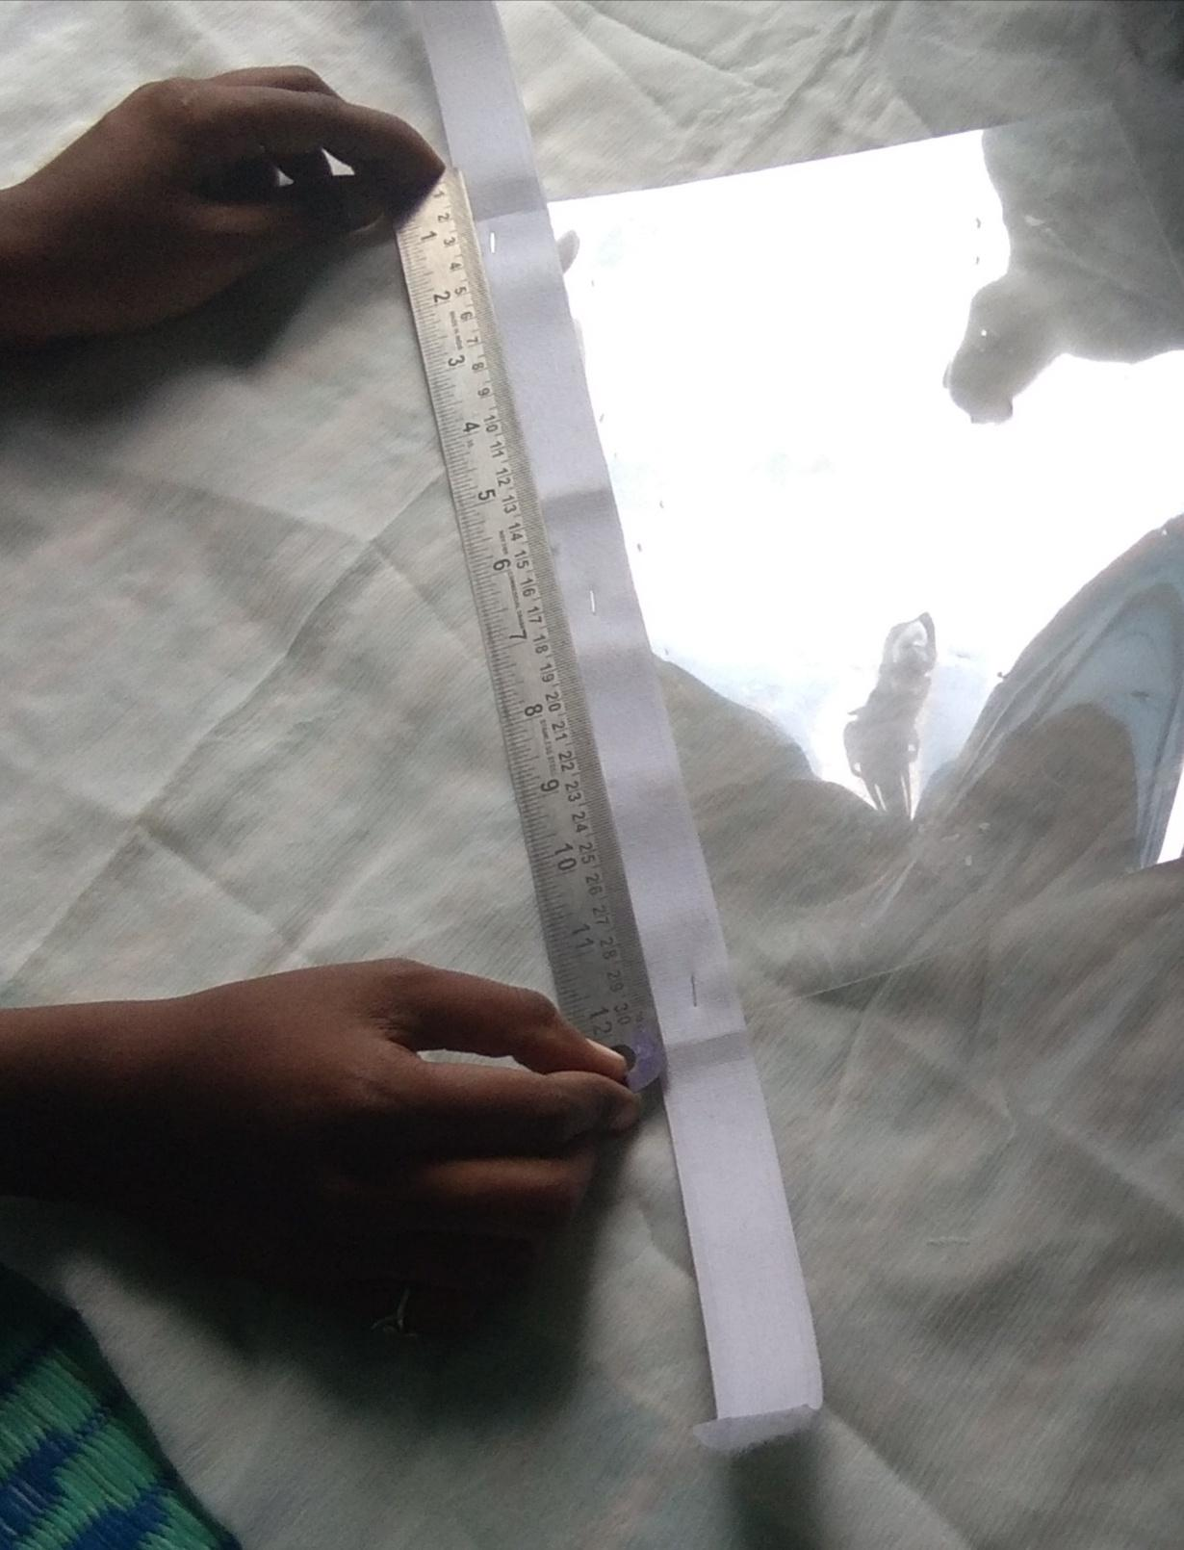
- Then take a 1mm transparent A4 size sheet, keep this in the middle of the velcro, leave the same length from both sides and staple it using a stapler and pins. Keep transparent sheet on front side and match velcro border with it( non sticky side of velcro)  Hold the steppler in horizontal direction along with velcro length, steeple with maximum 5-7 pins with keeping same distance in between. | 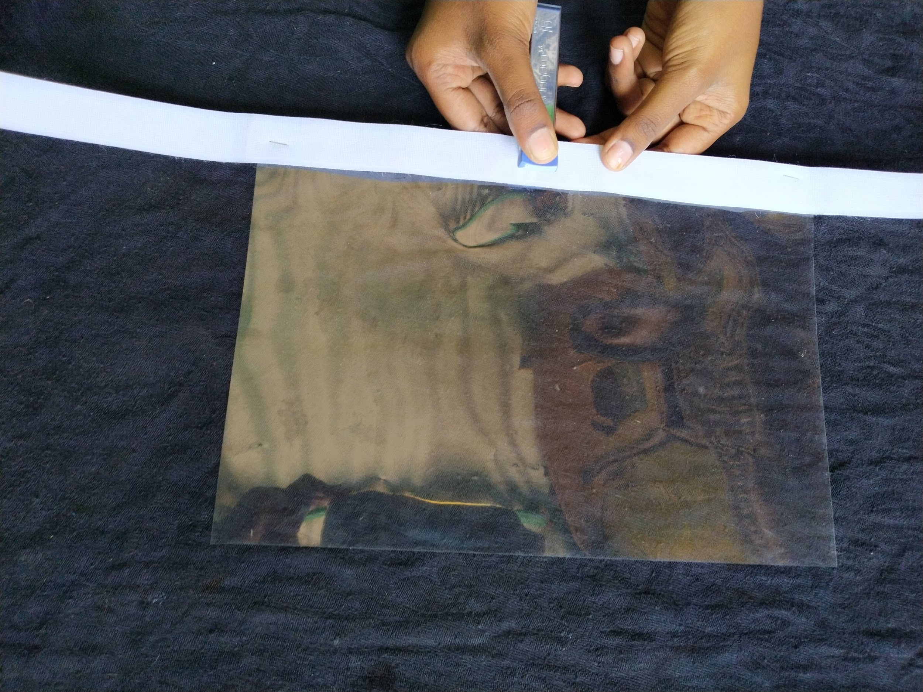
- Take a foam sheet and cut it with considering velcro width and length. Foam layer should cover the front face part only, so take length accordingly.  Now paste that foam sheet in middle  of velcro using Glue ,again keeping  the same length from both sides.  Foam layer is for keeping transparent paper away from the skin. | 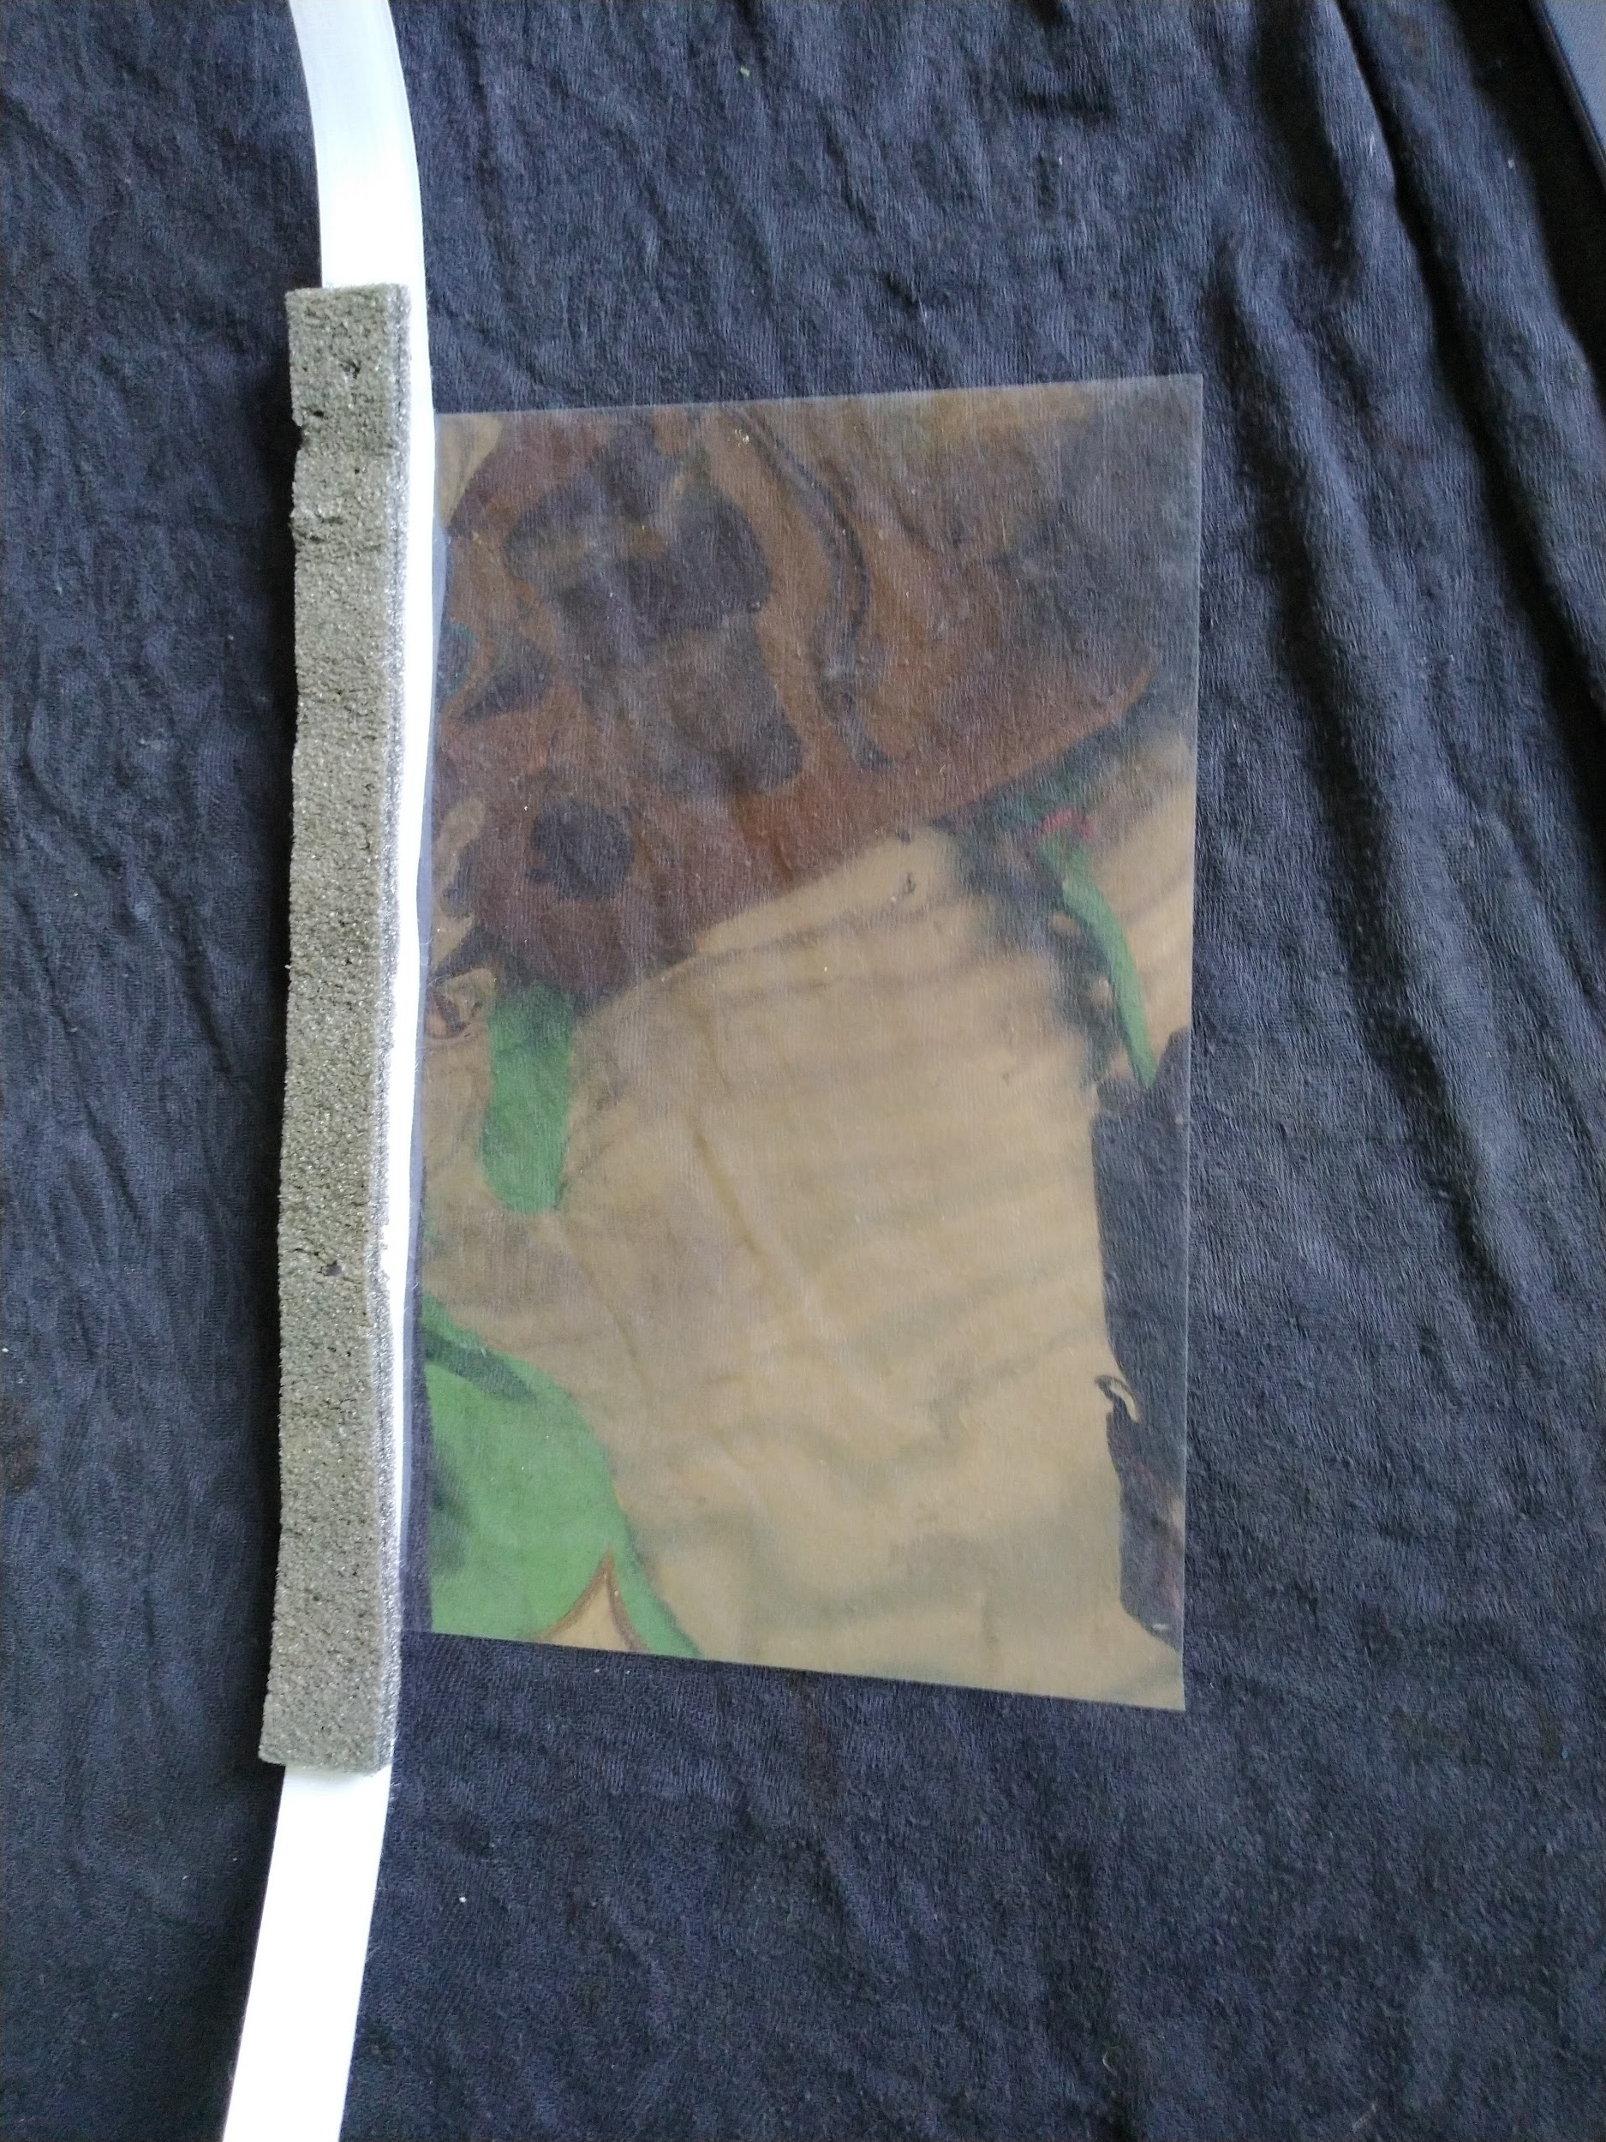
- Now cover this foam layer with cotton cloth , take a piece of dimension 28 cm x2.5cm.( it is same dimension of Foam) | 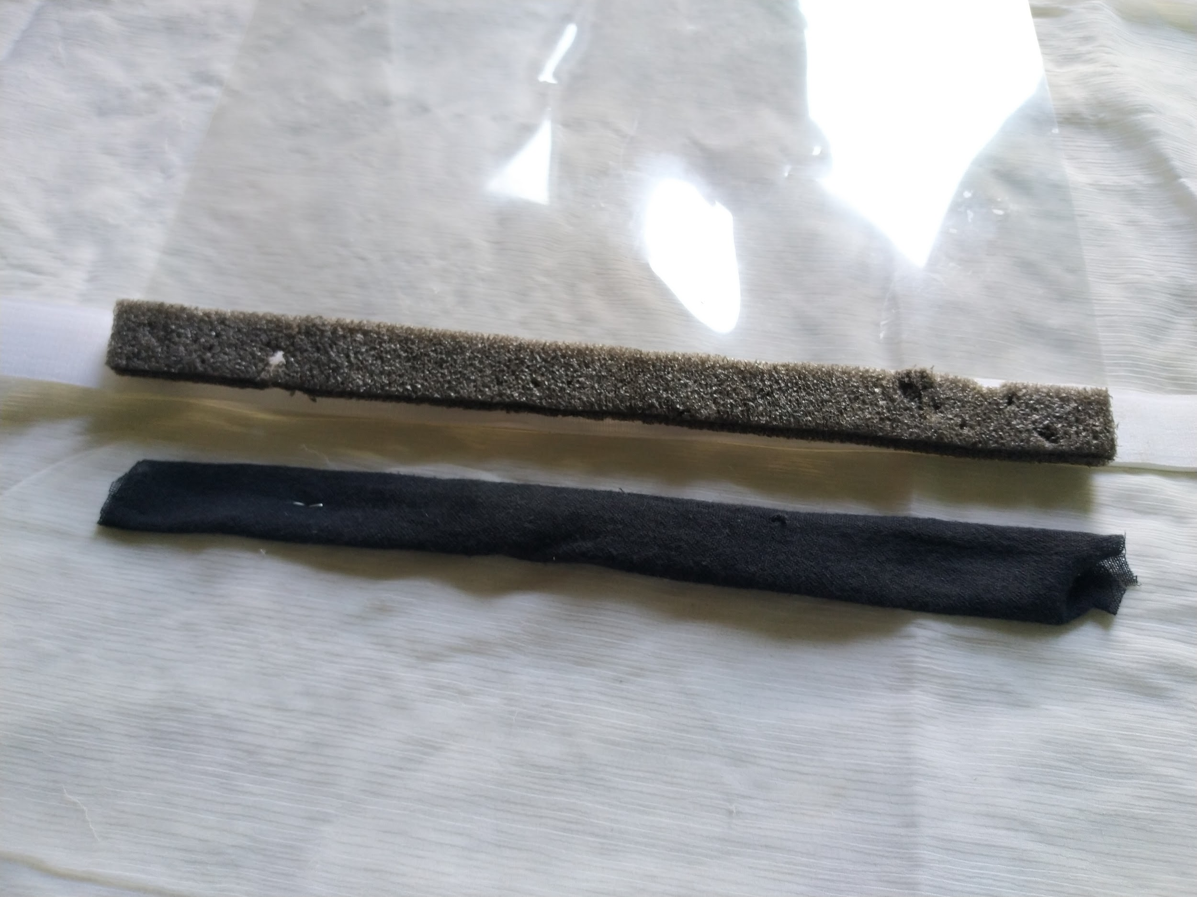
- Finally your shield is ready to use | 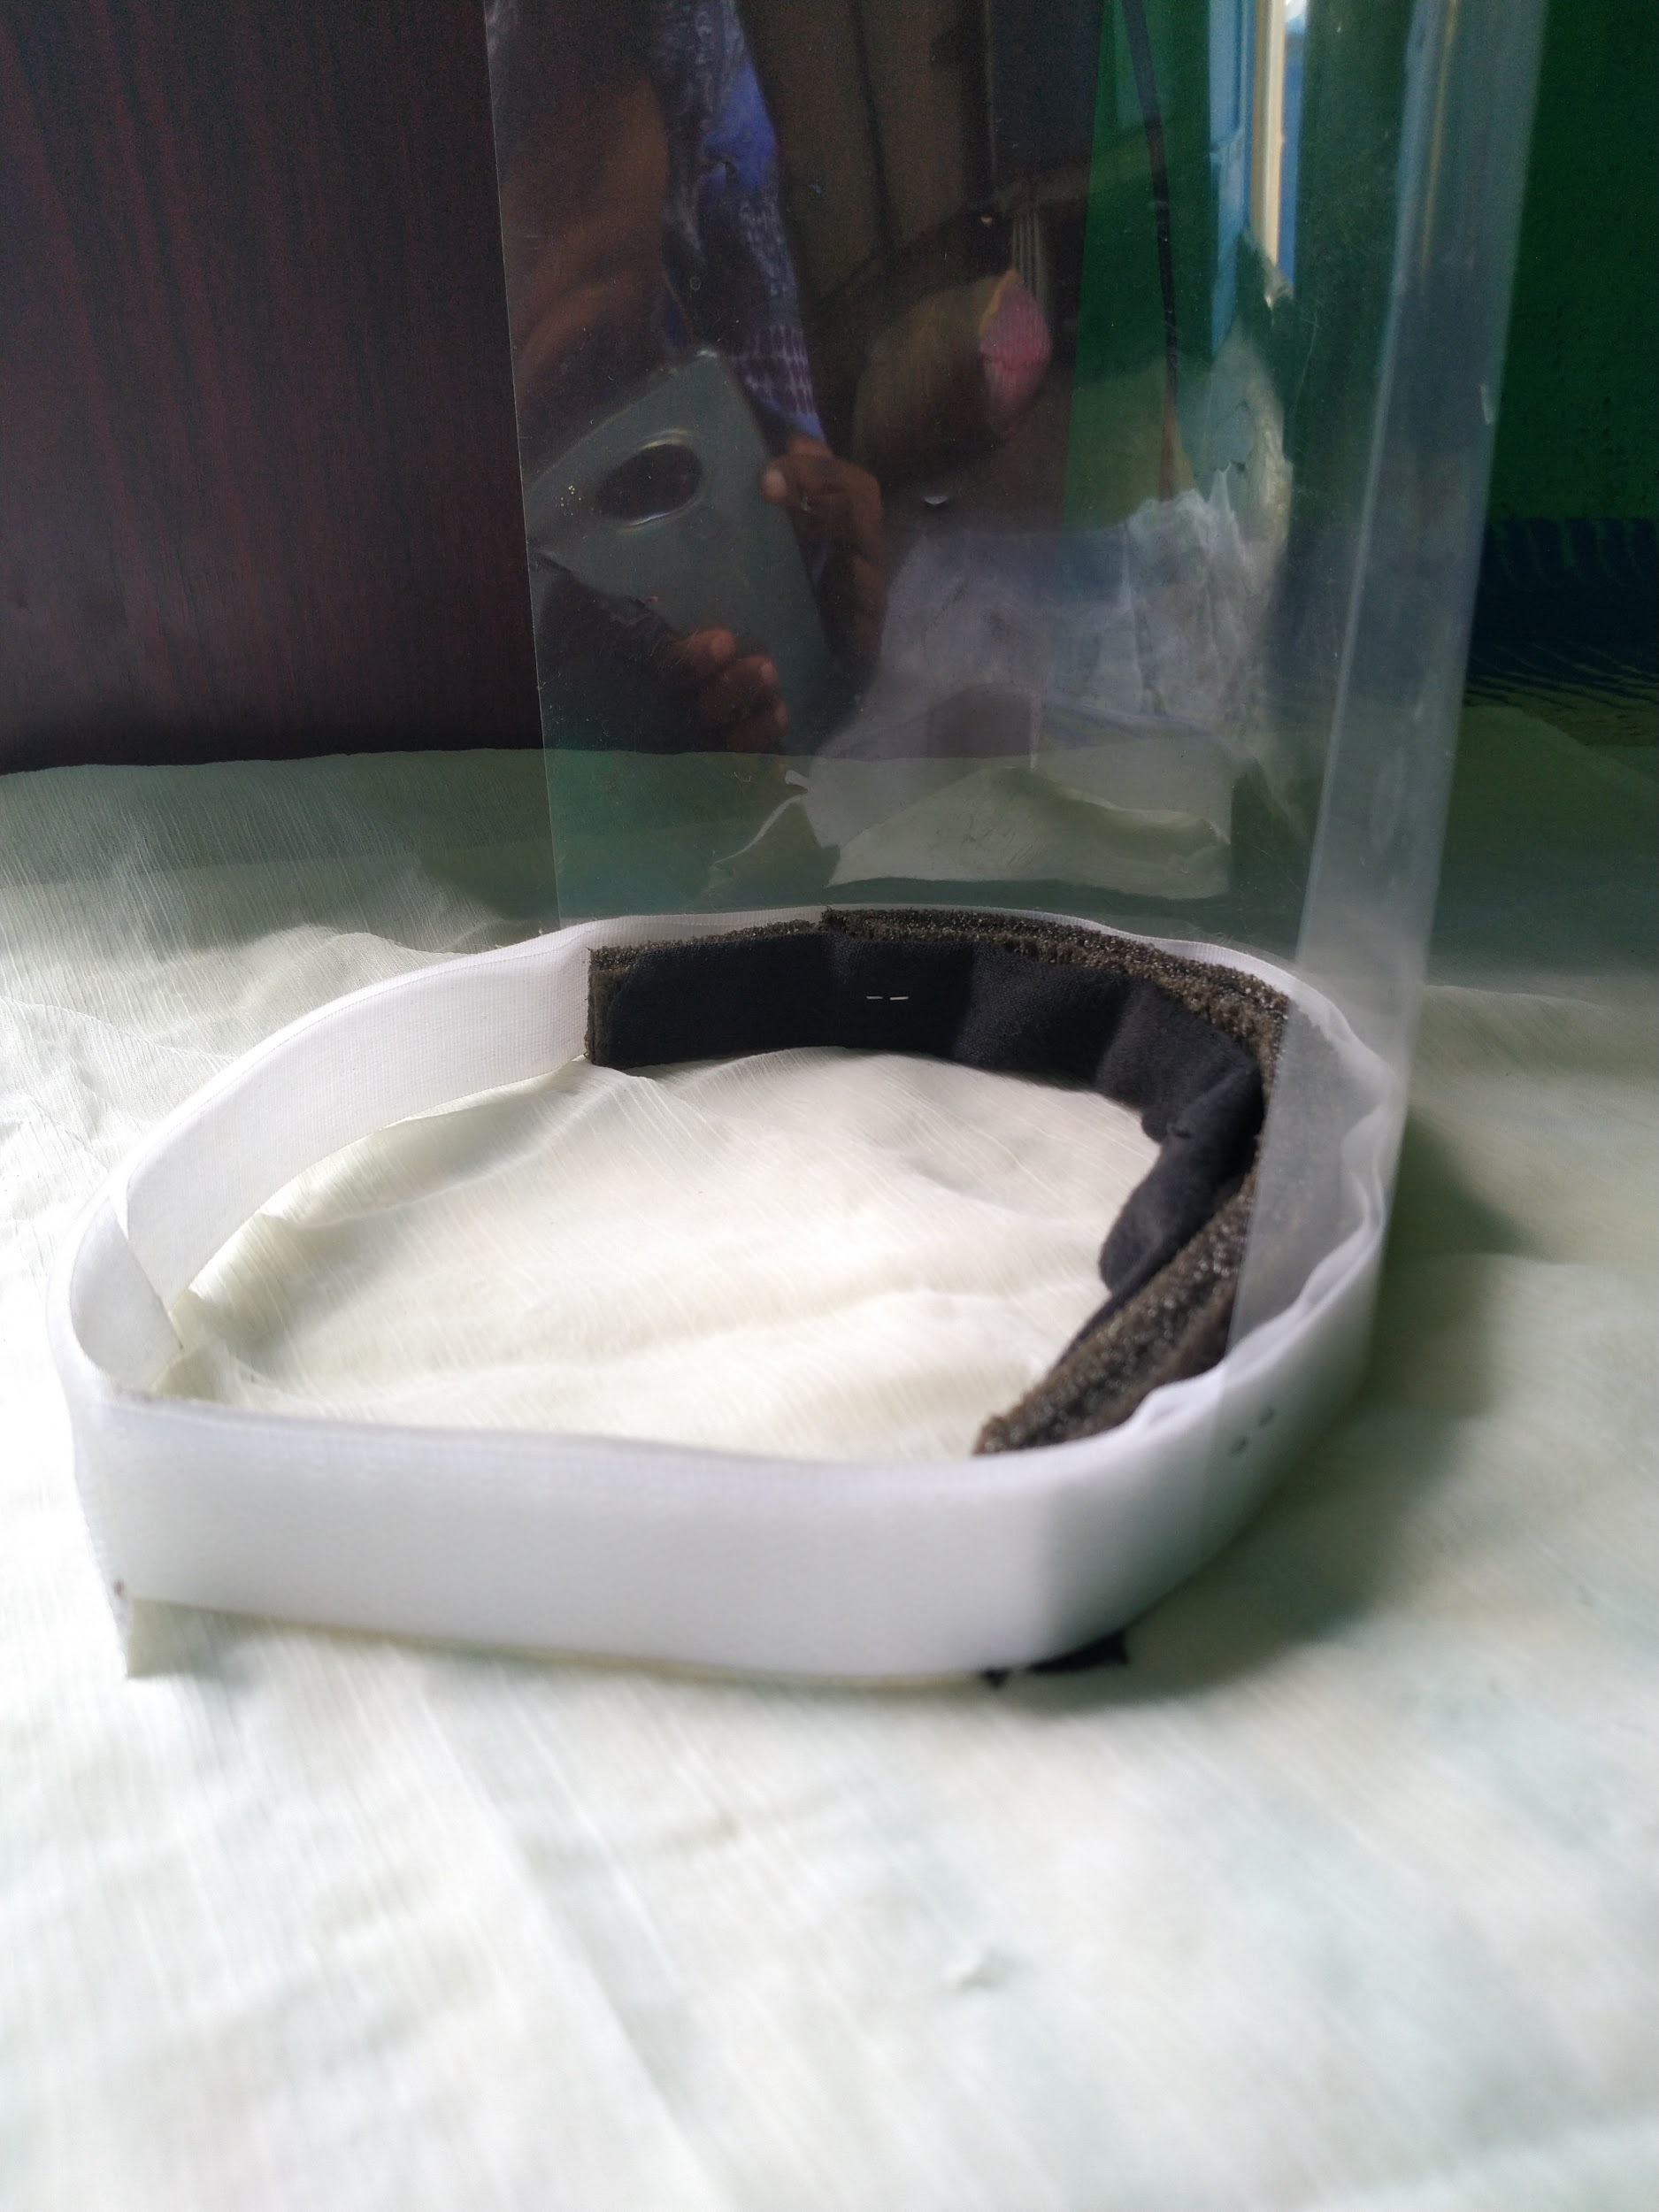

You can modify this design by using different materials, check material properties and consider medical constraints while selecting material.
Vigyan ashram fablab currently making and distributing this face shields to healthcare practitioners and social care takers. This design is free to replicate and modify, anyone can join this movement and help make India more stronger to fight against COVID 19. Stay safe!!
Photo Gallery :

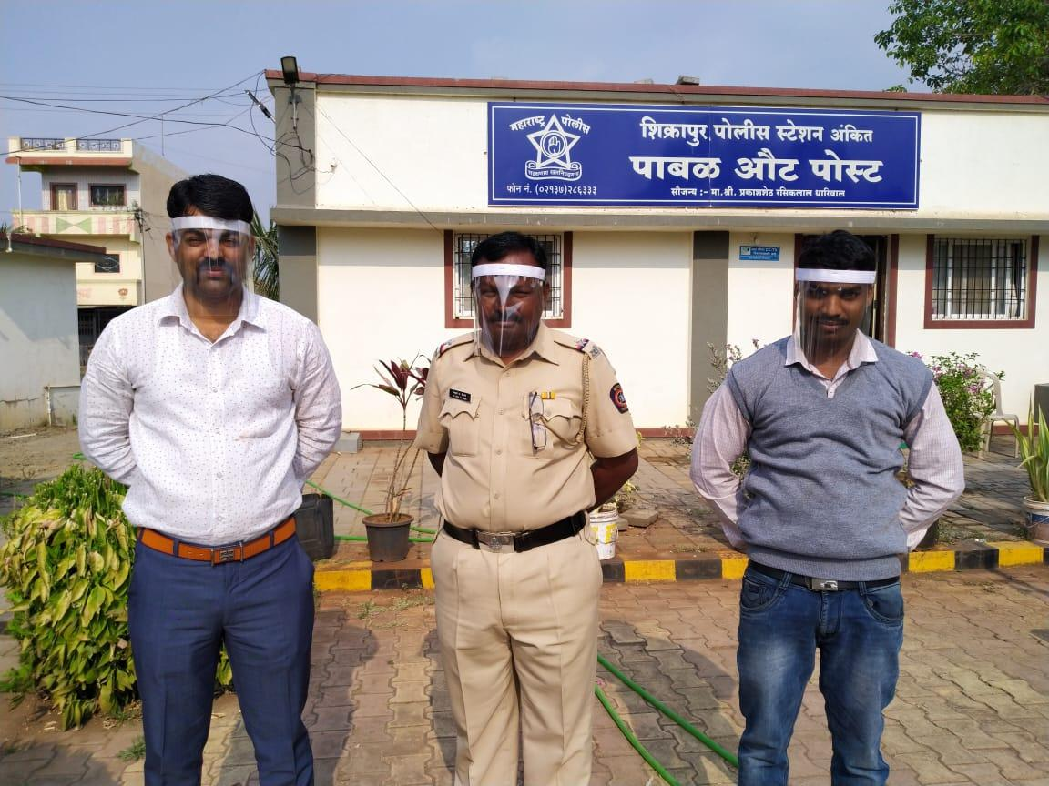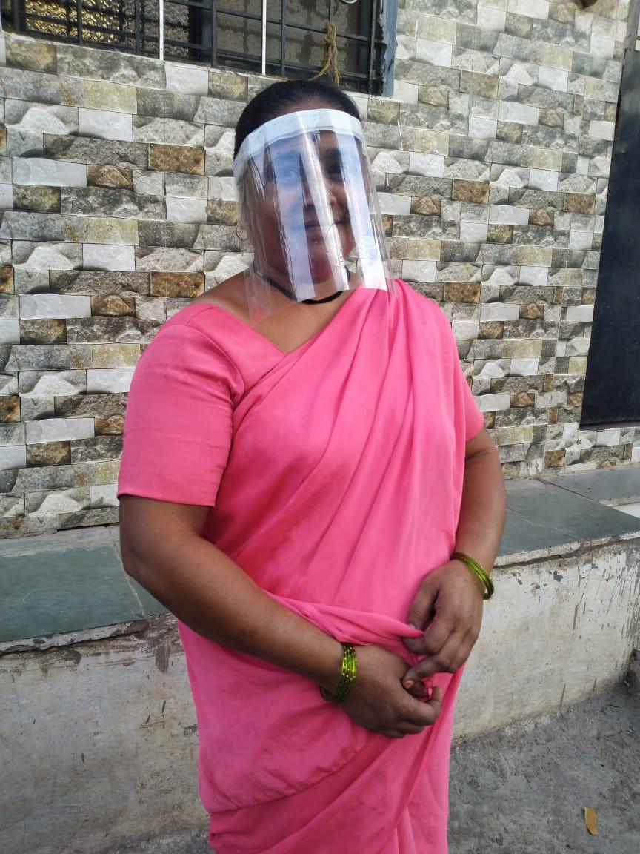
Image 1: Police station staff in Pabal village Image 2 : ASHA worker in Pabal village

