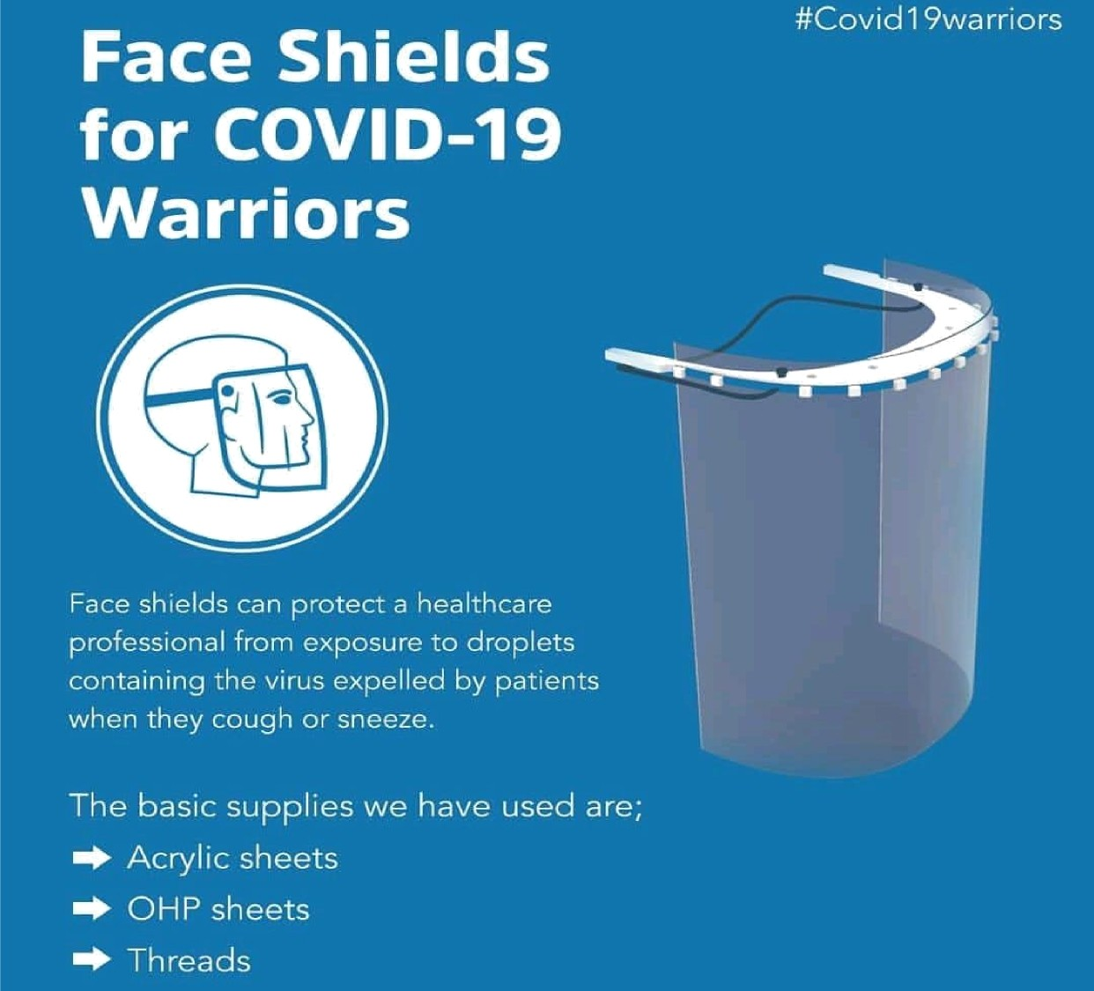

Design Innovation Center

WHYFaceshields?
Healthcare workers around the world are working 24*7 to test patients that might be carrying the coronavirus. These workers are in need of face shields during this time of intense testing in India. Face shields are personal protective equipment devices that are used by many workers (e.g., medical, dental, veterinary) for protection of the facial area and associated mucous membranes (eyes, nose, mouth) from splashes, sprays, and spatter of body fluids.

These shields are helpful to minimize direct exposure of healthcare practitioners to respiratory droplets maximize the lifetime of N95 masks
/ respirators.

Optically clear face shields
Protects face and mask from direct splatter
0.25" foam for comfort
Anti fog
Verified by doctors and healthcare professionals

T# ic mess He ight width We ig bt
Late x Free
Materi al ,Vi sor i "
Materi al Head Gear I " ” Usage
Frequency | Ve sor Frequency | Head Gear Price l INR
178 MI crons
2) 40 cm
J8 20 cm
10 15 grams
Yes
Cellulose Acetate
Foam Boarcl
Over N95/face masts
So ngle Use M ult i use 55/per M 19

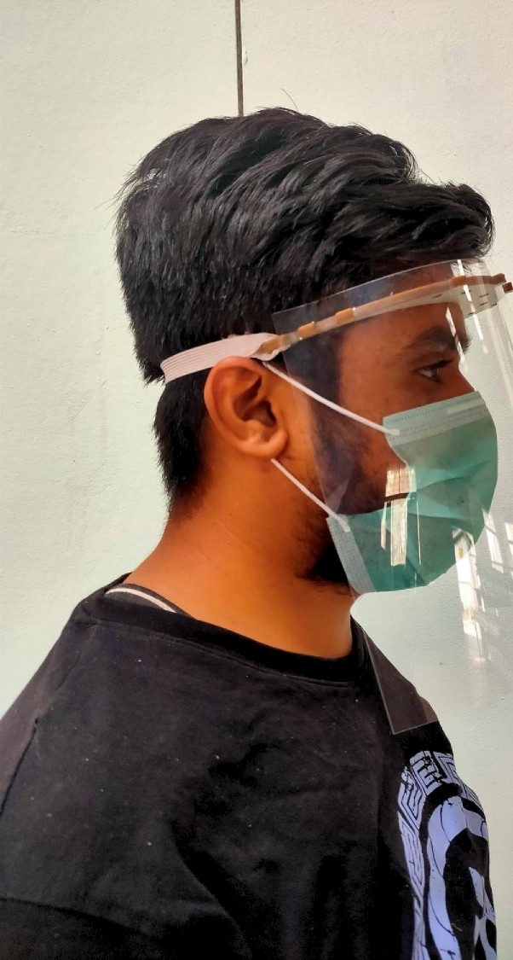

User Instructions
