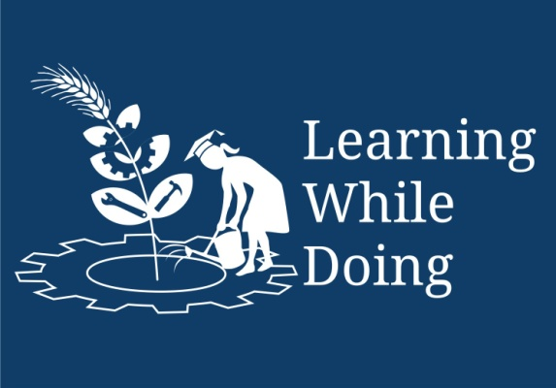
Food Safety

Open Education Resource

Food Safety
Food safety is about handling, storing and preparing food to prevent infection and help to make sure that our food keeps enough nutrients for us to have a healthy diet. Unsafe food and water means that - it has been exposed to dirt and germs or may even be rotten, which can cause infections or diseases such as diarrhea, meningitis, etc.
These diseases can make people very sick or even be life threatening. When people are sick, they are weak and would have difficulty working or concentrating at school. Some of these infections also make it difficult for our bodies to absorb the nutrients they need to get healthy. Unsafe or stale foods also deteriorate and are of poor quality, which means they lose nutrients and so we do not get enough of what we need for a healthy diet, so unsafe food can also lead to poor nutrition.
To get more information regarding food safety – follow the link below:
Food safety.pptx
Safe Food for Good Nutrition
Objective: To understand the importance of safe food and water for good nutrition and preventing diseases
Introduction
1. Point to the guideline on the "Consume clean and safe water and food" and is to help to understand the importance of safe food and water for good nutrition.
"Healthy Food" doesn't just mean that which is good for a balanced diet, but that this also means foods which are in good condition and safe to eat.
- What other things can we do to prevent contamination of our water?
Have separate water sources for livestock; prevent human and animal faeces from contaminating drinking water.
- What other things can we do to prevent contamination of food?
Bury or dispose of household waste in bags and bins (decaying food particles in litter attract flies, which can carry the disease to our food) use pit latrines, wash the udders of livestock before milking, keeping milking pails clean and properly stored.
- What can we do to avoid buying old food?
Check the "sell by" dates on containers; choose fresh, healthy-looking foods.
- Why do you think we should cook or reheat food properly? Heat from cooking can destroy germs.
Clean and safe food is very important to prevent germs from getting into foods and water. Such germs not only cause diseases, but they also destroy valuable nutrients in the food.
Some measures to followed while handling food sources and food:
- Wash hands with soap and clean water after going to the toilet, changing babies' nappies and working with animals. Also wash hands before working with food and before eating.
- Wash all fruit and vegetables in clean water before eating and cooking. Add a teaspoon of salt to this water.
- Wash the udder of the cow or goat well before milking.
- Wash dishes and utensils (knives, spoons, etc) immediately after use and store them in a clean place where flies or dust can't get on them.
- Choose fruit and vegetables that are fresh and healthy-looking.
- Boil water and milk for at least 5 minutes. (A small glass bottle, or china cup or saucer placed in the pot will stop the milk from boiling over).
- Do not eat cracked eggs. Wipe eggs clean with a clean, damp cloth before use, cook eggs until they are no longer runny.
- Avoid buying or eating food which is old. Check the sell-by dates on food products.
- Cook or reheat food properly, but avoid overcooking, because this can destroy nutrients. Also avoid cooking food in too much water, because the nutrients get lost when they go into the water.
- Keep cooked and raw foods apart when preparing or storing them. This helps to prevent germs from moving from one to the other.
- If you do not have a fridge, do not keep cooked food for more than a few hours in cool weather. In warm weather, eat it as soon as possible. To avoid waste, rather cook smaller amounts than cooking too much food which has to then be kept too long or thrown away.
- Keep food warm only as long as really needed; otherwise let if cool as soon and fast as possible. Warmth will encourage germs to breed.
- If you have a fridge, avoid keeping cooked food or raw meat for more than 24 hours unless it is in the freezer.
- Water and food should be stored in clean, covered containers in a cool, dark place. Covered containers protect food from dust, insects or rats and coolness helps food to last longer.
- Do not keep food in open tins, which can get rusty. Rather keep the food in clean plastic containers with lids.
- Keep food storage and preparation places clean and tidy.
- Prevent human and animal faeces from getting into water.
- Keep chickens away from the home. Chicken faeces carry germs and attract flies.
- Avoid or prevent littering. This attracts flies, rats and other organisms which spread disease.

