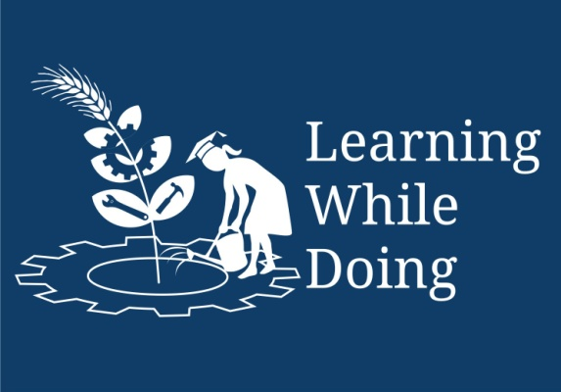

Productive Tasks:
Enlist your food diet along with timings
Planning a Balanced Meal
Collecting Your Own Recipes
Conducting a survey on food and water safety in the community and acting on the results

Concept:
Understanding the functions of some important nutrients in the body and learning about their food sources.
To understand - the 4 different Food Groups and their functions in the body
To understand - why a variety of (different foods from the 4 food groups) foods are needed by the body

Class-Age Group: 14 & above

Module IV- Food Processing
- Lesson 1 Food Fundamentals
- Mrs. Pallavi R Shanbhag
Open Education Resource
Productive task1:
Before starting the actual learning enlist your food diet along with timings.
For this follow the questionnaire:

- Your Name : _________________________________ Age :____________
- Your Weight :__________kg (wt at the beginning of course)
- Your Weight :__________kg (wt at the end of course i.e. after 3 months)
- General Schedule of solid food and liquid uptake :
  - At Morning (Mention time): __________a.m.
Diet contains: __________________________
  - At Afternoon (Mention time): __________p.m.
Diet contains: __________________________
  - At Evening (Mention time): __________p.m.
Diet contains: __________________________
  - At Night (Mention time): __________p.m.
Diet contains: __________________________
- Do you think all above timings with food are proper to maintain your body healthy?
- Classify your food as per taste given in table below:
Food Taste | Food item
Sweet
Sour
Salty
Bitter
- Identify essential major nutrients uptake from your food habits and classify them.
- Did you learn any ideas about how we could improve our current food and nutrition situation? What could we do?
- Mention name of food you will eat in next 7 days. Use following table:
 | Day 1 | Day 2 | Day 3 | Day 4 | Day 5 | Day 6 | Day 7
Breakfast
Snack
Lunch
Snack
Dinner
Drinks
- Keep a record of all the foods and liquids (beverages) that you eat and drink over 7 days.
Day | Cereals | Fruits &  Vegetables | Meat, beans,  milk, etc | Fats, oils &  sugars | Liquids
1
2
3
4
5
6
7

- Did you have at least one food from each group each day?
- Did you have at least 3 portions or servings from the whole grain group each day (for example bread, rice, pasta, cereal)?
- Did you have at least two fruits each day?
- Did you have at least three vegetables each day?
- Did you have portions or servings of food from the beans, meat, nuts and milk (protein) group each day?
- Did you have small amounts of sugar and fats each day?
After going through above questions you may have certain queries like what is food, diet, nutrients, food safety, etc.
We have 1 useful link to know all about food. Please click on the link
all about food.docx

Questions:-
- Why is it important to learn these basic facts about nutrients?
- What could happen if people don't know these basic facts?
- How will you use your new knowledge about the nutrients needed by our bodies?
- What happens to the body if we do not eat enough vitamins and minerals?
- What do you think is the general function of Vitamins in our body?
- What is the function of Iron in the body?
- What local foods are good sources of iron?
- What happens to your body if you do not eat enough Iron?
- What do you mean by carbohydrates?
- What are the diseases caused in deficiency of Carbohydrates?
- What do you mean by proteins?
- What do you mean by vitamins?
- What are the fat-soluble vitamins, water-soluble vitamins and where are they found?
- What are the diseases caused by the deficiency of vitamin A, C and B1?
- What do you mean by minerals?
- What do mean by macro and micro minerals?
Productive task 2:

Planning a Balanced Meal

Before doing the task you need to analyse your nutritional need.

For this the following link will help you.

Analyzing your nutritional needs.pptx

Write the Proper healthy diet after studying the topic and first task. Write at least 6 different types of meal in given table.
Meal | Food
1
2
3
4
5
6

*Food in every meal must contain all chief nutrients.
Questions :-
- What are available natural resources to get food?
- What is meant by balanced diet?
Productive Task 3:

Collecting Your Own Recipes
Project skill: | Collecting recipes to create a valuable resource for current and future use.
Task: You should collect at least 2 recipes.
Each should contain main ingredient as rice and wheat.
- Name of Recipe: ____________________
- Method of Cooking: __________________
- Servings: _____________
- Cooking time :____________ (in minutes)
- Ingredients: _________________________________________________
- Method: Stepwise
  - Step 1:
  - Step 2:
  - Step 3:
  - Step 4:
  - Step 5:
  - Step 6:
  - Uploading snaps:
- Ingredients: well arranged in small bowls (1 snap)
- Stepwise methods: (At least 6)
- For serving : (only one)
Questions:
- What you have learnt from the recipe?
- Can you find out nutritional value from above recipe?
- Can you add some variations in recipe without changing nutritional value?

Productive task 4:

Conducting a survey on food and water safety in the community and acting on the results
Introduction
1. In this activity you will conduct a survey on food and water safety in the community and planning action on the results.
Experience
2. Start by leading a discussion to identify areas of concern about food or water safety in the community or village. Some examples could be:
- Water points. Are these clean and in good condition? Are animals kept away?
- Rubbish disposal. Does rubbish and litter just lie around or is it properly disposed of?
- Food shops and open markets. Are these clean? Is food prepared, stored and served safely?
Before conducting survey follow the link for more information:
food safety.docx

Process
Whether you are going to buy groceries, writing a letter to a friend or in this case, planning what can be done to solve food and water safety problems in the community.
Explain that:
- WHY? Means our reason for taking action: a food and water safety problem area.
- WHAT? Is what kind of community or other awareness action can be taken?
- WHO? Means who should the awareness be aimed at or WHO will be taking action.
- HOW? Is the action going to be taken (examples: a poster campaign, writing letters to authorities or newspapers, phoning radio chat shows, etc).
- WHERE? The place or places where the action will take place.
- WHEN? Is the date or time in which the action should happen. This should be realistic and members should think about all that needs to be done, including getting materials or contacting necessary people.

Questions-
- Write the detailed report of survey using above information provided.
- Do you think this knowledge will help you to tell others in your community about the importance of Food Safety?
- Do you have ideas for other activities which could be done about Food Safety?

