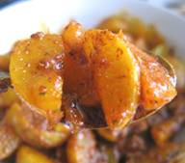
Aonla Pickle

Open Education Resource

Ingredients:
Aonla | 1kg
Salt | 150g
Turmeric powder | 10g
Red chilli powder | 10 g
Fenugreek | 30 g
Clove | 5 numbers
Oil | 350 ml

Aonla pickle recipe:
For the recipe please follow the flowchart given below-
