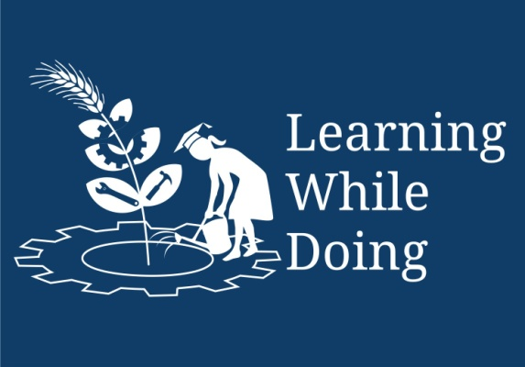
Fruit Candy

Open Education Resource

Preparation of Candy:
- Sweet Candy Preparation :
AONLA CANDY
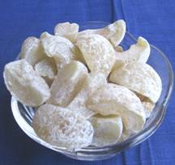

Ingredients
Aonla | 1 kg
Sugar | 1.120 kg
Water | 500 ml
Citric acid | 6.4 g
KMS | 1.2 g

Method
- Preparation of sugar syrup (addition of 765g of sugar in 500ml of water)
- Addition of citric acid and KMS
- Soaking of fruits for 24hr
- Boiling of sugar syrup to 60 Brix
- Addition of remaining sugar
- Soaking for 24hr and increased the Brix to 70 Brix for 7 days
- Aonla pieces and sugar (1:1.5)
- Packed the aonla preserve in glass jar
- Allow to dry in shade to get aonla candy
- Spiced Candy
AONLA SPICED CANDY*
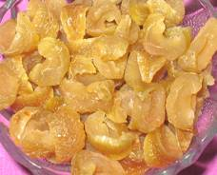

Ingredients
Aonla | 1 kg
Sugar | 300 g
Water | 700 ml
Chilli powder | 20 g
Salt | 20 g
Asafoetida | 5 g

Method
- Select well matured and sound aonla fruits
- Wash and soak in 2 per cent brine for 24 hours
- Steam aonla fruits for 10 minutes and cut into segments.
- Mix aonla with the other ingredients and boil for 30 minutes.
- Separate the boiled aonla candy and dry for 3 days (each Day 8 hours) in sunlight.

