

**Productive task** :

1. Collection of different soil samples from your area and identifying physical properties of collected soil samples.
2. Testing collected soil samples (any 2) for their basic physical properties.

**Concept** :

* Learner will be able to identify the type of his/her soil for selection proper crop as per soil type.
* Learner will able to do ‘soil testing’ for its basic physical property by using simple methods.

**Tools** :

**Class-Age Group** : 8th +

*Open Education Resource*

**Study of soil formation and physical properties of soil**  Mahesh Lade

**Concept Map (Image) :**

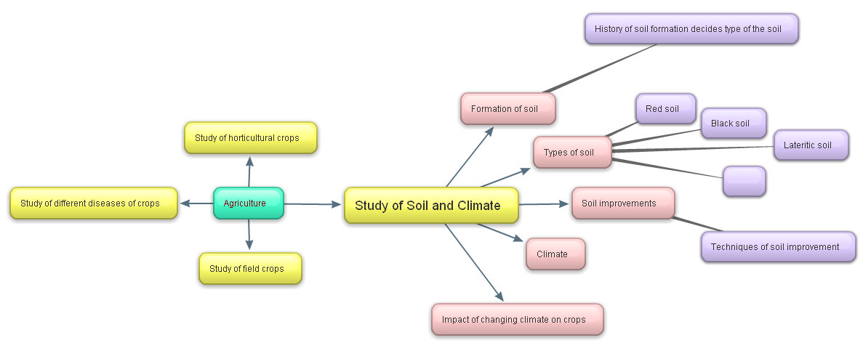

**Case story:**

Hi friend! My name is Soileeee , And I am made up of SOIL! Don’t be so surprised, actually in true sense, we all are made up of Soil . I mean we all are largely depending on Soil layer present on our earth for our life! Let me explain you little more –

We all know that that we live on Earth which provides food, shelter, cloths and all other thing for our life. Our earth is largly made up of soil (rocks) and water. We also know that water we get from rain but do you know how soil is formed on our earth? let’s see a small video clip first to understand it-



**Productive task 2:**

Watch Video : <http://www.youtube.com/watch?v=vg-hwKwT-Hs>

So friend, now you got some basic information about how soil forms, let’s see little more details about our soil -

Basically, soil is made up of different components. Following figure gives an idea of components of soil.

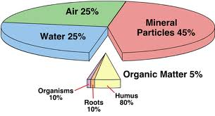

**Factors which contribute in the formation of soil are:**

Soil is formed from the rocks by the process called weathering of rocks and by different pedogenic processes. The properties a soil are dependent on the rock from which that is formed, climatic conditions, organisms and time. The study a soil profile gives us knowledge about its formation and quality.

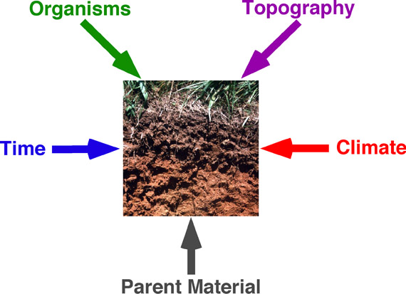

Well developed soil = Function of (Parent material + Topography + Climate + Living things + Time)

**Major types of Soils found in India:**

Now let’s see,

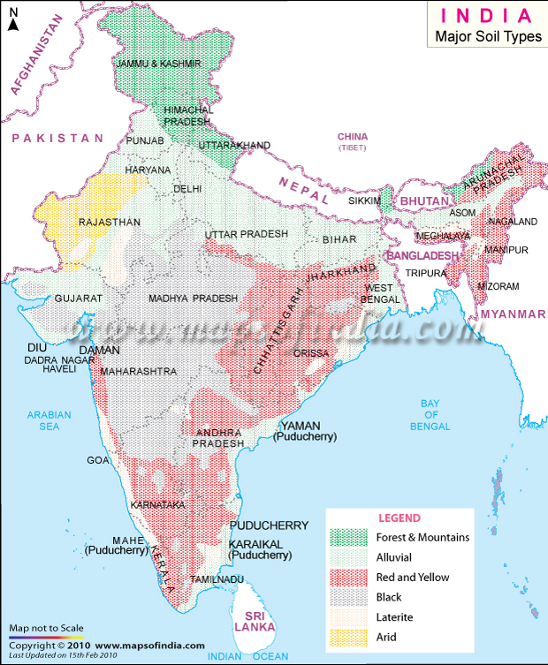

Source - [http://www.mapsofindia.com](http://www.mapsofindia.com/)

As shown in above map, there are 6 major types of soil found in India pre-dominantly accordingly topographical and climatic conditions of country. These are -

1. 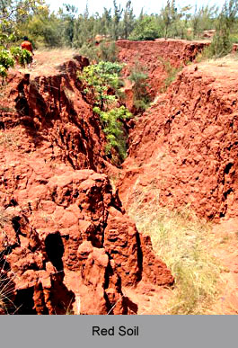**Red Soil:**

Generally these soils are light textured with porous and friable structure and there is absence of lime Kankar and free carbonates. They have neutral to acidic reaction and are deficient in nitrogen humus, phosphoric acid and lime

This type of soil is suitable for rice, millets, tobacco and vegetables (also groundnuts and potatoes at higher elevations)

1. 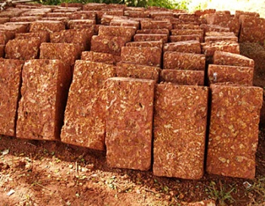**Laterites and Lateritic soil:**

These soils are red to reddish yellow in colour and low in N, R, K, lime and magnesia. These soils are formed in situ under conditions of high rainfall with alternation dry and wet periods. On account of heavy rainfall there is an excessive leaching of soil colloids and silica hence the soils are porous.

It is suitable for tea, coffee, rubber, cinchona, coconut and suitable for rice and millet cultivation if manure are added.

1. 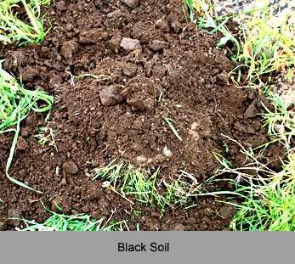**Black soil:**

These are mostly clay soils and from deep cracks during dry season. An accumulation of lime is generally noticed of varying depths. They are popularly lemon on. “Black cotton soils” because of their dark brown crown colour and suitability for growing cotton

These soils are ideal for cotton crop, for growing cereals, oilseeds, citrus fruits and vegetables, tobacco and sugarcane.

1. 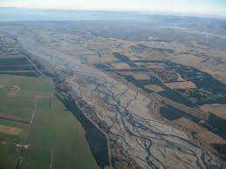**Alluvial soils:**

These soils occur along rivers and represent the soil materials that have been deposited by the rivers when are in flood. These soils are one of the most fertile soils in the world due to organic matter deposition by river flow.

1. 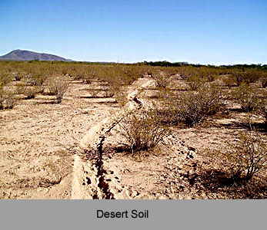**Desert soils:**

These are mostly sandy soils that occur in the low rainfall track. They are well supplied with soluble salts but are low in nitrogen and organic matter and have a high pH value. These are quite productive but often subjected to wind erosion

1. 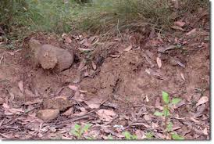**Forest and hill soils:**

These serve a very useful purpose by supplying forest product such as timber and fuel. Forest and hill soils are good for plantation of tea, coffee, spices and tropical fruits.

**Importance of soil in plant growth:**

(Role/functions of soil in crop production)-

* Soil provides necessary nutrients* to plants.
* Soil provides support to plant roots.
* Soil provide necessary environment to different micro-organisms which helps in decomposition of organic matter and soil nutrient. (Due to microbial action nutrients converted in available form so plants)
* Soil holds water which is required for plant growth.
* Soil holds air which is necessary for plants and soil microbial activity.
* Soil helps in maintaining proper temperature for plant growth.

Note * - Necessary nutrients for plant growth:

Plants need 16 essential nutrients for healthy growth and development. Most of these nutrients are provided by soil.

|  |  |  |
| --- | --- | --- |
| **Main nutrients** | **Secondary nutrients** | **Micro nutrients** |
| **Carbon (C), hydrogen (H), Oxygen (O) (available from air & water)**  **Nitrogen (N), Phosphorus (P), Potassium(K)** | Calcium (Ca), Magnesium (Mg), Sulphur (S) | Iron (I), boron (B), zinc (Zn), copper (Cu), molybdenum (Mo), chlorine (Cl), maganese(Mn) |

**Productive task 1**

* Collect at least 2 different types of soils/rocks from your area and identify type of your soils as per above soil types with list of crops farmers growing in your area.
* Try to find out relation between common crops of your area and type of soil you have collected.

**HPNPDL Session :**

After every activity or work exercise, all class will assemble together and brainstorm various questions. They will generate list of questions - What , Why , How, When , Where ? Attempt should be made that every student will ask min 2 questions.

The questions will be recorded. Teacher’s may able to answer some of them. It is not necessary to answer every questions but such questions must be recorded as ‘HPNPDL’ { Hame pata nahi par dhudh lenge }

**Why soil colour change as per area/ location?**

**Why alluvial soils are reach in organic matter contain?**

Now, as we have collected different soil samples let’s see, which kind of soil is best suited for our agriculture and which are the physical and chemical properties of soil -

Characteristics of an ideal soil with respect to plant growth:

* The soil should be well aerated: Plants take oxygen and hydrogen from the soil which is necessary for plant growth. Also, if oxygen is present in the soil, micro-organisms will grow there which eventually are helpful for crop growth.
* pH of the soil should be between 6 to 8: pH of the soil should be between 6 to 8 for proper crop growth This is because, in this pH, nutrient movement will be good.
* It should have good water holding capacity.
* It should also have well drainage capability for excess water.
* Soil should have good amount of organic matter and available nutrients.
* It should be free from soil borne diseases and pests.
* Soil should be deep, friable and well textured.

No soil would be completely IDEAL as per above qualities, but we can asses soil as per its physical and chemical properties. Soil analysis will help us in following way –

Physical and Chemical properties of soil:

* Physical properties & its analysis:

Physical properties of soil is referred to physical appearance of soil (color , texture, structure etc) of particular area/ land. Physical properties of soil are analyzed in lobotomy by using different methods.

* Chemical properties of soil & its analysis:

Soil can be analyzed for estimation of different nutrient (major and minor soil nutrients) content in soil. Similarly there are some other parameters which also affect plant growth as that of Soil pH, Soil EC (Electrical Conductivity) and Soil OC (Organic Carbon).

**In this OER we are only going to study Physical properties of soil and its simple analysis methods.**

For knowing more about important physical properties of soil Download following PPT –

**Physical properties of soil.pptx**

**Productive task 2**

Analysis your collected sample for

* Soil texture as per flow diagram method (Use following links for more information)- <http://www.ksre.ksu.edu/bookstore/pubs/MF2852.pdf>

<http://www.youtube.com/watch?v=IOyaBxj767s>

<http://www.landjudging.com/stieglerbook.htm>

* Soil water holding capacity as per field capacity estimation method (Use following links for more information)- <http://www.youtube.com/watch?v=Xfx3bhDd7YY>

**HPNPDL Session :**

After every activity or work exercise, all class will assemble together and brainstorm various questions. They will generate list of questions - What , Why , How, When , Where ? Attempt should be made that every student will ask min 2 questions.

The questions will be recorded. Teacher’s may able to answer some of them. It is not necessary to answer every questions but such questions must be recorded as ‘HPNPDL’ { Hame pata nahi par dhudh lenge }

* What is mean by soil pH?
* What is mean by soil profile?
* What is mean by soil erosion?

For more information-

<http://www.cfr.washington.edu/classes.esrm.409/2011_Student_Projects/Makker.pdf>

[http://www.britannica.com](http://www.britannica.com/)

indiawaterportal.org

en.wikipedia.org

[http://geographyias.blogspot.in](http://geographyias.blogspot.in/)