

**Productive task:**

* Practicing Nursery Operations
* Practicing Plant Propagation Operations
  + Propagation through Cutting
    - Leaf Cutting
    - Root Cutting
    - Stem Cutting (hard wood, semi hard wood, soft wood)
  + Propagation through Layering
    - Tip layering
    - Simple layering
    - Air layering
  + Propagation through Budding
    - Shield budding
    - T budding
    - I budding
  + Propagation through Grafting
    - Approach grafting
    - Stone grafting

**Concept**:

Learner will able to understand all Nursery Operations and Plant propagation operations like different types of cutting, layering, budding and grafting.

**Tools**:

Given in each task

**Class-Age Group**: 14 and above

**Module I - Agriculture & Animal Husbandry**

* *Lesson 4- Plant Propagation & Nursery Management*
* *Mrs. Pallavi R Shanbhag*

*Open Education Resource*

**Productive Task 1: Practicing nursery operations**

**Aim –** Learning various nursery operations like preparation of beds, filling of polythene bags, pots, shifting of plants, watering plants etc.

**Requirements** - Pick axe, spade, soil, compost, polythene bags, other pots for growing plants, plants grown in beds.

**Procedure –**

1. Do different nursery activities one by one.
2. First of all prepare nursery beds and raised bed. Dug the soil, crush the clods and prepare a raised bed of size 2m X 1m X 15cm. Also prepare a nursery bed of size 2m X 1m and depth 15 to 30 cm.
3. Sow the seeds on raised beds for growing seedling.
4. Place the plants grown in polythene bags in beds prepared.
5. Ensure that the bags have three to four holes for drainage. Make a mixture of soil (1part) + fine sand (1 part) + well decomposed compost (1 part). Fill the polythene bags with this mixture keeping 2 inch free space.
6. Fill different pots with different mixture of soil and compost.
7. Transplant the seedlings grown in beds in the polythene bags.
8. Water the nursery plants carefully and regularly.

**Observation –**

**Record the following observations**

1. Size of the beds and number: ______________
2. Number of seeds sown: _________________
3. Size of polythene bags: _________________
4. Age of seedlings transplanted: ___________________
5. Height of seedlings: _____________________
6. Number of leaves on the seedling: ___________________
7. Size of pots used: ______________
8. Types of soil mixture use with the proportions of material used: _____________________________________________________________

**Result** - All the nursery operations if done timely and correctly the growth and quality of seedlings found excellent

**Conclusion –**

________________________________________________________________________

Different nursery activities are carried out regularly in the nurseries. For successful nursery business, practicing these operations timely is important. Learning these operations will help the students in establishing a good nursery.

**Productive Task 2: Practicing plant propagation operations**

**Aim** **–** Learning different ways of propagation methods will help in understanding the multiplication methods of different plants.

**Requirements** - Secateurs, pick axe, pots, polythene bag, polythene strip and keradix powder.

**Procedure –**

**A) Propagation through cutting**

**1) Leaf cutting –** Marginal buds**,** Use of petiole and use of mid rib.

1. Select mature leaf and put it in soil covering only margins of the leaf with soil (Bryophyllum)
2. Cut the petiole of leaf along with leaf blade. Insert the petiole in soil keeping the blade exposed. (Peperomia)
3. Select a just mature leaf. Give cut with sharp knife at the junction of mid nib. Place the entire leaf in soil in such a way that the noted portion will be in contact with soil.

**Observations –**

|  |  |  |  |  |
| --- | --- | --- | --- | --- |
| Sr. No. | Name of cutting | Date of planting | Date of rooting | Time required for rooting |
|  |  |  |  |  |

**2) Root cutting –** Lagerstroemia, Black berries, Meligtonia.

1) Dig out the roots not smaller than 2cm diameter.

2) Cut them into pieces of 10 cm to 15 cm.

3) Place them in pot filled with soil either in horizontal or vertical position.

**Observations –**

|  |  |  |  |  |
| --- | --- | --- | --- | --- |
| Average length  (in Cms) | Average diameter (in Cms) | Date of planting | Date of sprouting | Remarks |
|  |  |  |  |  |

**3) Stem cutting -**

**1) Hard wood, semi hardwood, softwood**

1) For hard wood cutting select a mature pencil size thick branch, detach it from parent plant, remove all leaves, make the cutting of 15 to 20 cm. Give straight cut at the upper side and slanting cut just near the node at lower side. Place the cutting in rooting medium by inserting 1/3rd length of cutting in soil.

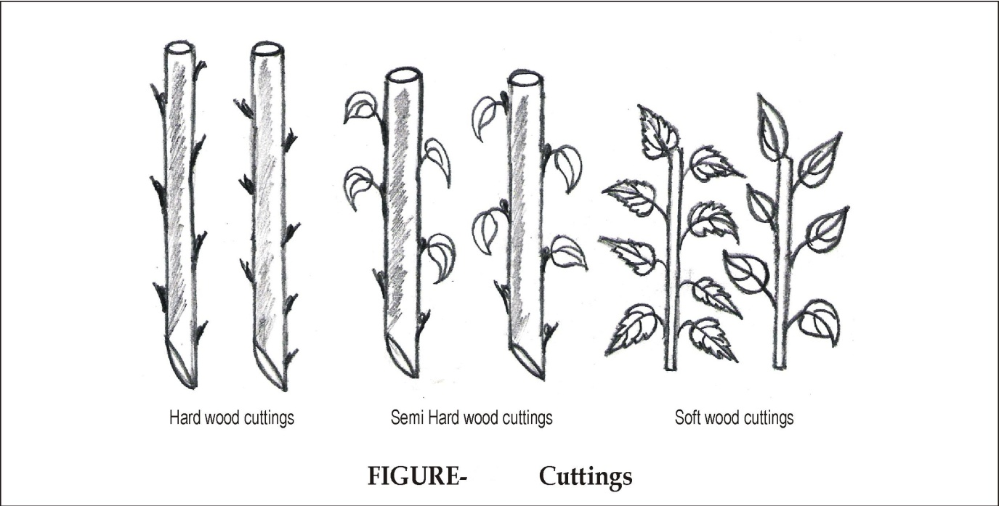

**Observations –**

|  |  |  |  |  |  |
| --- | --- | --- | --- | --- | --- |
| Sr. No. | Name | Date of planting | Date of rooting | Date of sprouting of buds | Time required for rooting |
| 1 | Grape |  |  |  |  |
| 2 | Pomegranate |  |  |  |  |
| 3 | Fig |  |  |  |  |
| 4 | Bougainvillea |  |  |  |  |
| 5 | Rose |  |  |  |  |

2) For semi hard wood cutting select healthy vigorous growing shoot. Cut it from parent plant and prepare a cutting of 15 cm length. The slanting lower cut is made close to the node pertain few top most leaves. Place the cutting in rooting medium.

**Observations –**

|  |  |  |  |  |  |
| --- | --- | --- | --- | --- | --- |
| Sr. No. | Name of cutting | Date of planting | Date of rooting | Date of sprouting | Time required for rooting |
|  |  |  |  |  |  |

3) For soft wood cutting select terminal cutting from parent plant and place a piece of 10 to 15 cm in appropriate medium. Record the observations as above.

**B) Layering –** Layering is a method of propagation using a branch of a tree and detaching it after rooting from the plant. There are several methods of layering.

**1) Tip layering –** Select or healthy branch of a tree, bend it towards soil and burry the tip of branch in soil. Water the layer regularly & observe the rooting. (Raspberry, Black berry)

**2) Simple layering –** Bend the branch of a tree and cover the portion of a branch with soil keeping terminal 30 to 40 cm part intact. Prior to covering with soil give a notch or tongue like cut at the spot which is buried in soil. Observe the rooting. (Guava)

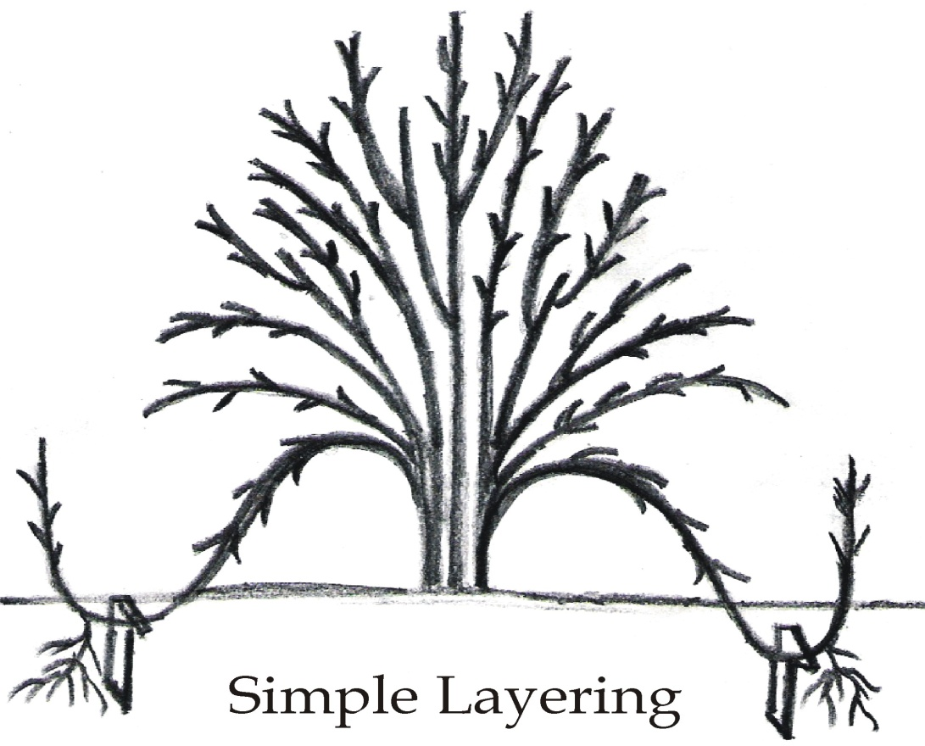

**3) Air layering – (Gootee)**

1) Select healthy mature branch of 60 to 70 cm length of desired tree.

2) Give two circular cut of 3 to 5 cm width at 60 cm from terminal bud. The upper cut should be near the bud.

3) Remove the ring of bark.

4) Cover the cut with moist sphagnum moss.

5) Wrap with the 25 cm2 polythene sheet by completely covering the moss.

6) Tie the gootee first at top and then at bottom with jute string.

7) Prepare such air layers in Rainy Seasons.

* Detaching layered branches from parent plant.

Give V shaped cut up to 1/3 depth of a branch near to the layered area towards the parent plant. Extend this cut up to 2/3 diameter after 8 days. Again extend the cut after eight days to detach the branch complete from mother plant.

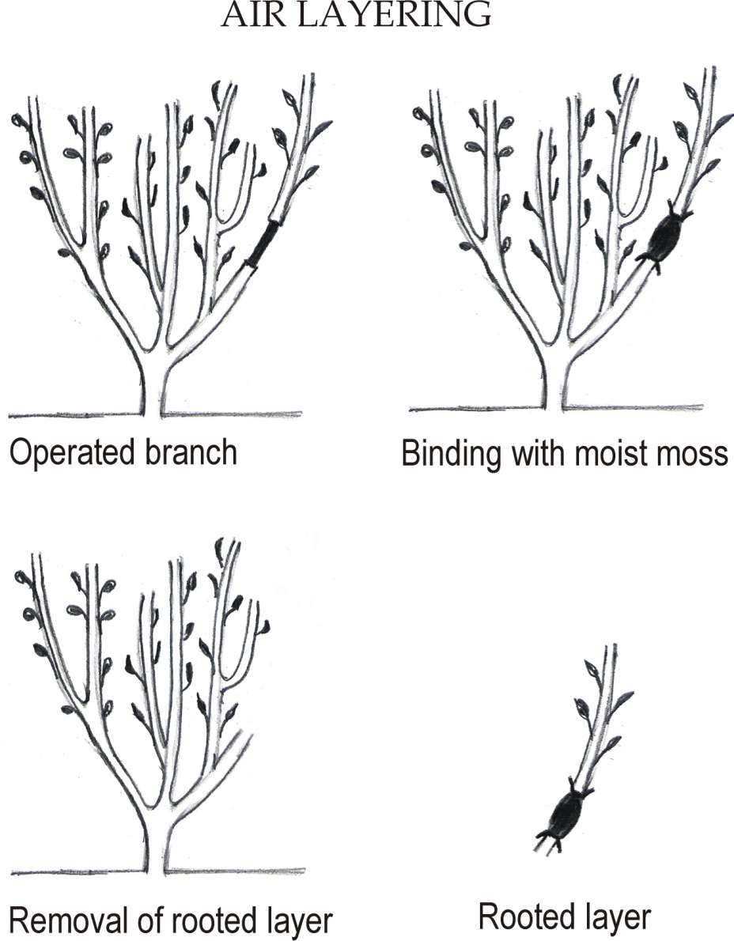

**C) Budding**

**Shield budding (T or I budding) - Rose, Citrus crops**

1. Select branch from desired tree. Select plumy auxiliary bud. Cut the leaf blade keeping petiole intact.
2. Remove the bud from tie bud stick by working budding knife around the bud.
3. Select the seedling root stock or root stock raised by cutting.
4. Loosen the flap of bank on root stock with the help of knife.
5. Insert the bud by pushing it down words beneath the bark and hold it in position
6. Tie the bud with polythene strip keeping the bud exposed.
7. Cut off the top portion above the bud union after about 4 to 5 weeks when bud is sprouted and the union is completed.

Likewise practice patch budding, ring budding and flute budding.

**Record the following observations:**

1. Name of the crop : ____________________
2. Root stock used: ______________________
3. Variety from which bud is taken: _______________________
4. Age of stock and bud stick: ___________________
5. Method of budding: ___________________
6. Days for sprouting of bud : ______________________
7. Percentage of success: __________________________

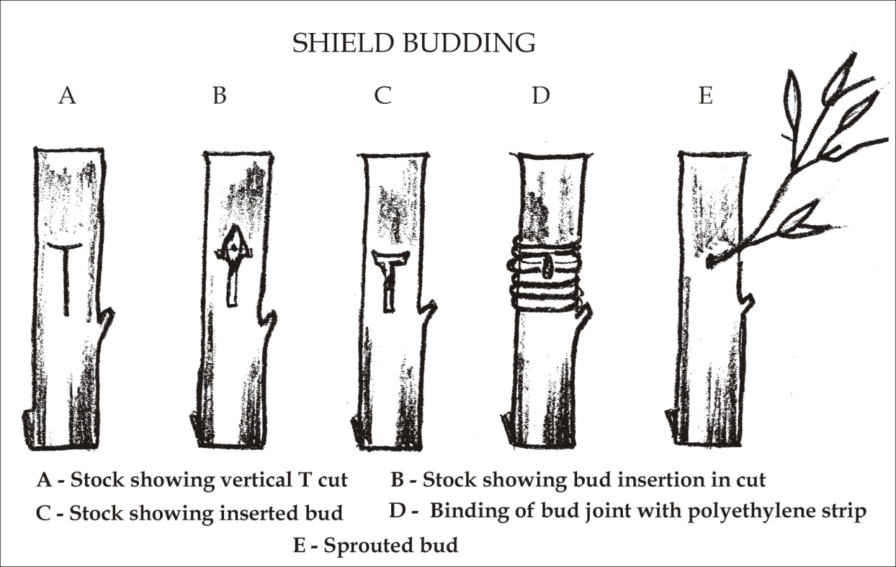

D) **Grafting –** It is a process of inserting a part of plant into another in such a way that union will form and two parts joined together would continue growing as normal plant.

**Simple approach grafting**

1. Select one year old terminal branch of about 60 cm long.
2. Select a healthy root stock established in a bag or pot.
3. Both the stock and scion should be of same thickness.
4. Remove the slice of bark along with wood about 5 cm long and 1 to 2 cm in breadth and 0.2 cm deep. Take similar cut on both root stock and scion.
5. Bring the cut surface together with pressure without leaving any hallow space
6. Tie them with banana leaf sheath and then with jute string.
7. Make necessary arrangement to keep root stock closer to plant
8. Water the stock regularly.
9. Remove the graft after the successful union of stock and scion.

**Record the following observations.**

|  |  |  |  |  |  |
| --- | --- | --- | --- | --- | --- |
| Sr. No. | Name of plant | Root stock used | Date of grafting | Date of removal | Percentage of success |
|  |  |  |  |  |  |

**Stone grafting –**

1. Collect the stones of mango and sow them in beds.
2. Select the scion stick with plumy apical bud. The age should be 3 to 4 months.
3. The stones germinate within a month. Take 8 to 10 days old seedling along with stone for grafting.
4. Remove the leaves from scion keeping petiole intact.
5. Give 5 to 6 cm slanting cut on both sides of scion to give it a wedge shape. The cut should be smooth.
6. Give horizontal and then vertical cut to the stock to split open it.
7. Put the wedge shaped scion in the vertical cut on stock in such a way that at least one side matches cleanly.
8. Tie the graft with polythene strip without disturbing the stock and scion.
9. Plant the graft in polythene bag and water it regularly.
10. This graft is prepared in the month of July, August.

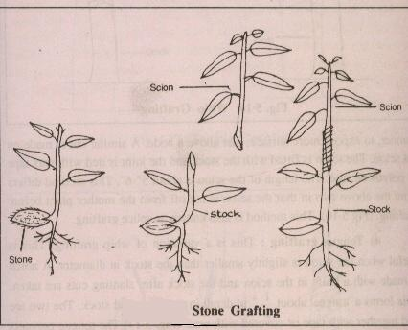

Likewise practice other grafting methods viz. Veneer graft, soft wood graft, side graft etc.

**Result:** Mention the results of all the propagation methods practiced.

**Conclusion –** Propagation by different means is practiced for multiplying some useful plants. Multiplying the true to type plants is possible by such methods.

C:\Users\Mandar\AppData\Local\Microsoft\Windows\Temporary Internet Files\Content.IE5\Z9BW6DE0\MC900371050[1].wmf **Learning Resources:**

|  |  |
| --- | --- |
| Sr. No. | MS Power Point Presentations |
| 1 | Plant Nursery Basics |
| 2 | Plant Propagation |
| Sr. No. | MS Word Documents |
| 1. | Nursery |
| 2. | Plant Propagation |
| 3. | Propagation Media |
| 4. | Rooting Medium |
| Sr. No. | Videos |
| 1. |  |
| 2. | Seed-Formation-in-a-Bean-Plant[www.savevid.com] |