

**Productive task** : Operating biogas Plant, feeding biogas and recording gas output

**Concept** : Functioning of biogas plant, non renewable energy sources,

**Tools** : visit Biogas plant, feed – cow dong/oil cake etc..

**Class-Age Group** : IX th Age 12 – 14th

**Operating Biogas Plant**

**Jenny Ralston, Emma Crichton, Sarah Lumsden**

*Open Education Resource*

**Concept Map (Image) :**

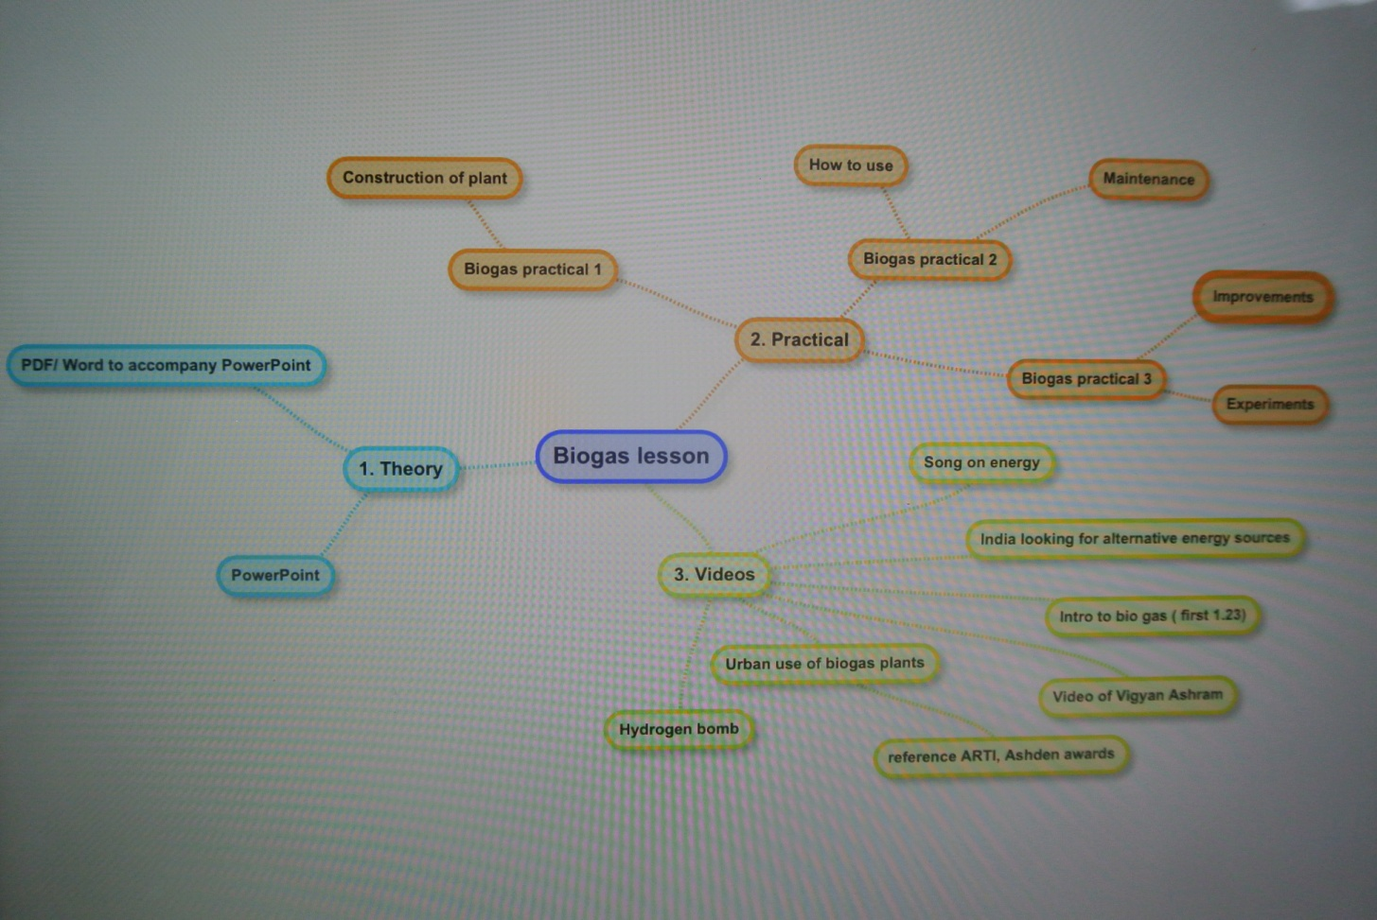

**Productive task1: Introduction to Biogas**

**Teacher/ Learner Instructions: Prior to Day 1:**

1. Learn about functioning of biogas plant in classroom session.
2. Learn about types of biogas plants.
3. Read through all material including **the notes section** in the PowerPoint (below each slide)
4. Find out different types of feed that can be used in Biogas plant.

You may use Power point presentation : Introduction to Biogas Plant

**Productive task 2: Estimate size of the biogas**

Find out availability of feed especially cow dung and estimate the size of biogas.

You may use Word document : ‘Estimating size of the biogas.doc’

**HPNPDL Session :**

After every activity or work exercise, all class will assemble together and brainstorm various questions. They will generate list of questions - What , Why , How, When , Where ? Attempt should be made that every student will ask min 2 questions.

The questions will be recorded. Teacher’s may able to answer some of them. It is not necessary to answer every questions but such questions must be recorded as ‘HPNPDL’ { Hame pata nahi par dhudh lenge }

**Productive Task 3 : Feeding the biogas and measuring gas output**

Students can be involved in following task.

1. If biogas is available in school/ community, measure the gas output for particular period of time.
2. Feed the plant. Mixing of water and feed etc.
3. Maintenance of biogas plant.
4. Use of slurry.

Please use the document : ‘Feeding and measuring biogas.doc’

**Productive Task 4 : Experimenting with feed : project work**

1. Use of different feed and estimate the yield of biogas.

A project can be given to students to feed the biogas plant for particular period (21 days) and find out gas generation.

Please use the document : ‘Experimenting biogas plant.doc’

**HPNPDL Session :**

After every activity or work exercise, all class will assemble together and brainstorm various questions. They will generate list of questions - What , Why , How, When , Where ? Attempt should be made that every student will ask min 2 questions.

The questions will be recorded. Teacher’s may able to answer some of them. It is not necessary to answer every questions but such questions must be recorded as ‘HPNPDL’ { Hame pata nahi par dhudh lenge }