

*Module III: Energy & Environmental Services*

**Lesson 8: Survey Techniques**

*Open Education Resource*

**Productive task**:

1. Draw a scale map of the room you are sat in
2. Finding out the answers related to dumpy levels
3. Drawing a map of surrounding place in scale with symbolic representation of the places

**Tools:**

Pen/pencil, paper, measuring tape...etc

**Class-Age Group**: 16 +

**Introduction:**

Surveying and mapping uses mathematical-based analysis to study the built and natural environments. This allows us to go beyond simply observing the world around us, to collecting and analysing data about it.

It is important to know about maps.

##### What is a Map?

A map is a representation of a selection of real features on the Earth.  It is designed to record the relationships between features and to allow the relationship between them to be analysed.

A map may be very simple (eg a sketch showing the location of plants in your garden) or very complex (eg a topographic map of the different states of India).

**You have probably used maps at some time in your life!**

- May be helping someone to explain a particular location in your village??

Some key characteristics of maps are:

* Maps portray, as accurately as possible.
* Maps are drawn to a scale (although this may vary across the map – especially for ancient maps and simple sketches)
* As a general rule, a map is usually a two dimensional representation (eg a ‘flat piece of paper’) of a three dimensional object (eg the Earth) – occasionally it may be a three dimensional object (eg a globe)
* Maps generally have a reference system (e.g. latitude/longitude) which allows the location of a feature to be described

**Maps and Plane table surveying**

**C:\Users\Hannah\AppData\Local\Microsoft\Windows\Temporary Internet Files\Content.IE5\N02VTYY2\MC900232110[1].wmf**

Hi I’m Anita and I’m going to help explain everything to you. This topic is my favourite, it is lots of fun! Let’s start by looking at the learning resources.

C:\Users\Mandar\AppData\Local\Microsoft\Windows\Temporary Internet Files\Content.IE5\Z9BW6DE0\MC900371050[1].wmf**Learning Resource:**

|  |  |
| --- | --- |
| S.No | Power Point Presentations |
| 1 | Introduction to Maps |

|  |  |
| --- | --- |
| S.No | Document |
| 1 | MAPS.doc |

**Productive task1:** Draw a scale map of the room you are sat in

Draw a scale map of the room you are sat in. To do this you will need to use a measuring tape and go around the room measuring everything. This will be a birds-eye-view of the room so we don’t need to measure the heights of the objects in the room. You will however need to measure the distance between different things in the room.

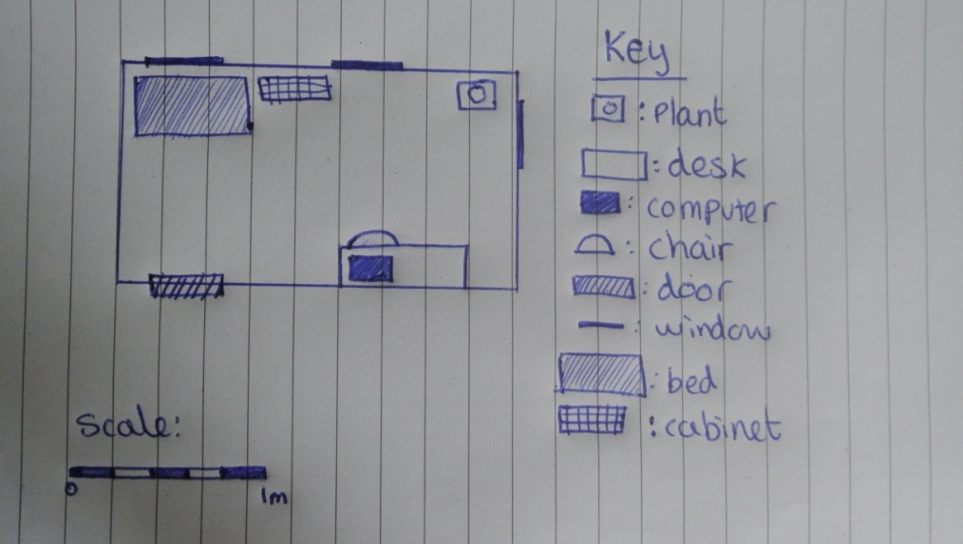

**C:\Users\Hannah\AppData\Local\Microsoft\Windows\Temporary Internet Files\Content.IE5\N02VTYY2\MC900232110[1].wmf**

Let’s now watch the two PowerPoint presentations and word documents listed below:

C:\Users\Mandar\AppData\Local\Microsoft\Windows\Temporary Internet Files\Content.IE5\Z9BW6DE0\MC900371050[1].wmf**Learning Resources:**

|  |  |
| --- | --- |
| S.No | Power Point Presentations |
| 1 | Plane Table Surveying.pptx |
| 2 | Contours.pptx |

|  |  |
| --- | --- |
| S.No | Document |
| 1 | Plane Table Survey & Maps.doc |

**Productive task 2:** Finding out the answers for the below questions?

Why you would use a dumpy level survey and plane table survey?

When would you need to use this?

Why would it be useful?

When will you use this skill in the future?

C:\Users\Mandar\AppData\Local\Microsoft\Windows\Temporary Internet Files\Content.IE5\Z9BW6DE0\MC900371050[1].wmf**Learning Resources:**

|  |  |
| --- | --- |
| S.No | Power Point Presentations |
| 1 | Dumpy Level- Surveying Introduction.pptx |
| 2 | Dumpy Levels-Levelling techniques.pptx |
| 3 | Dumpy Levels-Example of use.pptx |

|  |  |
| --- | --- |
| S.No | Document |
| 1 | Dumpy level.doc |

**Productive task 3:** Drawing a map in scale with symbolic representation of the places

Select a place nearer to your house and want to represent on the piece of paper (for example: may be a school/statue/garden/complex/shop/temple.....etc)

1. Draw a map of the selected place on the piece of paper
2. Map should be in scale (do mentioned the scale you have used)
3. Map should have surrounding landmarks covered and represent those with symbols
4. Show this map to your friend, who may not know the place already and check if he can actually find the place easily and map the symbols represented in your drawing.

**Other useful references:**

<http://www.instructables.com/id/-WATER-TUBE-LEVEL-from-scraps-/>

<http://www.youtube.com/watch?v=UMdPgp5oMRw>