

*Module II: Rural Industries*

**Lesson 10: Bamboo**

*Open Education Resource*

**Productive task**:

1. Preserving bamboo with non chemical method
2. Making own bamboo product.

**Tools:**

Survey tour in village market. Hacksaw , hammer...etc to prepare your own bamboo product

**Class-Age Group** : 16 +

**Objective:**

After going through this unit you will be able to learn bamboo types, advantages and disadvantages of bamboo. Different bamboo preservation methods and bamboo uses

**Introduction:**

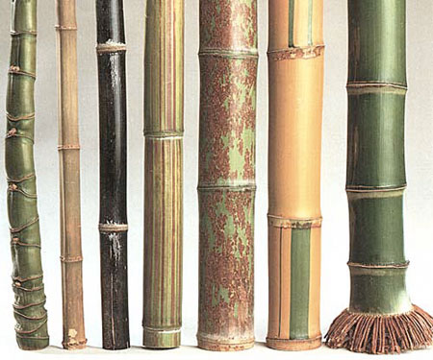

a temporary exterior structural material. Due to good physical and mechanical properties, low shrinkage and average density, it is well suited to replace wood in several applications.

Bamboo has many applications beyond imagination. Its uses are broad and plentiful.

India is home to almost 45 % of world's bamboo forests.

Bamboo is one of the oldest building materials used by mankind. The bamboo Culm, or stem, is used for producing domestic household products to industrial applications. Examples of bamboo products are food containers, handicrafts, toys, furniture, flooring, pulp and paper, boats, charcoal, musical instruments and weapons. In Asia, bamboo is quite common for bridges, scaffolding and housing, but it is usually a temporary exterior structural material.

To know more about bamboos refer below learning resource:

C:\Users\Mandar\AppData\Local\Microsoft\Windows\Temporary Internet Files\Content.IE5\Z9BW6DE0\MC900371050[1].wmf **Learning Resources:**

|  |  |
| --- | --- |
| Sr. No. | Power Point Presentations |
| 1 | Bamboo.pptx |

**Productive task 1: Preserving bamboo with non-chemical method**

After going through the above lesson, you must have realised the importance of bamboo.

In the upcoming productive tasks you will get to learn about bamboo’s uses and you will make your own bamboo product. But before that it is important to know how bamboo is preserved? It is important to learn the preservation methods to make long lasting bamboo products.

What is expected in this productive task?

Find out the bamboo product maker in your village (there will be at least a one in your own or nearby village) and visit his place to find out following:

1. Do they perform any treatment on bamboos at their place?
2. If yes, then what is the procedure they follow?
3. Collect two small pieces of non treated bamboos and treat only one piece using non-chemical preservation method. (you may need to keep it for longer period) Keep on observing both the bamboos after few months to check the impact. **(Note: This step may need longer period and hence not mandatory )**

Following resource will be useful to know about different preservation methods.

C:\Users\Mandar\AppData\Local\Microsoft\Windows\Temporary Internet Files\Content.IE5\Z9BW6DE0\MC900371050[1].wmf**Learning Resources:**

|  |  |
| --- | --- |
| Sr. No. | Power Point Presentations |
| 1 | Bamboo preservation.pptx |

**Productive task 2: Making your own bamboo product**

Now it’s time to design and make your own product.

What is expected in this productive task?

You will design and make your own bamboo product. Confused about which product? Here are few examples: vegetable container, chair, mat, bamboo house, any show piece....etc

**Step 1:** Draw a design of a product you want to make on paper

**Step 2:** Make a product using bamboo

Following is the example where students are making sofa.

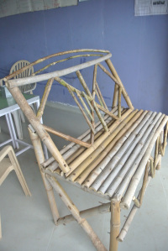 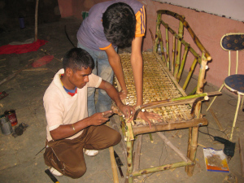

C:\Users\Mandar\AppData\Local\Microsoft\Windows\Temporary Internet Files\Content.IE5\Z9BW6DE0\MC900371050[1].wmf**Learning Resources:**

|  |  |
| --- | --- |
| Sr. No. | Power Point Presentations |
| 1 | Bamboo uses.pptx |

Watch the below video’s to know more.

**Other useful references:**

<http://www.youtube.com/watch?v=5Bwo2YEY75Y>

<http://www.youtube.com/watch?v=tTm30fJP3Hc>

<http://www.youtube.com/watch?v=4mK3xvbVRQU>