

Module II: Rural Industries

Lesson 5 Engineering drawing

*Open Education Resource*

**Productive Tasks**:

After completing this module it is expected that you will learn the drawing techniques and implement those while you are working on other modules like fabrication, construction...etc.

* **Productive task** : Drawing different structure views in scale

**Concept**:

Engineering drawing makes it possible to convey ideas from one person to others. So after going through this module you will be able to understand how to represent your ideas in the form of drawing with proper scale

You will learn the different techniques of projections used in engineering drawing.

**Class-Age Group**: 14 & above

**Introduction**

Drawing is universal language. It has several advantages over textual information. It is easily understood, - even by illiterates. Engineering drawing is the language of the technicians. Like any other language, engineering drawing has its rules and grammar.

We must learn to use principles of engineering drawing to convey our ideas. It makes it possible to replicate the jobs in large numbers without any deviations. In this lesson, we are going to study basic rules of drawing.

Drawing Basic Shapes

1)Triangle

We can use compass and scale to draw triangle.

**Step #1:**  
  
Take your ruler and a pencil and construct a segment of any length on a piece of paper as shown below

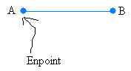

Then, you will try to set your compass opening to match the length of segment AB  
  
Take your compass. Make your sure that the pencil is included in it.  
  
Put the needle of the compass at endpoint A and adjust your compass so that the tip of your pencil touches endpoint B  
  
**Step #2:**  
  
Put the needle of your compass at A and draw an arc

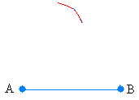

Put the needle of your compass at B and draw an arc

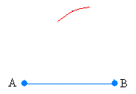

The two arcs should meet as shown below:

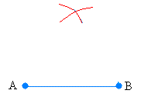

**Step #3:**  
  
Draw the segments from the two endpoints to the point where the two arcs intersets

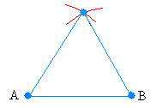

2) Quadrilateral

Quadrilateral has four sides. Sum of angles of quadrilateral is 3600. Square has all four sides of same length. Rectangle has two opposite sides of same length. Square /rectangle is drawn as follows:

- Take a pen, paper and measuring scale.

- Draw a 4 cm AB horizontal line on a paper.

- Draw a perpendicular line of 3.5 cm CB ┴ AB on AB.

- Draw another perpendicular line of 4 cm DC _|_ BC. (DC || AB).

- Join AD.

3) Regular Pentagon

Following are the steps in drawing pentagon of five sides of equal length.

For e.g lets draw a pentagon of 5 cm in length:

1. Draw a line AB of 5 cm.

2. Draw a circle of 5cm radius by taking A as a center. Then draw another circle with B as a center. Both circle will cross each other at point X and Z. Join length XZ.

3. Now take distance ZA in compass and draw circle with Z as a center. The circle will cut other circles at point S and R.

4. Now draw line RC and line SE passing through point Y. 5. Using compass ,mark arc of length

5 cm from point E and C. The arc will cross each other at point D. 6. Now join all points A B C D E, to form a pentagon.

4) Hexagon.

Hexagon has six sides. Draw hexagon of equal side.

1. Draw a circle of radius equal to side of hexagon.

2. Put the compass anywhere at the edge of a circle, call that point as A.

3. Draw arc of circle cutting circle at point B and F. Now put compass at point B and mark point C using compass. Similarly point D and E are marked.

4. Join all points using scale to get a hexagon.

C:\Users\Mandar\AppData\Local\Microsoft\Windows\Temporary Internet Files\Content.IE5\Z9BW6DE0\MC900371050[1].wmf **Learning Resources :**

|  |  |
| --- | --- |
| S.No | Power Point Presentations |
| 1 | Drawing basics.ppt |
| 2 | Drawing basic shapes.ppt |

**Productive task : Drawing different structure views in scale**

* Measure all the dimensions of a small structure on site and draw different views indicating scale of the structure on paper.
* You can choose your own site and structure or choose one structure from the below examples :
  + Examples : The bamboo hut, the weather station, or a chicken hut. You will draw different views of the structure.

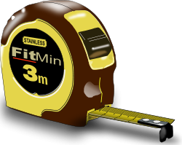

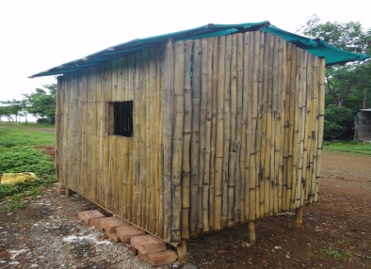 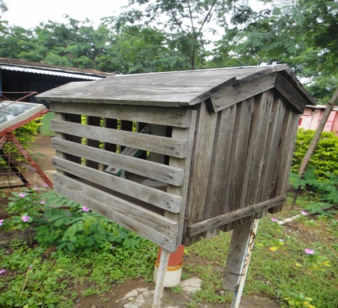 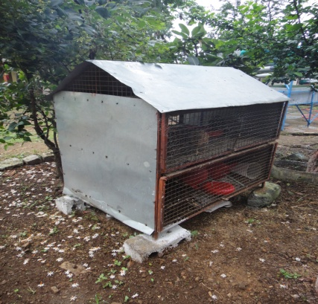

C:\Users\Mandar\AppData\Local\Microsoft\Windows\Temporary Internet Files\Content.IE5\Z9BW6DE0\MC900371050[1].wmf **Learning Resources :**

|  |  |
| --- | --- |
| **S.No** | **Documents** |
| 1 | Engineering Drawing -11.0.doc |
| 2 | Engineering Drawing 10.0.doc |

|  |  |
| --- | --- |
| **S.No** | **Power Point Presentations** |
| 1 | Drawing to Scale - generic.ppt |
| 2 | Drawing -Area and Volume.ppt |
| 3 | Engineering Drawing.ppt |