Do-It-Yourself Disinfection Chamber

Make this chamber from locally available materials at a low cost.
(You can install the system in any chamber or make chamber as per your budget)

Project Background :

Considering the current situation - Corona COVID 19 virus has proven that it's difficult to identify it's or any viral presence without symptoms on the human body. It's spreading rate doubles every time because of this, destroying many human lives in a very short time. It comes under infectious diseases, so additional care needs to be taken is the only way for now.

At Vigyan Ashram, we have worked on designing Disinfecting chamber. This chamber mainly disinfects a single person at a time with misting disinfectants i.e. H2O2 and RO water in the right proportion. There are two misters fitted inside which are running for a one-minute duration and sprays the open surface and clothes of the human body. A person needs to stand in front of the mister and rotate himself/herself while misting to cover the entire area. It also has provisions to cover sensitive body parts i.e. eyes, nose, mouth, ears, etc. with a transparent face shield.

Expected results and success indicator:

- We’re expecting everyone to take care to prevent COVID 19 and use this chamber.
- Our expectations are if anyone passes from this chamber as per directions given, it will get disinfected without harming any other body part.
- It should reduce the spreading rate of COVID 19 and secure lives.

Project concept sketch and description:

The suggested chamber is with dimensions 1 m* 1m * 2m (L*B*H) covered with plastic sheet curtains from all sides. One side will be the entrance and exit will be on another side. A disinfecting solution storage box can be kept in a suitable position or on one side of the chamber along with electronics consisting of a motor and controller. Electronic circuit will trigger for one minute when a user enters inside. Misters will be at chest position and knee position to cover entire body parts. The user needs to rotate himself/herself for better coverage, also the user will need to use a face shield that will cover mainly sensitive parts before entering the chamber.

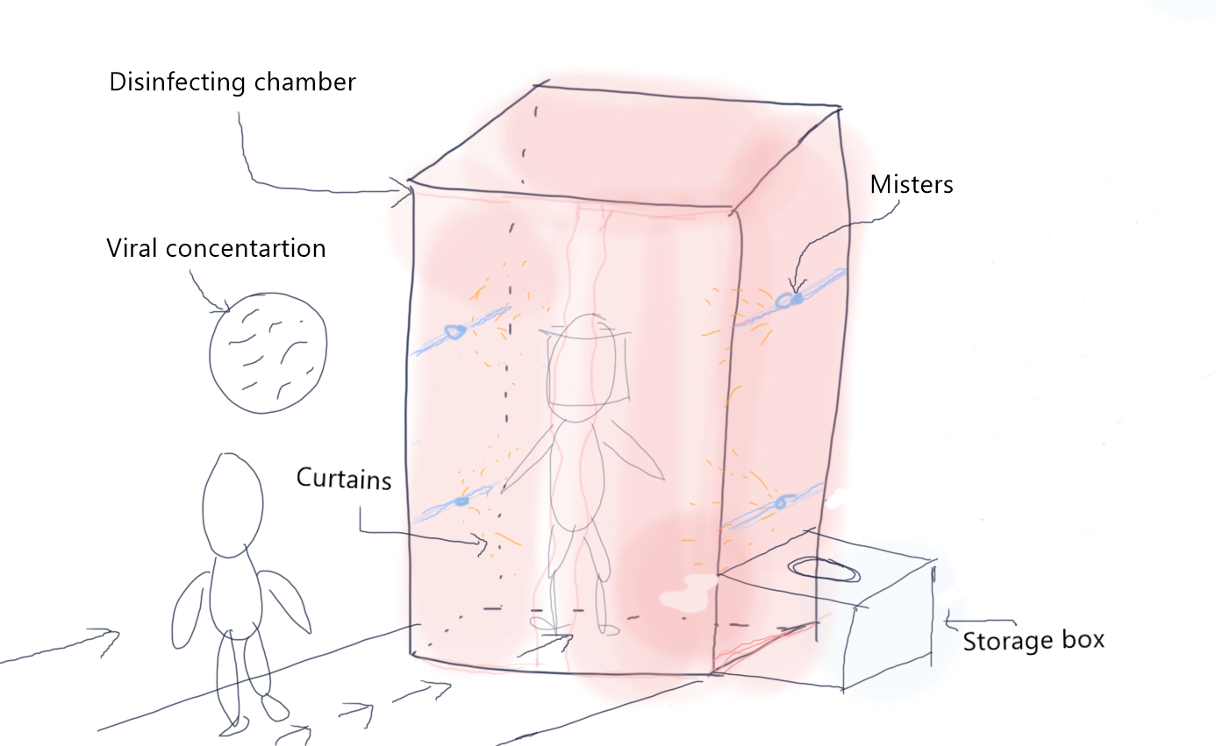

Image 1: Project concept sketch

This project mainly divided into three sections listed below-

- Foggers, pump selection, and plumbing
- Antiviral substances / Solutions preparation
- Chamber design and fabrication (optional)

A detailed description of all these sections given below:

- Pump and Nozzles arrangements-
For making the mist of disinfectant hydrogen peroxide with given concentration for 15 to 20 seconds, misters, pump, hoses, and controller is required as mentioned below.

- Pump
Specifications:
12 V, 3.5 A Agriculture spray pump motor.
4.5 Lpm discharge without nozzles, 6.5 bar pressure
This pump and control panel assembly has to fit at the bottom of the right side corner of the chamber.

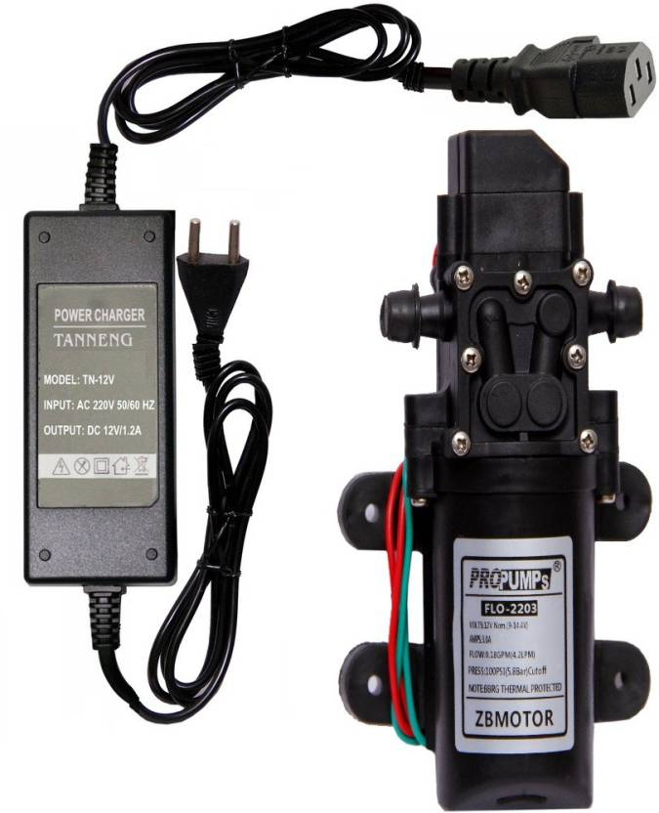

- Mist Nozzles
Type of nozzles - Low-pressure mist/fog nozzle
The pressure required - 5 to 10 bar
Mist size - 40 to 50 microns
Spray angle 120 degrees

Positions of nozzles -
1st nozzle at 2.5 ft from the platform and 2nd nozzle should be at 4.5 ft from the platform in the right side corner of the chamber

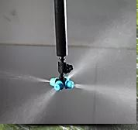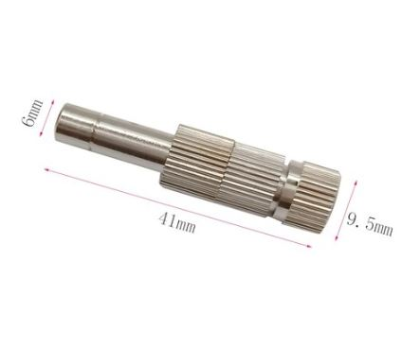

- Controller
The misting of 15 to 20 seconds required for one person to disinfect. Arduino UNO board along with the relay module and push-button is used for resetting.

Bill of Material -

Sr.No. | Material Description | Specifications | Quantity | Unit Price | Total Price  (In Rs)
1 | Pump | 12 V, 3.5 A DC pump, 4.5 LPM discharge, 6.5 bar pressure | 1 | 450 Rs | 450
2 | Pipe | ⅛ inch | 10 ft | 6 Rs/ft | 60
3 | Arduino board | UNO |  |  | 450
4 | Relay module | 5V, 10 A |  |  | 60
5 | Adopter | 12V, 5A |  |  | 450
6 | Adopter | 5V, 1 A |  |  | 150
7 | Switch | Push-button |  |  | 10
8 | Two core wire |  | 10 ft | 5 Rs/ft | 50
9 | Nozzles | 50 micron, 120 degrees wide | 2 nos | 150 Rs/nos | 300
10 | Reservoir Tank | 50 Litres | 1 |  | 500
Total |  |  |  |  | 2480
B. Antiviral substances / Solutions preparation

We are using Hydrogen peroxide as a disinfecting solution in this disinfecting chamber. Hydrogen peroxide is a strong oxidizing agent that dissociates to hydrogen (H+) and hydroxyl (OH−) radicals. These oxidative agents readily attack proteins, lipids and nucleic acids. Since we know that bacteria and viruses having protein structure.

Making 0.5 % Solution -
- H2O2 is readily available in the market with a concentration Of 6% Hydrogen peroxide.
- Mix 1 Litre of Hydrogen peroxide and 12 Litre water to get 13 Litre solution of 0.5 % concentration.
Why H2O2?
Hydrogen peroxide is typically sold in concentrations of about 6%. It can be used as it is or diluted to 0.5% concentration for effective use against coronaviruses on surfaces. It should be left on surfaces for one minute before wiping. H2o2 kills viruses on a hard surface as well as textiles for up to 8 hr before it degrades into nonpotable water, This makes it far more long-lasting than a bleach(NaOCL) and water spray.
What are the other options? why we were not using that?
Ans:-There are many disinfectants to kill bacteria and viruses like Ethyl alcohol, isopropyl alcohol, UV light, Sodium Hypochlorite (NaOCL), and Detergent, etc.
why we were not using?
a) Effect of isopropyl Alcohol and Isopropyl alcohol :
alcohol needs to use up to 70 to 90 % to get the expected result. (Ethyl alcohol is stronger than isopropyl alcohol)
b) Effect of UV Lights - Exposure to UV Lights in virus killing results up to 99.99 %. But it can not be directly used as direct exposure to humans or animals.
c) NaOCl: if exposed directly to skin and eyes then it many cause etching of skin and irritation of eyes also it has a corrosive effect on metal surfaces.
Reference:
“Inactivation of Coronavirus by Hydrogen peroxide was effective with a concentration of 0.5% and an exposure time of 1 min.”
https://www.sciencedirect.com/science...
https://www.pacificmedicalcenters.org...
https://www.cdc.gov/coronavirus/2019-...
https://www.wired.com/story/coronavir...
https://www.cdc.gov/coronavirus/2019-...
https://www.wikihow.com/Make-a-Natura...
https://www.insider.com/does-hydrogen-peroxide-kill-germs-and-viruses

C. Chamber design and details
The chamber is optional to fabricate. If you have chamber-like structure or room available with approx dimensions of 1 m * 1 m * 2 m (l*b*h).

Considering disinfecting a single person at a time chamber is designed with dimensions of 1m * 1m * 2m (l*b*h). All details are given below;

Structure details
Chamber schematic

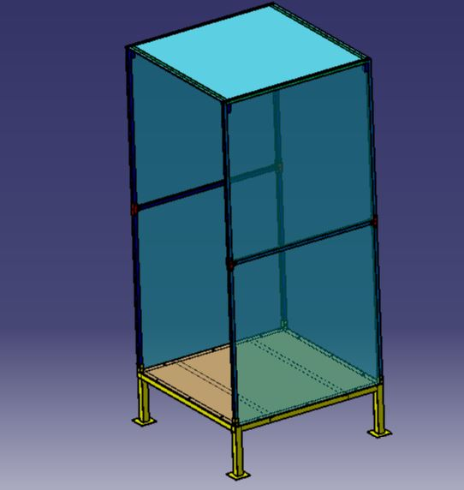

Chamber final drawing
Please find the detailed drawings in Annexure 2.

You can make this chamber with given dimensions as per availability of materials with your idea of designs also.

Bill of Material-

Sr.No. | Material Description | Specifications | Quantity | Unit Price | Total Price  (In Rs)
1 | Square tube | 40*40*3 mm | 4 ft | 25 Rs/ft | 100
2 | Square tube | 20*20*2 mm | 40 ft | 12.5 Rs/ ft | 500
3 | MS CRCA sheet | 3 mm thick | 1m * 1m |  | 1300
4 | L angle | 35*35*3 mm | 28 ft | 27.5 Rs/ft | 770
5 | Nut and Bolts | M6 * 30 mm | 20 nos. | 3 Rs/nos | 60
6 | Nut and Bolts | M10 * 30mm | 15 nos | 5 Rs/nos | 75
7 | Transparent plastic paper | 200 microns | 10 sq. mtr | 90 Rs/sq. mtr | 900
8 | Adhesive | 10 ml |  |  | 150
Total |  |  |  |  | 3855

Pilot Testing at Vigyan Ashram :
We have developed a prototype at Vigyan Ashram. It is in use. The following are photographs. It cost us less than Rs.10,000/- for material excluding machining and labor cost.

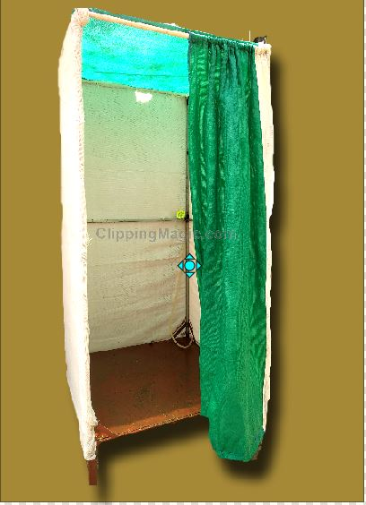

Please go through the video on following link to see use of disinfecting chamber -
https://www.youtube.com/watch?v=fAx0wVzdNbU

Safety Instruction while using the disinfecting chamber :
Always wear Goggles or face shields before entering into the chamber. You should cover your eyes and never expose them to a spray solution.

Disclaimer :
This design is shared with the best interest to collaborate with other makers. The process followed is based on secondary research. References are given at appropriate places. The maker does not guarantee or claim the results of the use of the chamber. We intend to get it tested from the appropriate authority in due course of time.

For more enquiry :
contact -
Amol Khamkar @ Vigyan Ashram Pabal.
Email - vapabal@gmail.com, amolkhamkar22@gmail.com ; Phone - 9158699159 / 9730005016

[ Makers team @ Vigyan Ashram - Sonal Shinde, Snehal Gawali, Arti Khamkar, Pratik Gajare, Priyanka Gawade, Prasad Patil, Sunny Bansode, Prasad Diwekar, Tejswini Chaudhari, Ghanshyam Bande, Vipul Shinde, Aditi Kharade, Sanket Walse, Priyanka Gharat, Amol Khamkar
Designed by – Suyash Chavan ]

Annexure 1:

Arduino UNO code for 15 seconds misting

const int Pushbutton = 2; //Pushbutton connected to pin D4
const int LED = 13; //LED connected to pin D7
int value = 0; // Variable for reading pushbutton status

void setup() {
// put your setup code here, to run once:
pinMode (LED, OUTPUT); //LED pin is Output
pinMode (Pushbutton, INPUT); //pushbutton pin is Output with external Pull-up resistor
}

void loop() {
// put your main code here, to run repeatedly:
value = digitalRead(Pushbutton); //Reads the status of the pushbutton
if (value == LOW) //If the Pushbutton is pressed
{
delay(10); //10 milliseconds debouncing Delay
if (value == LOW) //check again if the Pushbutton is still pressed
{
digitalWrite(LED, HIGH); //LED ON
delay(5000); //5 Second Delay
digitalWrite(LED, LOW); //LED OFF
}
}
}

Annexure 2:
Detailed drawings for Chamber fabrication

- Isometric view

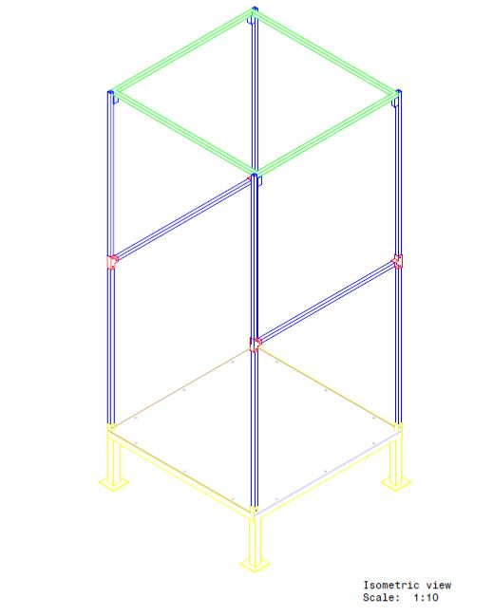

- Front, Left side and top views
