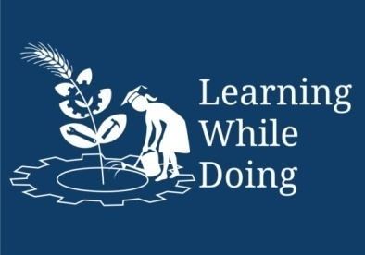
Open Education Resource
Productive task:
- Identifying and listing simple machines around your workplace / school with their working principle.
- Fabrication of 1 unit of coconut peeler using leaver technique.(In the group of 3-5)
Concept:
What is simple machine, Common type of simple machines, Force, Load, Weight, designing simple machine.

Tools:
Measuring tape, metal fabrication tools (welding machine, drill machine, grander etc)

Resource person – Maths teacher, Science teacher (Physics) , IBT instructor (Workshop section).

Class-Age Group: 14 +

Designing of Simple machine
- Types of simple machine
- Mr.Anand Gosavi & Mahesh Lade
Concept Map (Image) :

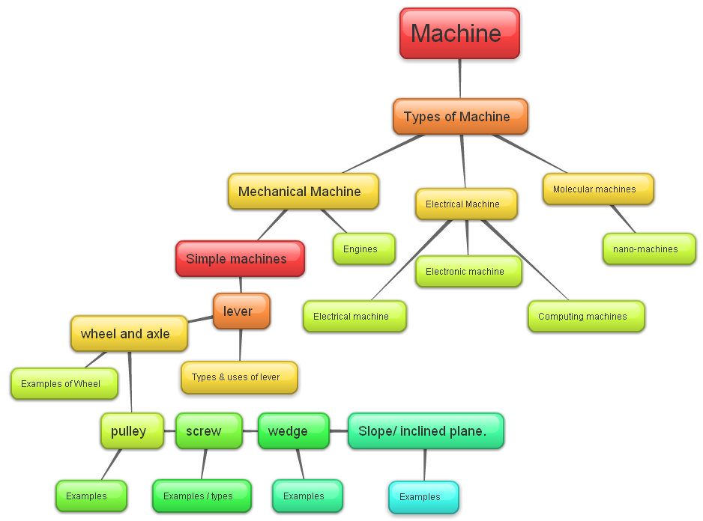

Productive task:
- Identifying and listing simple machines around your workplace / school with their working principle.
- Fabrication of 1 unit of coconut peeler using leaver technique.(In the group of 3-5)
Productive task objective:

After going through this unit you will be able to, apply simple machine techniques in day to day work of metal fabricating.

Introduction: What is machine?
Before Starting a lesson let’s watch a movie clip in Hindi
What is a machine?

Click (Ctlr+ right click) on the Button for video link

3 Idiots _ Definition of Machine.mp4

From above video you must have understood that –

Machines help us to reduce efforts required to do the work.

So, Machines became part of our daily lives. They help us to do work easily. Scissors, brakes, pulley, hears, screw jack etc. all are examples of machines. Machines help us to reduce efforts required to do the work. They have few or no moving parts. These machine uses energy to do work.

Let’s cheek is this true or false? By watching video’s given below, decide which machine is used in video to reduce human efforts’ and in which video human efforts are reduced to the large extend.

Video 1 which shows efforts required in lifting a bucket. Click on - No Pulley Bucket Lift.MOV

Video 2 which shows reduced efforts in lifting a bucket using a pulley. Click on- Simple Pulley.MOV

Video 3 which shows reduced efforts in lifting a bucket Block and Tackle. Click on - Block and Tackle.MOV

To understand concept of simple machines lets follow following PPT link –

Simple machines.pptx

Common types of simple machines:
Let’s now, study which are different types of simple machines around us and how they work or reduce human efforts –

- Wheel and Axle -
The axle is a rod that goes through the wheel. This makes it easier to move things from one place to other.
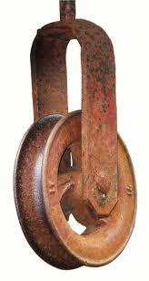
Wheel.pptx for more examples of Wheel as a Machine
You can also wiki link given below for further details –
Please click here

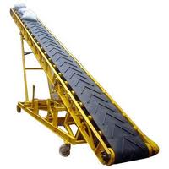
- Slope or inclined Plane-
Slope or inclined plane, is a machine which moves object to lower or higher place.
Slope.pptx for more examples of slope as a Machine
Please click here for wiki link on slope or inclined plane

You can also wiki link given below for further details –
Please click here

- Pulley-
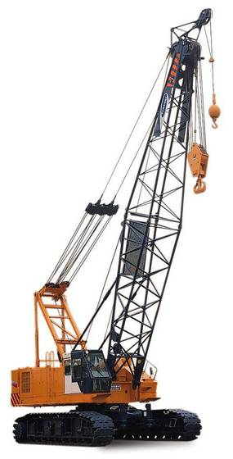
Pulley is made of a wheel with a groove between two flanges around its circumference. A rope, cable or belt usually runs inside the groove.
.
Please Click here for wiki links to Pulley.
Please click here for video links to Pulley.

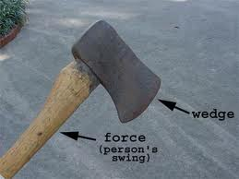
- Wedge-
A Wedge is a simple machine used to push two objects apart. A wedge is made up of two inclined planes. These planes meet and form a sharp edge. This edge can split things apart.
Wedge.pptx for PPT link on Wedges

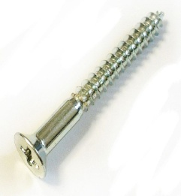
- Screw-

A screw is nothing but an inclined plane wrapped around a rod.
Screew.pptx for PPT link on Screw

Productive task 1 -
- Identifying each of above simple machines around your workplace / school with their working principle.

HPNPDL Session:

- Follow PPT links to know more about , designing of simple machine by using pulley as simple machine –
Working principle of pully.pptx
- Now let’s try in groups 4-5 students , a pulley designing game for designing as simple machine-
Designing pulley structure.pptx

Productive task 2 –

- Fabricate a coconut peeler device as per drawing given below ( under instruction of your teacher / guide / instructor) with leaver principle –

