Extraction of Coconut Oil with the help of Hydraulic Press:

- Ms. Anita S. Pansare
Open Education Resource
Productive Task:
Removal of excess oil from dry coconut, with the help of hydraulic press mechanism

Objective:
- To reduce fats, by removing excess oil from dry coconut.
- Preparation of low fat coconut chikki
Tools and material needed:
Hydraulic press machine (manually operated), dry coconut, sharp Knife, bowl, plastic bottle, weighing machine.
Procedure:

Step 1. | Crush the dry coconut to make pieces. | 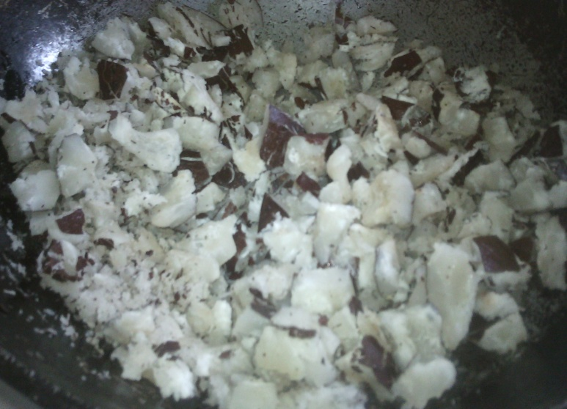
Step 2. | Fill the cylinder with the crushed coconut. | 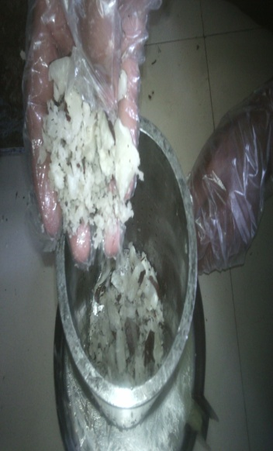
Step 3. | Arrange the whole assembly of hydraulic press in order to get pressed the crushed coconut. | 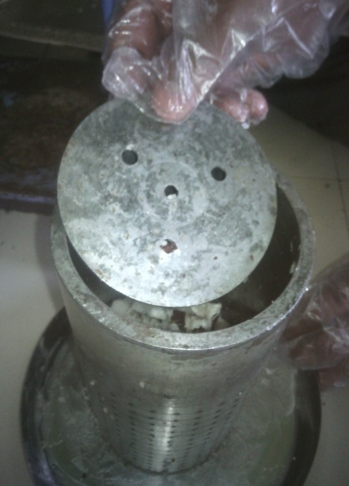
Step 4. | Adjust the pressure and take care that pressure shouldn’t exceed 2000PSI. | 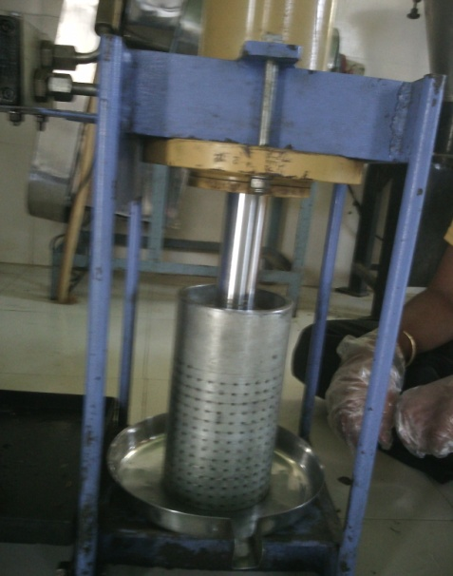
Step 5. | Manually press the pump to get the extracted oil. | 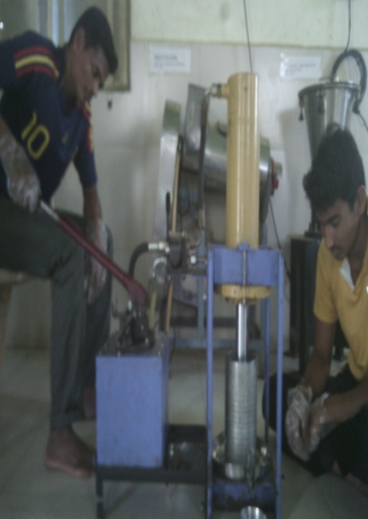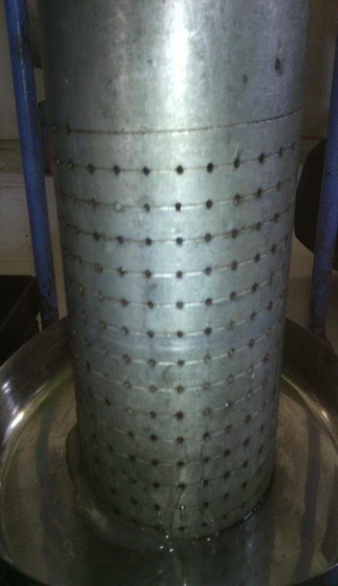
Step 6. | Fill the oil into the plastic bottle.

Conclusion:
From 1 Kg of coconut we got 350 ml. of pure coconut oil.

