Manual for Water Testing

- Ms. Anita S. Pansare
Open Education Resource
Concept Map (Image):
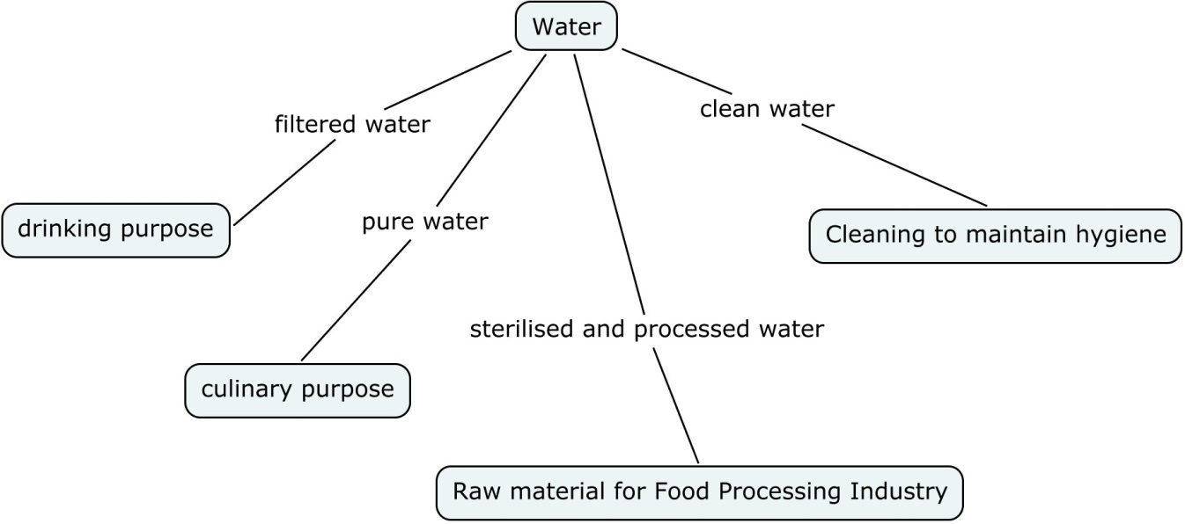

Introduction of Different kinds of water tests
- Hardness testing
- Alkalinity test
- Fluoride test
- Chloride test
- Nitrate test
- Iron test
- pH test
- Turbidity test
Productive work-
- What is mean by hardness, turbidity, alkalinity, pH of water?
- What is actual meaning of bacterial test?
- What is the standard amount of hardness present in water?
Productive work objectives-
- To learn how water testing is carried out
- To know actual meaning of bacterial test
- To know different kinds of concept like hardness, pH, turbidity, alkalinity present in water
EXPECTED SKILLS-
- The given person must to know how to collect water sample for testing.
- The given person must to know how to handle all tools.
- The given person has that potential to observe the colour change in water.
- Must create awareness among the students about dangerous bacteria present in water.
1. Hardness Test
AIM – To check hardness of water
OBJECTIVE- To check hardness level present in water for purity of water
PRINCIPLE- In this test adds Reagent-B and Reagent D-25 and check end colour. The end colour indicates hardness level in water.
MATERIAL REQUIRED - Reagent-B, Reagent D-25, Water sample, Test tube etc.
PROCEDURE-
- Take 10 ml water in the given test tube.
- Then add 5 drops of Reagent-B in that water and mix it well.
- After that with the help of 100 mg spoon add Reagent-A powder to that test tube. When we are add Reagent-A powder then water turns in pink colour that colour indicates Hardness present in water.
- Then add step by step drops of Reagent D-25 and mix it well. Add drops of Reagent D-25 up to that pink colour are change into blue colour.
- Check how many drops of Reagent D-25 are required for to change the pink colour into blue.
- Check hardness level present in water sample as follows-
1 drops of D-25 reagent = 25 ppm.

NOTE- If we got hardness level 200 ppm or less than 200 ppm then please follow next test or method.

- Take 25 ml water in the given test tube.
- Then add 10 drops of Reagent- B in that test tube and mix it well.
- After that with the help of 50 mg spoon add Reagent – A Powder in that test tube and mix it well.
- Then add step by step drops of Reagent D-25 and mix it well. Add drops of Reagent D-25 up to that pink colour are change into blue colour.
- Check how many drops of Reagent D-25 are required for to change the pink colour into blue.
- Check hardness level present in water sample as follows-
1 drops of D-25 reagent= 10 ppm
OBSEVATION-
How many drops are required to change pink colour into blue- …………..
RESULT – The given water sample contain …………… ppm hardness.
2. ALKALINITY Test
AIM- To study the level of alkalinity present in water.
MATERIALS REQUIRED- Water testing kit, water sample etc.
PROCEDURE-
- Take 10 ml water in the given test tube
- After that add Reagent T powder (50 mg) and mix it properly. When we are adding this reagent T powder then the water colour changes into green.( If water turns into red in colour then its indicates that the alkalinity of water is zero.)
- Then add ALK- 25 liquid (Reagent- ALK- 25) in drop wise manner and mix it in proper way. Add that drops up to it turns into green to red.
- After that count the drops required for red colour change. Then count the total alkalinity present in water.
1 drop of ALK- 25 drops= 25ppm
NOTE- If we got alkalinity level upto 250 ppm or less than 200 ppm then please follow next test or method.
- Take 25 ml water in the given test tube.
- After that add Reagent T powder (50 mg) and mix it properly. When we are adding this reagent T powder then the water colour changes into green.( If water turns into red in colour then its indicates that the alkalinity of water is zero.)
- Then add ALK- 25 liquid (Reagent- ALK- 25) in drop wise manner and mix it in proper way. Add that drops up to it turns into green to red.
- After that count the drops required for red colour change. Then count the total alkalinity present in water.
1 drop of ALK- 25 drops= 10ppm
3. CHLORIDE TEST
AIM- To study the level of chloride present in water.
MATERIAL required - Water testing kit, water sample, etc.
PROCEDURE-
- Take 5 ml water with the help of syringe in test tube.
- With the help of 50mg spoon add CL- -B powder in that test tube and mix it properly. When we are adding this CL- -B powder the water change into yellow in colour.
- After that add (Reagent CL-B) liquid in drop wise manner and mix it in proper way. Add that reagent up to the water changes into yellow to brick red colour.
- Count the drops required to change the water into yellow to brick red colour.
1 drop of CL-B = 25 ppm
NOTE- If the total count of Chloride in water is 250 ppm or less than 200 ppm then please follow next test or method
- Take 12.5 ml water in test tube with the help of 5 ml syringe.
- With the help of 50mg spoon add CL- -B powder in that test tube and mix it properly. When we are adding this CL- -B powder the water change into green in colour.
- After that add (Reagent CL-B) liquid in drop wise manner and mix it in proper way. Add that reagent up to the water changes into yellow to brick red colour.
- Count the drops required to change the water into yellow to brick red colour.
- drop of CL-B = 25 ppm
4. FLUORIDE TEST
AIM- To study the level of fluoride present in water.
MATERIAL REQUIRED - Water testing kit, water sample, etc.
PROCEDURE-
- Take 3 ml water in test bottle.
- Then add 10 drops of Reagent- 10 in that test tube. After that closed the lid of test bottle and tilt it 3 to 4 times for proper mixing. Then place for 1 min at stable condition.
- After that place it into the colour comparator. Compare that colour in the presence of sun rays. Then match the colour of the water sample with the help of colour comparator.
FLUORIDE COLOUR COMPARATOR
- In the fluoride kit colour comparator is present.
- In that kit total 6 colours are present from pink shade to yellow shade.
- Place the testing bottle in that colour comparator.
- Compare the colour of water with the help of colour comparator.
- Check the colour in the presence of sunlight.
- On that colour comparator 0.0, 0.5, 1.0, 1.5, 2 as like measurements are present.
- If we got the result between 0.5 and 1 then take the reading between that.
5. NITRATE TEST
AIM- To study the level of nitrate present in water.
MATERIAL REQUIRED – Water testing kit, water sample, etc.
PROCEDURE-
- Take 0.5 ml water with the help of 1 ml syringe in test bottle
- Then add Reagent N-1 20 drops of it and mix it properly.
- With the help of funnel add 100 mg powder of Reagent N -2 in that test bottle.
- After that closed the lid of test bottle and tilt it 3 to 4 times for proper mixing. Then place for 1 min at stable condition.
- After that place it into the colour comparator. Compare that colour in in the presence of sun rays. Then match the colour of the water sample with the help of colour comparator.
NITRATE COLOUR COMPARATOR
- In the nitrate kit colour comparator is present.
- In that kit total 5 colours are present from pink shade.
- Place the testing bottle in that colour comparator.
- Compare the colour of water with the help of colour comparator.
- Check the colour in the presence of sunlight.
- On colour comparator 10, 20, 30, 40, 50ppm as like measurements is shown.
- If we got the result between 40 and 50 then take the reading between that means take final reading as 45ppm.
6. IRON TEST
AIM- To study the level of nitrate present in water.
MATERIAL REQUIRED – Water testing kit, water sample, etc.
PROCEDURE-
- Take 10 ml water in test bottle.
- After that add 10 drop of Reagent Fe- A in that test bottle and mix it properly.
- Then add 1-0 drops of Fe-c liquid and mix it in proper way.
- After that closed the lid of test bottle and tilt it 3 to 4 times for proper mixing. Then place for 1 min at stable condition.
- After that place it into the colour comparator. Compare that colour in in the presence of sun rays. Then match the colour of the water sample with the help of colour comparator.
IRON COLOUR COMPARATOR
- In the nitrate kit colour comparator is present.
- In that kit total 5 colours are present from orange shade.
- Place the testing bottle in that colour comparator.
- Compare the colour of water with the help of colour comparator.
- Check the colour in the presence of sunlight.
- On that colour comparator 0.0, 0.3, 0.5, 0.7 and 0.7 and 1ppm as like measurements are present.
- If we got the result between 0.3 and 0.5 then take the reading between that.
7. pH test for water
Aim- To study the level of pH present in water.
Material required- water testing kit, water sample etc.
Procedure-
- Take 10 ml water in test bottle.
- After that add 5 drop of Reagent pH- 1 in that test bottle and mix it properly.
- After that closed the lid of test bottle and tilt it 3 to 4 times for proper mixing. Then place for 1 min at stable condition.
- After that place it into the colour comparator. Compare that colour in the presence of sun rays. Then match the colour of the water sample with the help of colour comparator.
pH colour comparator:
  - In the pH kit colour comparator is present.
  - In this kit total 5 colours are present from pink shade.
  - Place the testing bottle in that colour comparator.
  - Compare the colour of water with the help of colour comparator.
  - Check the colour in the presence of sunlight.
  - On colour comparator 0.0, 0.3, 0.5, 0.7 and 0.7 and 1ppm as like measurements are present.
  - If we got the result between 0.3 and 0.5 then take the reading between that.
8. Turbidity Test for water
Aim- To study the level of turbidity present in water.
Material required- water testing kit, water sample etc.
Procedure-
- Firstly take a clean test jar.
- Then Add water up to the mark.
- Check that colour of water in sunlight and match the colour which present on the turbidity chart.
- Now check the turbidity level as per the chart.
Turbidity chart-
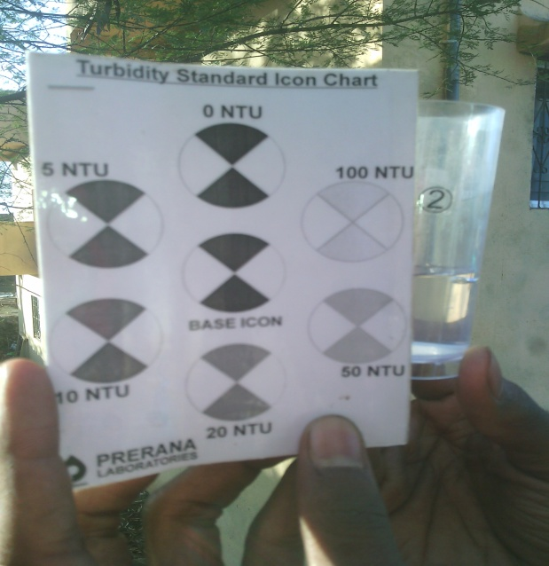
Record Observations and write the conclusion for each test of your sample.
Thank You

