Productive task : Making of khichadi by using various fuels

Concept : Calorific values, Types of fuels, How to calculate calorific value?, How to
Tackle the problem of Fuel scarcity?, Historical background of the khichadi. How
to do the comparative study of the fuels used.

Material & tools : Cooking vessels, stove, gas cylinder, wood, Chula, Match box, Kerosene,
Weighing machine
Class , Age group : 9th std. Age group – 14/ 15 years.

Class-Age Group :

Making of Khichadi
- Comparative study of fuels calorific values
- Adwaita Vartak
Open Education Resource
Concept Map (Image) :

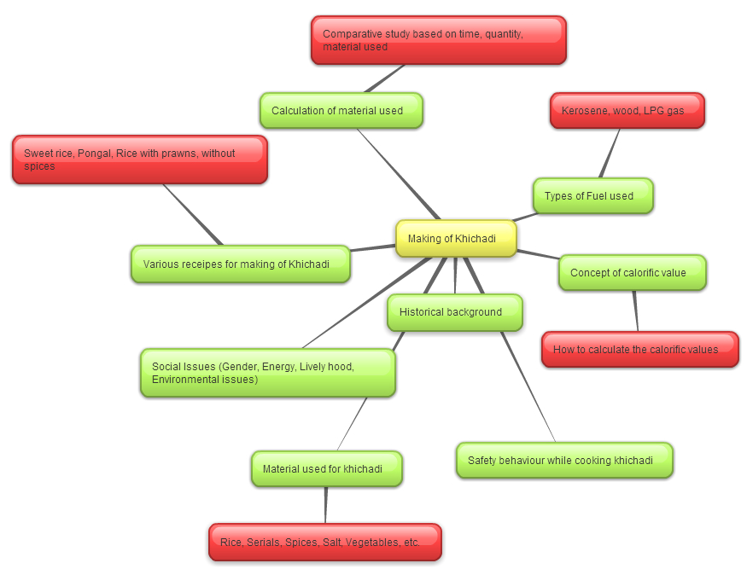

Productive task1: Introduction to the TASK on hand

Teacher to introduce students about objective of the lesson, doable objectives etc. He can use following resources
- Showing power point presentation about the History of mid day meal scheme in India.
- Types of khichadi – By its ingredients, way of cooking, etc. (Teacher can get various recipe from internet & other sources)
- Discussion about the current scenario of the fuel in your village.
- According to the availability of the fuel – select the 3 fuels to use.
Productive Task 2: Knowing about the various fuels used in our day to day life.

Survey: Teacher can ask the students to do the survey in the village to know the present use of kerosene, LPG & wood for cooking. (Approximate numbers – for traditional Chula users, gas users, smokeless Chula users if any)
Teacher can use/make the PPT presentation about the availability of fuel, its various uses.

HPNPDL Session:

After every activity or work exercise, all class will assemble together and brainstorm various questions. They will generate list of questions - What , Why , How, When , Where ? Attempt should be made that every student will ask min 2 questions.
The questions will be recorded. Teachers may able to answer some of them. It is not necessary to answer every questions but such questions must be recorded as ‘HPNPDL’ {Hame pata nahi par dhudh lenge }
Sample questions:
- What is the average consumption of fuel in your house?
- How can we calculate that?
- How to reduce the same?
- What are the alternative sources for fuel?
- What is mean by calorific value of fuels?
Productive Task 3: Selection of the task

- Making of Khichadi :
Depending upon the availability of the resources with the school, & number of student’s task for making of khichadi will be selected. Students / teachers may be involved in the selection of task. Make sure that Girls will able participate equally.
Suggested task will be:
- Cooking of Khichadi
- Try various recipes of khichadi
- Try various fuel to use
- Calculate the calories of the khichadi
- Calculation of the calorific values of the fuels used.
For Various Recipes of Khichadi - http://www.sanjeevkapoor.com/Search.aspx?text=khichadi

Productive Task 4: Understanding the concepts

Teacher need to conduct classroom discussion on following topics. He can use resources such as power point/video as given below.
- Show the Chart of calorific values of various fuels See the ppt attached
- What is the current scenario of fuel availability in India?
- What affects the availability of fuel?
- Safety measures: Teacher needs to discuss this in class. See the ppt attached
- What is the impact of high use of natural resources?
- How to reduce the use of fuel in day to day life.
- Alternative sources for the conventional fuels.

- While preparing for the task, divide students into at least 3 groups so that one group can cook with kerosene, one can cook with wood (Traditional Chula), & the another group can cook with LPG.
- While cooking the khichadi other members of the group can note the quantity of the materials used for khichadi, quantity of fuel, time taken for cooking.
- Make note of type of Vegetables, type of rice, serials, spices & quantity of the same is used for the khichadi.
- After the actual work done of cooking of khichadi with different fuels, Teacher can ask students to share their experiences with others.
- As per the notes taken calculation of each group activity, according to the quantity, time & calorific value of that particular fuel used.
- Experiences of the students – Learning from them needs to be considered by the teachers.

Celebrating the Task:
Celebrating the task :

Students should document the work done.
Costing of the material need to be done. They should write a report and may submit it (if possible) computer typed and with photographs.

Other Tasks:

As this is the 1 day activity, so teacher needs to make plan for this activity. As follows.

- Select the class/ group
- Divide the students in 3 groups (10 students per group)
- Then ask students among themselves to discuss about the activity
- Then ask them to measure the ingredients
- According to the groups ask them to measure the fuel which is going to be used.
- These all things need to be noted down somewhere by the students
- Ask students to get involve in each and every activity
- Ask students to do the costing of the same
- Then teacher needs to discuss the concept of calorific value of the fuel
- Calculation of the same need to be taught by the teacher
- Comparative analysis of the same

HPNPDL Session :

- What is the average consumption of fuel in your house?
- How can we calculate that?
- How to reduce the same?
- What are the alternative sources for fuel? See the ppt attached
- What is mean by calorific value of fuels?

