Productive task : 1) 1) Welding – for benches, Si-saw, Swing, Fencing, Shelter, dustbins
2) Carpentry – For Benches, Welcome sign
3) Gardening – Hanging pots, Drip arrangements, Hanging Bottles
4) Ferro - Cement Tank, Benches
5) Bamboo Processing – for Chairs, Monuments, Sculptures
6) Colouring of the benches, Si-saw, Swing, Fencing, Shelter, dustbins, sculptures
7) Costing – of the required material
8) Survey of the land - Soil Testing, Dumpy level Survey
9) Designs of the Social Space – Selection according to the need & availability of the resources
10) Drawings according to the actual availability of the land.
11) Various sculptures – for decoration
12) Reuse & recycling of the waste material

Concepts: Basics of Welding, Carpentry, Gardening, Surveying, Drawings etc.

Tools: Dumpy level survey kit, Welding machine, welding rods, tin sheets, Bamboo processing kit, Cement, Still, chicken mesh, plastic west bottles, Drips, pots, wooden shits, Plants, Soil Testing Kit. Iron rods, Oil Paints, Brushes
Class / Age Group - 5th – 9th.

Concept :

Tools :

Class-Age Group :

Making of a Garden in a school
- Adwaita Vartak
Open Education Resource
Concept Map (Image):
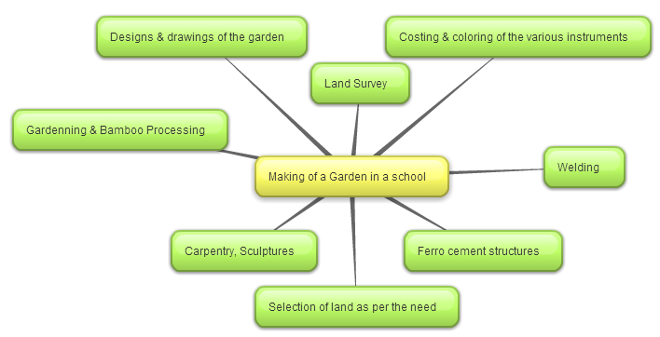

Productive task1: Introduction to Task on hand
Teacher to introduce students about objective of the lesson, doable objectives etc. He can use following resources-
- What is mean by Social Space – Concept Understanding – Here Teacher can conduct various tasks – such as various spaces, concepts in the day to day life.PPT
Showing the PPT for Concept of the social space

- Need of the social space for the school – Discussion – Inputs from the students
- Location & Area Selection on actual field.
- According to the available area designs of the social space.
Subject Link: Write an essay on “My Idea about Social Space”

Productive task 2: Knowing about the social space in our own life, community & surrounding

Survey of the Land:
i) Levelling of the land – With the help of Geography Teacher - Dumpy level survey of the available land.
According to the readings levelling of the land.

HPNPDL Session :

What is the use of social space?
ii) What should be the design of the social space?
iii) In your village, at how many places you are having social space?
iv) What are the needs of your School?
v) What is the difference between Social space in village & City?

Productive Task 3: Understanding the concept

Teacher to conduct classroom discussion on following topics. He can use resources such as power point/video as given below.
- Show PPT attached ‘What is mean by Social Space’
- Safety: Teacher will give instruction about Safety, Show video: U-Tube about safety for welding, carpentry etc.
- Activity: Introduction about the Idea of the Social space. Students may be asked to take a round in village or nearby places to list out different types , designs of the social space, Types of gardening used, sitting tools, new innovative ideas from students
- To built the Social space what basic skills students need to have??
For that Teacher should conduct prior informative session.

Productive Task 4: Selection of the task

Depending upon the need of school or community, resources available with schools and number of students, tasks for making Social Space will be selected. Students / teachers may be involved in the selection of task. Make sure that Girls will able participate equally.
Suggested tasks will be:
Here Teacher needs to give the idea of the tasks, & accordingly need to distribute the students in various tasks.
i) Survey of available land, Levelling of Land
ii) Welding of the swing, si-saw and other Equipments.
iii) Repair of existing material as the instrument to play in social space.
iv) Carpentry work for the Gate, Welcome sign, Chairs, Benches.
v) Welding/Repairing of the thing in students homes (Students should be asked to inquire at their home for any welding/repair requirement (As this is the need of the school, the school should bare the entire expense for the making of social space)
vi) With the available bamboo, can make hangings, Benches, tree guards etc. by bamboo processing?
vii) Digging the pits for plantation, Making of tree guards.
viii) Drawing of the designs
ix) Ferro-cement instruments
x) Selection of the final design as per the availability of land & resources.

Productive Task 5: Actual work with Hands

- Teacher will give the guidelines to the students.
- According to the need of the school, what need to be installing in the social space.
- As per the availability of the resources what need to get newly done & what from the recycling of the existing material.
- For this activity students should make the survey of the waste products which are getting accumulated as waste products in school premises.

Task 6: Estimating material required for all the jobs including the recycling of the waste

Teacher with the help of students will make estimate of quantity of material required. He will introduce them to branded material/ ISI material etc. Ask them to visit shop and get the quotation.
Teacher will introduce them with accounting instruments like Quotation / Estimate – purchase – Invoice
Students will be asked to purchase the material from the market.
Students should document the work done.
Task 7: Celebrating the work

They should write a report and may submit it (if possible) computer typed and with photographs. With actual costing for the entire job done.
Task 8: Sharing of the experiences

Reviewing or analysis of all the task & activities. To ensure that all the desire work done completely. Summery / report writing for the social space. - (Experiences, Learning, readings, etc)

