Productive task :
- To Survey Workshops and list out the types of welding methods
- To Carry out Welding of two metal parts
- To List out the equipments used in Welding
- To Perform Costing of Welding Job done

Concept :

List the Important skill required by the professional welder.
List the component skill require for the welding profession.
Explain the roll of different machine & material in welding process.
Describe various methods of welding.
Explain the safety precautions need to be taken during welding process.

Tools :
Welding machine, welding rod, safety equipments.

Class-Age Group :
Class: 9th
Age Group: 14 +

Welding
- Opportunities in welding
- Anand Gosavi
Open Education Resource
Concept Map (Image) :

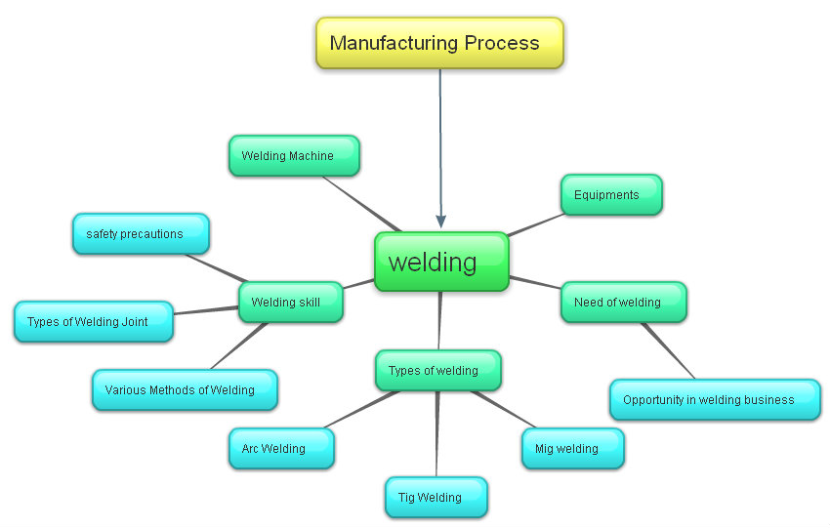
Introduction:

In the Manufacturing process jointing of different metal is main process. this process was done by using machines, tools and labour. Today we are going to learn about welding process in mechanical engineering field. This process is basic processes for converting raw material into products. We will also learn the basic safety precautions while working in the fabrication workshop. In practical section, you are going to fabricate tripod stand using these operations yourselves

Definition of welding:

Welding is a fabrication or sculptural process that joins materials, usually metals. This is often done by melting the work pieces and adding a filler material to form a pool of molten material that cools to become a strong joint.

Activity 1:

Visit to various places of your village and survey old and new construction of bridges, temple, Houses and keep notes how they joint metal.
Download Presentation on Welding types and machine.
See videos of welding process,

Activity 2:

Visit your village welding workshop and prepare a list of Equipments and welding machineries in that workshop.

HPNPDL Session:

Which equipments and devices are used in arc welding and gas welding?

What are the types of basic joints in welding?

Types of welding:

Arc Welding
Arc welding is a type of welding that uses a welding power supply to create an electric arc between an electrode and the base material to melt the metals at the welding point. They can use either direct (DC) or alternating (AC) current, This is the earliest type of welding Even Today it is widely used for fabrication of steel structures and automobile welding.

TIG Welding
It is also known as Gas tungsten arc welding (GTAW), also known as tungsten inert gas (TIG) welding,
It is an arc welding process that uses a non-consumable tungsten electrode to produce the weld. A constant-current welding power supply produces energy which is conducted across the arc through a column of highly ionized gas and metal vapors known as a plasma.
GTAW is most commonly used to weld thin sections of stainless steel and non-ferrous metals such as aluminum, magnesium, and copper alloys.
It is stronger type of weld but complex and time consuming

MIG Welding(Metal Inert Gas)
It is also known as Gas metal arc welding (GMAW), It is a welding process in which an electric arc forms between a consumable wire electrode and the work piece metal(s), which heats the work piece metal(s), causing them to melt, and join. Along with the wire electrode, a shielding gas feeds through the welding gun.
Originally developed for welding aluminum and other non-ferrous materials in the 1940s, GMAW was soon applied to steels because it provided faster welding time compared to other welding processes.

Oxy Acetylene Gas Welding
Oxy-fuel welding (commonly called oxyacetylene welding, oxy welding, or gas welding and oxy-fuel cutting are processes that use fuel gases and oxygen to weld and cut metals, respectively. Pure oxygen, instead of air, is used to increase the flame temperature to allow melting of the metal material in a room environment. The flame temperature is at about 3,500 deg Celsius.

See videos of co2 welding, arc welding.
Oxy-fuel is one of the oldest welding processes. Still used in industry
In oxy-fuel welding, a welding torch is used to weld metals. In oxy-fuel cutting, a torch is used to heat metal to its kindling temperature. A stream of oxygen is then passed on the metal, burning it into a metal oxide that flows out.

HPNPDL Session:
- What is the temperature of flame in gas welding?
- What are the safety precautions to be followed while welding?

Opportunities in welding:

Fabrication is having lot of scope, and also lot of companies prefer to outsource the welding jobs to good workshops; hence Welding is having lot of potential opportunities as a business and also as a job career.

Activity 3:

– Visit to nearer Fabrication Company and see the different types of welding machine.

Activity 3:

- Join 2 metal pieces by performing welding. Use Gas welding and Arc welding and notice the difference in both the types of wildings

