Productive task: Making a Bench from used plastic Bottles.

Concept: Problem of plastic waste, What is mean by recycling, Types of wastes, Types of Pollution, Effects on ecosystem, use of renewable/non-renewable resources for manufacturing cement and plastics, importance of reducing usage of material made from non-renewable resources (plastics are made from petroleum products) or which are manufactured in polluting industries (cement); Surface area, Volume, structural design and aesthetics

Tools and materials: Discarded Plastic bottles, Sand, Cement, Water, waste material that are not bio-degradable, wooden sticks for stuffing bottles, Basin for mixing cement, trowel, tools for digging foundation, tool for spreading cement, 4 steel angles of 50cm length each

Class & Age Group : 9th Std. 14 years.

Class-Age Group: 8th& 9th , Age group : 14+

Time Duration :3/4 days

Waste Management
- Recycling of Plastic Wastes
- Adwaita
- Indira
- Shital
- Laltu
Open Education Resource
Concept Map (Image):
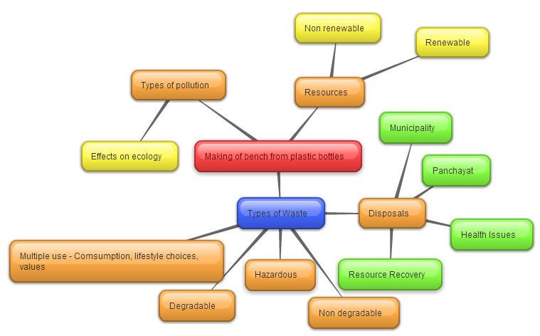

Productive task1:

For introduction : See the PPT attached

Making of Bench from used plastic Bottles.
See Activity flow for sequence and details of activities and approximate time required

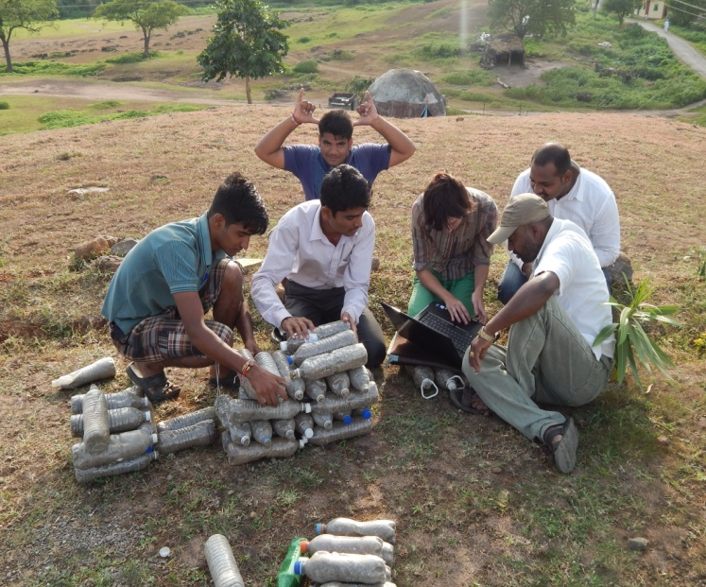

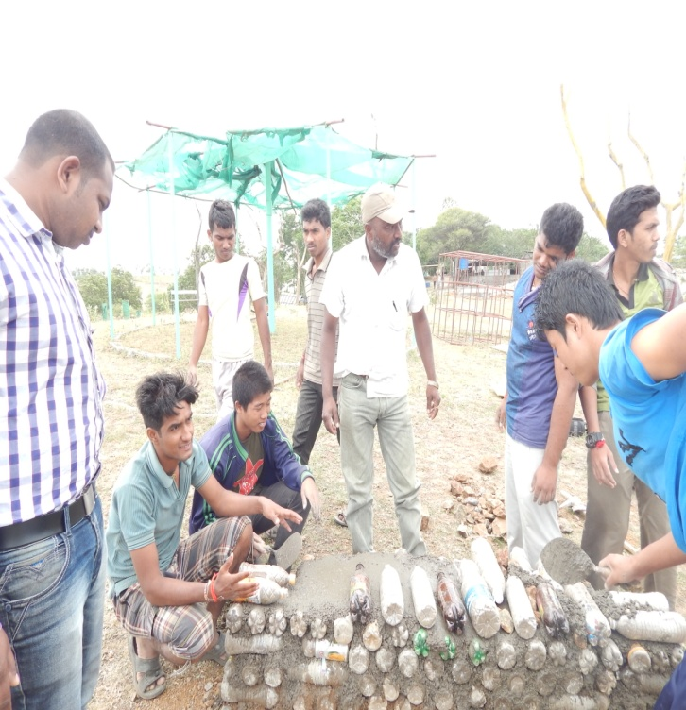

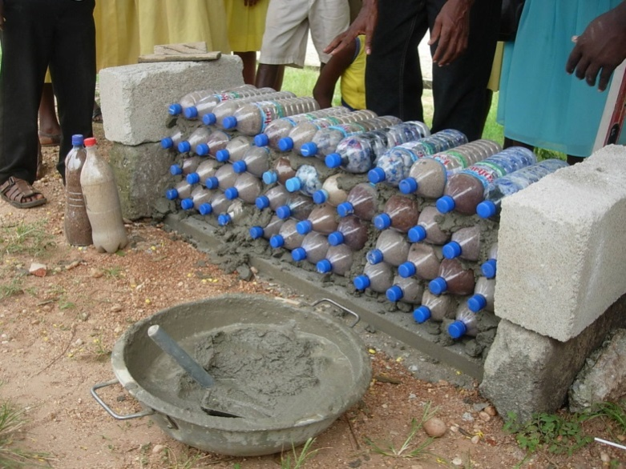

Link for the Plastic bottle construction

http://www.samarpanfoundation.org/website/index.php?option=com_content&view=article&id=95:house-construction-with-plastic-bottles&catid=52:delhi-projects

What are the types of Waste, What are the ways of waste segregation? See the PPT attached- Problems of waste management

HPNPDL Session:
- What is the difference between the bench make by traditional construction & Plastic bottles construction?
- What is the importance of using plastic bottles for construction?
- For filling the bottles what other material can be used?
- Instead of plastic bottles what are the alternatives are available?
- Cost wise what is the main difference in both the ways?
- What are the other ways to reuse the plastic bottles?
- Can we use only plastic bottles?
- What would be the different designs for bench?
- Which other tool we can make from the plastic waste at our School?
- Among all types of plastic which kind of plastic is recyclable & how?
- How to reduce the use of plastic? At domestic level, School?
- What are the solutions of problem in waste management?
See the PPT attached- Project Design

Other Tasks:

Tasks for day 1 :

- Discussion about the topic of waste management based on the story. It includes present situation, what needs to happen – how? Why? (45 minutes)
- School waste survey (45 minutes)School waste survey : Survey needs to cover the school premises; quantity of wastes and type of waste (bio-degradable, non-biodegradable and hazardous)
Students walk in pairs through different areas in the school, noting down the type of waste, method of disposal. If dust bins are used they will bring the contents of the dustbins and spread it out on a large newspaper sheet and note down the different materials present in the waste. In a small school the quantity of different type of wastes generated in a given day can be estimated by mass and volume.
–
(Ref. Std. 8thScience Textbook Chapter 3)

HOME WORK
- List down the names of waste products found in your house
- Find out what happens to the waste when it leaves your home –who collects it; where it is taken; is it dumped nearby…
Task for Day 2:
Making a school wide waste management plan (45 minute discussion and 45 minute planning)
Teacher will initiate a discussion about waste based on the survey results. Results should be tabulated. Students may want to think about the sources of waste and the problem of plastic wastes. Teacher may introduce ideas about resources that go into manufacturing of plastics and problems of health and pollution caused by improper disposal of wastes.

See the PPT about the problem of plastic waste
The class may brain storm ways of recycling different materials and teacher may steer the discussion towards the importance of segregating different types of waste to improve recycling and resource recovery. Teacher can introduce the idea about constructing a park bench using plastic bottles filled with dry waste material and soil/sand.

http://articles.timesofindia.indiatimes.com/2013-11-05/times-view/43693278_1_plastic-waste-roads-great-example

(Ref. Std. 9th. Science Chapter 13 – Why do we fall Ill?)
(Ref. Std. 8th. Science Textbook Chapter no. 18 Pollution of Air & water)

Make a waste management plan for the school keeping in mind the types of waste, the points of waste generation, the recycling possibilities, spaces available for keeping collection bins and cost.
CONNECTION WITH: LANGUAGE
Write an essay on below topics
- Garbage : As crisis
- Ways of waste management
- Autobiography of a Plastic bottles

Task for Day 3:

- Implementation of waste management plan (45 mins)
Implement the school waste management plan by placing collection bins and creating posters/signs for members of the school community. Allocate duties for periodic removal of waste and further processing. Wet wastes should be ideally used for making compost for the school garden and dry wastes can be suitably stored before sending for recycling. Paper, plastic etc and various non-degradable material can be stored to be used in making plastic bottle bricks which will be used for making the bench. Children can create a collection centre for plastic bottles from homes and other places in an around the school.
- Designing the park bench (45mins)
Students will identify a suitable place for the bench. They will discuss the height, shape and area of the bench. They will calculate the number of bottle-bricks, cement and sand required for the bench and also estimates the cost. The school will help the students to purchase cement.
(a bench measuring 100cm x 30 cm x 50cm height requires approximately one bag of cement and 45 bottle bricks)

Task for day 4:

Actual construction of the bench (3 -4 hours)
Students will measure and mark the space on the ground where they are going to construct the bench.
A foundation of 15 cms deep has to be dug out and a layer of cement : sand (1:1) mixed with water is poured into the foundation and spread evenly to a height of 4 cms. Embed a steel angle at each corner of the bench for support. Lay a row of bottles on the cement. Again a layer of cement sand slurry is spread over the bottles and a second layer of bottles is placed on top of this. Repeat this process till the desired height is reached (4 or 5 layers of bottles).
Top off the topmost layer of bottles with cement sand slurry and spread a layer of cement slurry to create a smooth surface to sit on.
The bench has to be watered twice a day for the next three days and covered with a wet sack.
After drying students may decorate the bench with enamel paints as they like. They may choose to cover the bottles with cement plaster or leave them exposed.

